CMIT 350 WAN and SOHO Skills Implementation

Use this document as a guide for formatting and organizing your CMIT 350 Skills Implementation challenge.

Title Page
Professionalism will be key to your success and advancement in your academic and professional career. Use the title page to identify relevant information such as your name, the course, professor and submission/completion date.

Document Index/Contents
Organization will allow your document to be divided into key areas of consideration and allows an overall structure to be placed over the submission.

Sample text:
- Site “XXXXXXXX” Challenges and Implementation
- Site “XXXXXXXX” Challenges and Implementation
- Site “XXXXXXXX” Challenges and Implementation
- Bibliography

Site “XXXXXXXXXX” Challenge and Implementation
(Provide a section for each site, as suggested in your table of contents.)

Site Details and Challenges (Summary)
Here you will simply summarize the site requirements and/or challenges you are attempting to overcome. You will not need to implement solutions of discuss your approach at this point in time. This information is provided to you and can simply be organized and restated as you understand it. Think of this area as what needs to be corrected. Suggested length would be one or two paragraphs.

Sample text:
As described in the scenario, the xUMUC site was developed without any VLAN structure, and administrators have found the need to isolate broadcast traffic from a layer-2 perspective.

Site Solution(s) and Technologies
With the challenges stated, you will be able to clearly define your approach to solving those challenges and can state the technologies you will be implementing to do so. Be sure to use this area to justify your approach and selection of technologies as well. The specific length and details of this area will vary based on the specifics and depth of the challenge you are facing. Your justification would be your selection of a specific technology or approach over another and why you chose the approach you are taking. Show off your knowledge in the foundational skills here!

Sample text:
In order to relieve the administrative tasks surrounding the implementation of manual IP addressing per device, we will configure and implement a DHCP (dynamic host configuration protocol) server, per site requirements. The DHCP allows for devices to identify, request and implement IP configurations as well as other settings….

Since this area may call for facts and details around technologies and approaches, you will most likely find yourself using in-text citations, which would appear as follows:

Open Shortest Path First is an open standard routing protocol that’s been implemented by a wide variety of network vendors, including Cisco [1].

Sample Configuration
Understanding the technologies will satisfy a portion of the documents requirements. You will also need to display how the solutions you are suggesting would be implemented. This will include the specific commands used to configure the devices. Instructions will state when sample configurations are required, and any sample configurations should be limited to the devices provided, per the site topology. Device syntax to be used can be found in your training suite, TestOut’s LabSim. Show off your technical competency here!

Sample text:
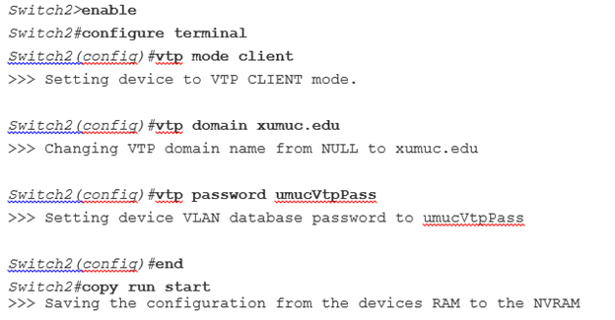

Sample Device Configuration 1

Supporting Tables/Diagrams
When structuring solutions per certain sites, you may find it helpful or even necessary to structure information with tables and/or diagrams. These items can be used to support and display your understood solutions located in the “Site Solution(s) and Technologies” area. Display your organizational and logical skills in this area!

Sample table:
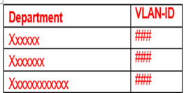

Sample Table 1

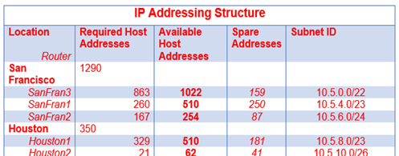

Sample Table 2

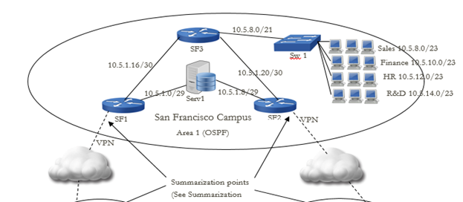

Sample Diagram 1

Repeat the format to include all required document components for each site. In this sample, sections numbered II and III in your table of contents would be provided next, followed by the bibliography.

Bibliography

Be responsible with your research and included works. Provide proper credit in the IEEE format to those original authors and their works that you decide to leverage in your submission.

Sample Entry:
[1] T. Lammle. CCNA Routing and Switching Study Guide. Indianapolis, ID: Sybex Wiley, 2013, p. 386.

