Project 2:
This is for college project and due on 11/20/2015 before 8 pm (EST). The course is relates to Environmental Science. Please include at least 2 references for each answered. Do not copy from the other scholar paper or other homework markets because we have plagiarism rules. Each answer worth 10 points (half page should be fine. 1 page max). There are total of 4 questions.
See below for details.
Questions 01
Background: Family trees are excellent indicators of the population dynamics within a family.
Please answer: Draw your family tree and discuss the fertility rates in at least three generations. Is the Total Fertility Rate the same or has it changed in the three generations? What are some of the reasons for these differences?
Question 02
Background: Population profiles, also called population pyramids, show the distribution of any population into sex and age cohort/groups.
Please answer: Discuss a CURRENT population profile of your state. What does it show? Is the population growing, declining or stable? What is the projected population? List your references (at least three references are required).
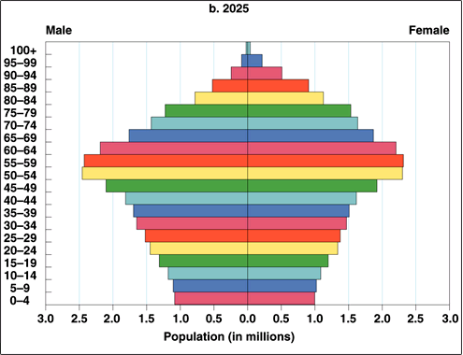
Question 03
Background: Human migration has been going on for hundreds of years as people move in search of better economic and educational opportunities and improved social lifestyles. Today, immigration is a global discussion. Many developed countries in the world are feeling the pressure from high numbers of immigrants coming into their countries from different cultural, socio-economic, and educational backgrounds.
Please answer: Discuss two similarities and two differences between immigration concerns of the U.S.A. and another developed country of your choice. List your references (at least three references are required).
Question 04
Background: As of 2011 the global population passed the seven billion mark. The Earth's resources are constant as the human population continues to grow. All of these increases are a result of high birth rates in the poor developing countries of Asia, Africa and South America. India has the world's oldest family planning program, and China has the world's only One Child Population Policy.
Please answer: Should governments decide the number of children a woman can have in her life time? Discuss the relationship between women's rights (human rights) and education and fertility rates? List your references (at least three references are required).

Thank you.

