I want to program in any language enters the values of the ABC and then draw triangle and add a drop-down options such as:
1 translotion
2 rotation
3 halfturn
4 reflection
5 guild reflection
Ex:
translotion :
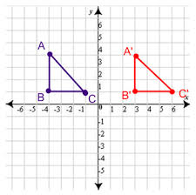
rotation:
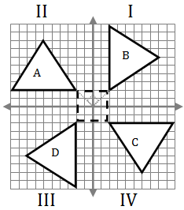
reflection :
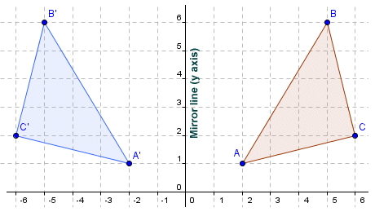
half turn :
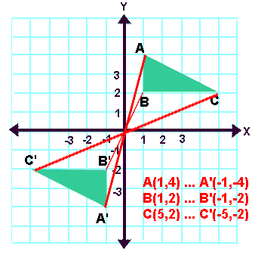
guild reflection :
I do not have example
---------------------------------
Please check outputs // thanks a lot ^_^

