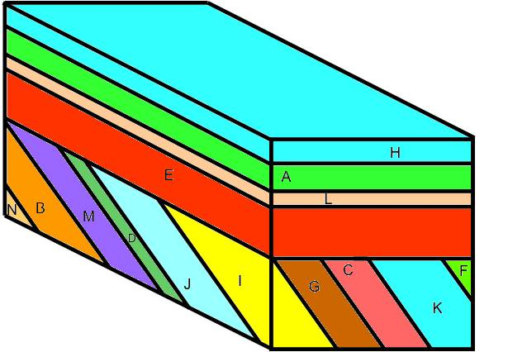
1. Observe this block diagram. Place events in order of occurrence in the respective places below. Work from oldest to youngest, bottom to top. Be sure to note any unconformities and their types.

16.

15.

14.

13.

12.

11.

10.

9.

8.

7.

6.

5.

4.

3.

2.

1.
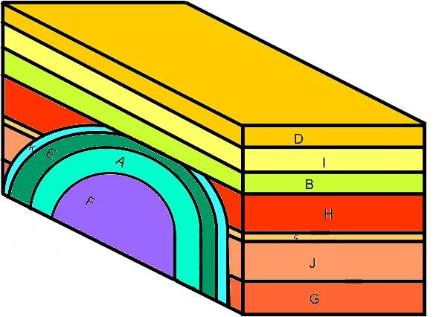
2. Observe the block diagram above. Place events in order of occurrence in the respective places below. Work from oldest to youngest, bottom to top. Be sure to note any unconformities and their types.

13.
12.
11.
10.
9.
8.
7.
6.
5.
4.
3.
2.
1.
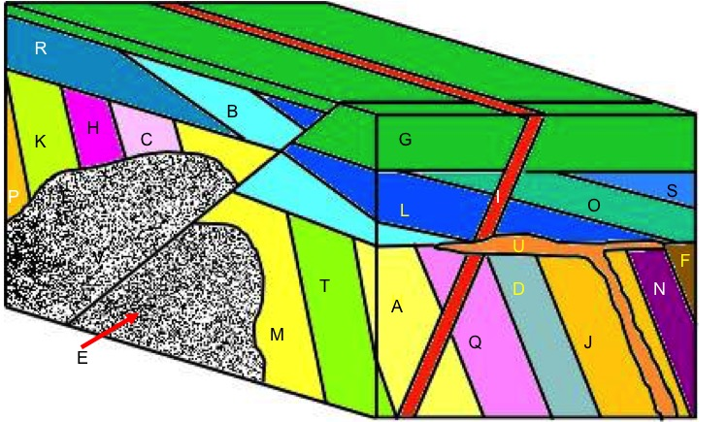
ir3. Observe the block diagram above. Place events in order of occurrence in their respective places below. Work from oldest to youngest, bottom to top. Be sure to note any unconformities and their types.

28.
27.
26.
25.
24.
23.
22.
21.
20.
19.
18.
17.
16.
15.
14.
13.
12.
11.
10.
9.
8.
7.
6.
5.
4.
3.
2.
1.
Absolute Dating
In this part of the exercise, you will be calculating the actual, or absolute, ages of the rock. 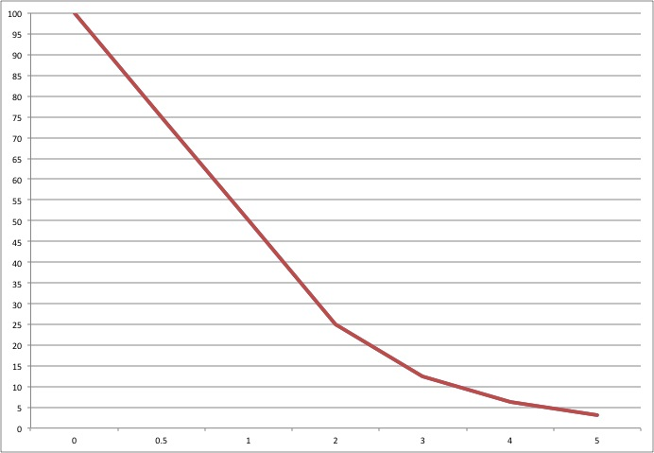
The figure above shows the relationship between the percentage of parent material and the number of half-lives that have passed.

4. What percentage of the parent material is present after one half-life?
Two?
Three?
Four?

5. If you start with 80 grams of an isotope, how much would be left after-one half-life?
What about three half-lives?

6. If an isotope has a half-life of 600 million years, how old is a rock that contains the isotope after 50% of the parent has decayed?
How old is the rock after four half-lives have passed?

7. You discover the parent isotope in a lava flow has gone through 0.75 half-lifes. If a half-life is 800 million years, how old is that rock?

8. In number 1, at the beginning of the exercise, Layer F was dated at 260 million years old. Layer E was determined to be 235 million years old. When did the fold occur?
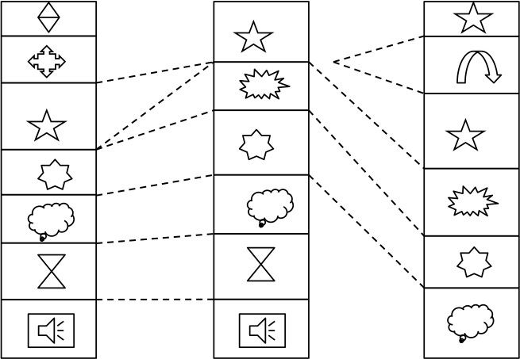
9. The image to the left show a series of sections containing various fossils. If the star is 325 million years old (ma), and the heptagon (the 7-sided fossil) is 337 ma, how old is the 15-sided fossil in between?

If the star existed for three million years, from 324ma-327ma, how old must the arched arrow in section three be?

10. Based on what you learned about fossil preservation, how might the following be preserved as fossils?

Dinosaur bones?
Microscopic organisms like bacteria and protists?
Skin or feathers?
DNA?

