Attempt to wireless scan from printer (scanner setup tests properly and scanner shows network connection)

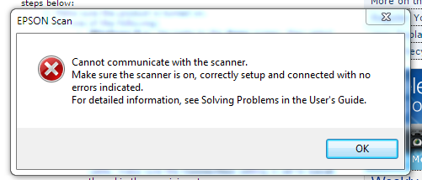

Attempt to print via USB cable to PC

“Communication error”. Check if the computer is connected.” Or “Computer is read only”.

Attempt to print from menu to PC (EPSON3CDCF5)

“Computer in use. Try again later or select another printer”.