Elevation.pdf - Google Drive

Elevation.pd!

Page 1 of 1

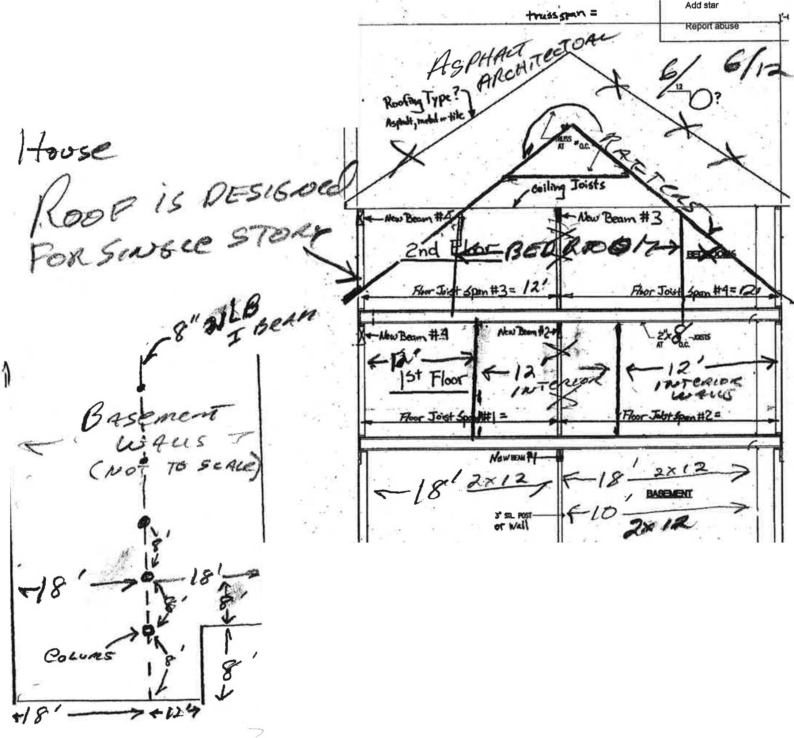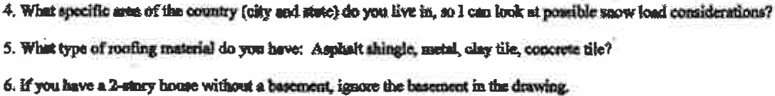Open with
•

Send feedback Embed Item•..

'-4'.

J, J!'l.,-Joot Mdm!)'pl<el-ms mdmdio.o!o lO!li<li lien locolloo )W-lilalOhot¥edoqno40-., 1,2, ), 4 or 5). Wllotwill

-ofdilo_....,?

3.0oyou_ mof _11,at . _ 111o-'«-111or <foyo,,i.-..,,oo/foodoUllll ...bclng-- intoyot1t- V
Arelbo- lgjt(-pi.sotmcmbor Jolma)?

1.lfJOU hl>ea l·ICioq-willlolll •........, i...,..Ibo md 1•Soor1&ibodmrlaa1D11"""""'1""2"' ii Ille 1"ftoor.
1.lfJUllba"'•l .olorr """""_.•i..c.-.-a.2."'n-;.ioo1"ilool'i!!l!l-lho t•11oatmcu'"'-l.

1,., /'1(\ /,.,f\1 C

