CLASS 1,4,5 SERVICE BULLETIN

Nissan Forklift Corporation
240 North Prospect Street; Marengo, IL 60152
DEPARTMENT

Important Meter Panel Information
SB 2007-271 POLICY

Date: January 26, 2007
To: All Dealer Principals All Service Managers
From: Customer Satisfaction Department - Technical Publications
Subject: Platinum II 1F1/1F2 Cushion Models Meter Panel Instructions

Applied Models: All Platinum II Series 1F1/1F2 Cushion Models Effective Date: January 2007
SATISFACTION

Attached to this bulletin are important Meter Panel instructions for your Service department to use as new 1F1/1F2 units arrive at the dealerships.

CD's, along with Operator, Parts, and Service manuals, will be sent in the next few days to all dealer locations.

If you have any questions regarding this bulletin please contact Kelly Geishert; 815-568-2123 or Shane Hauser; 815-568-2117 in the Service department, or Wayne Wilde; 815-568-2140 or Rick Grossert; 815-568-2532 in the Training department.

Sincerely,
Nissan Forklift Corporation

Wayne Wilde Sr.
CUSTOMER
Director, Training and Technical Publications Attachment

The information provided in this bulletin is not to be construed as a basis for any claims against NFC, unless otherwise stated.
Phone Number: (815) 568-0061 Fax Number: (815) 568-0186

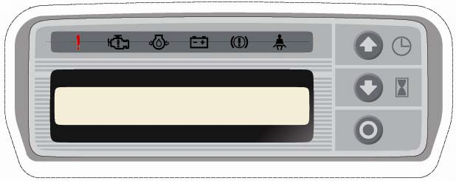

Platinum II
Meter Panel Operation

January 2007

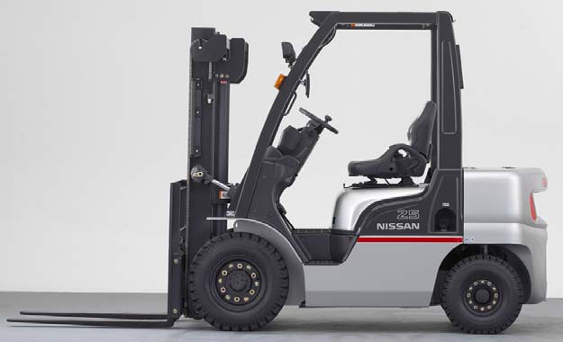
Agenda

Y Warning Display

Y Operation

Y Screen navigation for:

Y Operator
Y Manager

Y Service Tech

Y2

Warning Display GAS/LPG/DUAL

YMIL (Check Engine) Warning

YGlow plug lamp
YDiesel Yonly

YOil Pressure Warning

YCharge Warning

YParking Brake Warning

YSeat Belt Warning

YMulti Purpose warning

YLCD
YShift direction, YWater temp YFuel level YClock
YPUSH SWITCH
YUse for select Yof display, Ychange the Ysetting value

Y3

Combination Meter Indicators

Multipurpose Warning (STD for all trucks) Turns on when LCD has a warning.

Check Engine Warning (STD for DUAL & LPG) When engine (ECM) has code.

Glow Warning (STD for DIESEL truck)
When IGN-SW is turned on, this warning is on Till pre-heat is complete

Oil pressure Warning (STD for all trucks) When engine oil pressure is low, this warning Will turn on.
Charge Warning (STD for all trucks)
When charge system is troubled, this lamp is on.

Parking brake Warning (STD for all trucks) When parking lever switch is on, warning is on.

Seat-belt Warning (STD for all Trucks)
When seat-belt is not buckled, this warning is on.

Y4

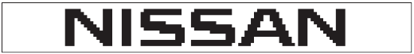

Starting Display

When the key switch is turned on, NISSAN is indicated on display .

Y5

Normal Display (Clock Shown)

After the starting display,the display is changed to normal.
Left : Position indicates shift direction Middle：upper : Coolant temperature Lower : Fuel level
Right ：Clock

Y6

Calendar

It is possible to change the display from the Normal Display to calendar by using the push-switch.

Y7

Indication of Hours

It is possible to indicate the Hour-Meter by using push-switch.
Meter has two functions for Hour-Meter.
- Hours for IGN-ON
- Hours for Engine-ON
Must be configured in tech mode.

Y8

Indication of Speed

When the speed of truck is over 2MPH , meter indicates speed automatically.

Y9

Indication of Maintenance Time

The meter panel will indicate maintenance when required. This indication is shown 15sec. after IGN-SW is turned on.

Y10

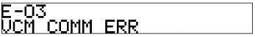

Indication of Error

Error Code (Maximum of 40)

YLanguages available YEnglish YSpanish YFrench YGerman YJapanese

If a fault code is in the VCM or ECM, the meter indicates the Error Code.
When the up or down button, is pressed, the panel indicates the cause of error.

Y11

Indication of Warning

warning

If a warning occurs the display indicates a warning symbol and illuminates the multi-purpose warning .
- Mast Interlock
- LPG level / LPG Rack Lock
- Torque Converter Temp
- Coolant Level
- Air Cleaner Clogged
- Fuel Filter (Diesel Only)

Y12

LCD Warning Symbols

Torque converter fluid temp Turns on when transmission fluid temp is high.

Radiator Level Warning Illuminated when the engine coolant is low.

Fuel Filter Warning
(Diesel Only)
Turns on when the fuel filter has become full with water.

LPG level warning / LPG Rack Lock
Illuminates when LPG is low. Also when LPG rack is not securely set.

Air Cleaner Warning
Turns on when the air cleaner has become clogged.
Mast Interlock Warning Illuminates when Ignition switch is on & operator is not seated on the seat.

Y13

Fuel and Water Temp

tem p |  | indication | step
h igh |  | ＋ | 4
 |  |  | 3
 |  |  | 2
 |  |  | 1
lo w |  |  | 0

f uel |  | i ndi cat i on | s t ep
f ul l |  |  | 5
 |  |  | 4
 |  |  | 3
 |  |  | 2
 |  |  | 1
e mpt y |  | ＋ | 0

Y14

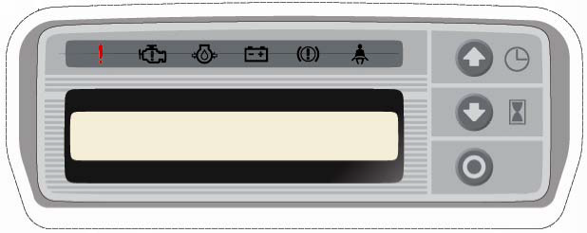

How to select indication

YClock normal display YCalendar

over 2 mph

YIndication of hours
YIndication of speed

Y15

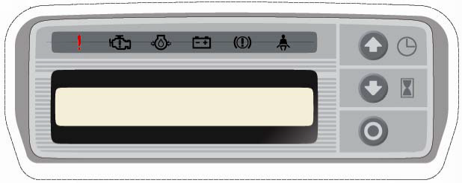

How to set clock

Push and hold after key is turned on

10:25 12:25

12:25 12:50

Y16

How to set calendar

Push an hold after
Key has been turned on

05/02/31
14:25

06/02/31
14:25

06/06/31
14:25

06/06/26
14:25

06/06/26
07:25

06/02/31
14:25
06/06/31
14:25
06/06/26
14:25
06/06/26
07:25
06/06/26
07:45

06/06/26
07:45

Y17

Operator mode

Y Purpose

Y Prevention of theft
Y Restrict the operator
Y Administration of operator (each operator’s hour meter)

How to enter :
1. KEY ON

2. Select an operator. (A B C D E)
3. Enter password. (A-E each have password)

If the password is entered wrong 3 times, the engine will start but after 3 seconds mast lockout on and Trans to N.

Y18

Operator mode

YThis screen will be displayed when
Ythe key is turned on.

YThe operator can scroll to his letter
YBy using the up/down arrows.

YWhen the correct letter is selected
YPress the enter button.

YNow the operator can enter his/her YNumber code by using the up/down keys and hitting enter.

YIf enabled by the manager, the operator must enter the correct number code (password).

YMaximum of 5 operators (A-E)

Y19

Manager mode

Y To enter the manager mode hold down at the same time for approximately 7 seconds after the key has been turned on.
Y 8653 is the factory installed manager code.

Y20

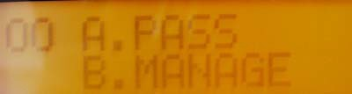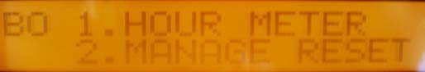

Manager mode

YPress to enter
A0  1 | PASS ENTRY  ENTRY TIME | OFF  6h
A0 | PASS A | 1234
2 | PASS B | 2345
A0 | PASS C | 3456
3 | PASS D | 4567
A0 | PASS E | 5678
4 | PASS (MANAGE) | 8653

Mgr. Can change how often the operator must enter his password per shift.
Above >ENTRY TIME 6H< means operator only enters his password every 6 hours.

Manage password can be changed in Tech Mode.

Y21

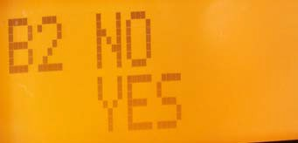

Manager mode

YPanel shows Hrs. for each
YOperator (A,B,C,D)
Y(E) is on the next screen

YManager can reset
YHrs. by pressing up / down
YThen enter

Y22

Password entry for Diagnosis (Tech Mode)

YTruck is off

Push while turning KEY ON

YNumbers are entered by using the up/down keys and then pressing enter.

YEnter 0312

Y23

Diagnosis screen

YNavigation tip: To go back a screen, Ypress both up/down buttons at the same time.

Y24

Mode for Diagnosis

AO 1. VCM 3. MP
2. ECM

A1 SPEED SEN 0.0km/h
01 OIL PRES 0.000MPa

A2 ENG.REV 0rpm
01 IDLE SW ON
YNavigation: YUP
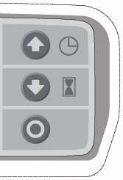YDown YEnter

A3 PKB SW ON
01 BRAKE OIL LOW OFF

OO A. MONITOR C. ALARM
B. SET D. TEST

BO 1. VCM
2. MP

B1 CONT TYPE MC
01 T/M TYPE ATM

B2 SER REMIND MANU
01 MANU HOUR

CO 1. HISTORY
2. CLEAR ALL

DO CAUTION TO MOVE ! EXE? NO YES
NO

YES
C1 NO ALARM HISTORY

C1 02. F-3 XXXXX
02 CLEAR? NO YES

C2 CLEAR ALL HISTORY
01 NO YES

D0 1.VCM 3. MP 2.ECM

Press both Together To go back A screen

Y25

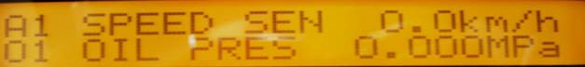

VCM Input output monitor A1

YData lines 11-20 are on
A1  1 | SPEED SEN  OIL PRES | 0.0km/h  0.000MPa
A1  2 | TILT ANG  WHEEL ANG | 0.0V  0.0V
A1  3 | ACCEL SEN  IGN ST SW | 0.00%  OFF
A1  4 | MAST HIGH SW  Lift OPE SW | OFF  OFF
A1  5 | TILT OPE SW  SPEED LIMIT SW | OFF  ON
A1  6 | POWER ECO SW  SEAT SW | OFF  ON
A1  7 | SEAT BELT SW  ACCEL SW | ON  OFF
A1  8 | TILT STOP SW  COOLANT LOW SW | OFF  OFF
A1  9 | AIR CLEANER SW  T/M WARNING SW | OFF  OFF
A1  10 | INCHING SW  MFC CHANGE SW | OFF  OFF

Yon the next page.

Y26

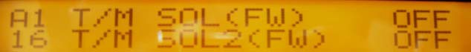

VCM Input output monitor A1 (cont.)

YData lines 21-30 are on
A1  11 | AUTO START SW  FC RELAY | OFF  ON
A1  12 | AUTO LIGHT RLY  WARN 1 BUZZER | OFF  OFF
A1  13 | WARN 2 BUZZER  N-SIGNAL | OFF  ON
A1  14 | RESERVE (OUT)  STARTOR RELAY | OFF  OFF
A1  15 | ENG.STOP RELAY  GLOW RELAY | ON  OFF
A1  16 | T/M SOL (FW)  T/M SOL 2(FW) | OFF  OFF
A1  17 | T/M SOL (BW)  T/M SOL | OFF  4mA
A1  18 | PS SOL  PS SOL | OFF  4mA
A1  19 | T-LOCK SOL  T-LOCK SOL | OFF  0mA
A1  20 | L-LOCK SOL  L-LOCK SOL | OFF  0mA

Yon the next page.

Y27

VCM Input output monitor A1 (cont.)

YData lines 31-34 are on
A1  21 | ULOADC1 SOL  ULOADCL SOL | OFF  4mA
A1  22 | FC SEN(LIFT)  FC LIFT (UP) | 0%  OFF
A1  23 | FC LIFT (DN)  FC LIFT | OFF  9mA
A1  24 | FC SEN (TILT)  FC TILT (FW) | 0%  OFF
A1  25 | FC TILT (BW)  FC TILT | OFF  4mA
A1  26 | FC SEN (ATT1)  FC ATT1 (A) | 0%  0FF
A1  27 | FC ATT1 (B)  FC ATT1 | OFF  9mA
A1  28 | FC SEN (ATT2)  FC ATT2 (A) | 0%  OFF
A1  29 | FC ATT2 (B)  FC ATT2 | OFF  9mA
A1  30 | FC SEN (ATT3)  FC ATT3 (A) | -99%  OFF

Yon the next page.

Y28

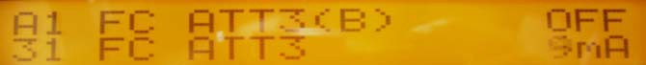

VCM Input output monitor A1 (cont.)

YTo go back to last menu screen, Ypress both up/down buttons at the same time.
A1  31 | FC ATT3 (B)  FC ATT3 | OFF  9mA
A1  32 | SHIFT LEVER (F)  SHIFT LEVER (N) | OFF  ON
A1  33 | SHIFT LEVER ®  SHIFTLEVER (2F) | OFF  OFF
A1  34 | BAT VOL. | 12.3

Y29

ECM Input output monitor A2

A2  1 | ENG.REV  IDLE SW | 0rpm  ON
A2  2 | THROTTLE ANGLE  BAT VOL. | 0%  12240mV
A2  3 | ACCEL ANGLE  COOLANT TEMP | 0%  24 C
A2  4 | INJPULSE GAS  INJPULSE LPG | 820 us  0us
A2  5 | STARTOR SW  NEUTRAL SW | OFF  ON
A2  6 | ELEC LOAD SW  BRAKE SW | OFF  OFF
A2  7 | AIR-CON SW  A/F ALPHA CLR | OFF  NOT
A2  8 | IDLE AIR VOL F  IDLE AIR VOL N | NOT  NOT
A2  9 | IGN TIMING ADJ  A/F ALPHA ADJ | NOT  NOT
A2  10 | POWER BALANCE  FUEL PRES CLR | NOT  NOT
Y30

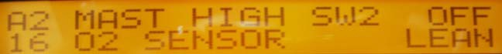

ECM Input output monitor A2 (cont.)

A2  11 | SELF - DIAG CLR  AIR FLOW | NOT  335mV
A2  12 | CHARG EFF GAS  CHARG EFF LPG | 86%  75%
A2  13 | A/F ALPHA GAS  A/F ALPHA LPG | 100%  100%
A2  14 | CHG FUEL SW1  CHG FUEL SW2 | ON  OFF
A2  15 | FUEL CONTROL  MAST HIGH SW1 | LPG  OFF
A2  16 | MAST HIGH SW2  O2 SENSOR | OFF  LEAN
A2  17 | FUELPUMP RELAY  LPG RELAY | OFF  OFF
A2  18 | THROTTLE RELAY  O2 SEN HEATER | ON  OFF
A2  19 | OFF ACCEL PO.  IDLE AIR COMP | DONE  DONE
A2  20 | CON CONSULT II  IGN.TIMING | OFF  0deg
Y31

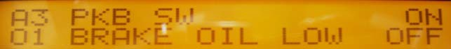

MP Input output monitor A3

A3 | 1 | PKB SW  BRAKE OIL LOW | ON  OFF
A3 | 2 | ENG. PRES LOW ENG. TEMP | ON 7 C
A3 | 3 | FUEL LEVEL TURN SIG (RH) | 83 Ohms OFF
A3 | 4 | TURN SIG (LH)  FUEL WARN SW | OFF  OFF

Y32

How to get to VCM set

A1 SPEED SEN 0.0km/h
01 OIL PRES 0.000MPa

AO 1. VCM 3. MP
2. ECM
A2 ENG.REV 0rpm
01 IDLE SW ON

A3 PKB SW ON
01 BRAKE OIL LOW OFF

OO A. MONITOR C. ALARM
B. SET D. TEST

BO 1. VCM
2. MP

B1 CONT TYPE MC
01 T/M TYPE ATM

B2 SER REMIND MANU
01 MANU HOUR

CO 1. HISTORY
2. CLEAR ALL
NO

YES
C1 NO ALARM HISTORY

C1 02. F-3 XXXXX
02 CLEAR? NO YES

DO CAUTION TO MOVE ! EXE? NO YES
C2 CLEAR ALL HISTORY
01 NO YES

D0 1.VCM 3. MP 2.ECM

Y33

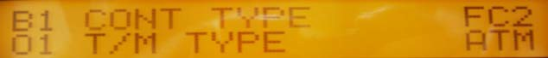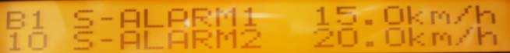

VCM Set B1

CONTROLLER TYPE
TRANSMISSION TYPE
ENGINE TYPE
LEVER LIMIT SWITCH
VALVE UNIT
LOAD CAPACITY
ECM CONTROLLER
DCM CONTROLLER
MAXIMUM SPEED CONTROL
TILT AUTO STOP
POWER ECONOMY CONTROL
AUTO STOP/AUTO START
LOAD METER
SPEED ALARM
LOAD ALARM
AUTO LIGHT CONTROL
CYLINDER DIAMETER
GEAR RATIO
ALARM SPEED SETTING 1
ALARM SPEED SETTING 2
Y34

VCM Set B1 (cont.)

Y35
ALARM LOAD SETTING
VEHICLE SPEED LIMIT (EXTERNAL) SETTING
VEHICLE SPEED LIMIT (INTERNAL) SETTING
TIRE ANGLE SENSOR NEUTRAL VALVE
TILT ANGLE SENSOR NEUTRAL VALVE
TIRE LOAD PRESSURE
AUTO LIGHT ON
AUTO LIGHT HYSTERESIS
SPEED DISPLAY
LOAD DISPLAY
CHASSIS NO.
SEAT SWITCH
SEAT BELT SWITCH
SOFTWARE VERSION
LPG HOUR CONTROL
BATTERY VOLTAGE
LANGUAGE

MP Set B2

SERVICE REMIND
REMIND MANUAL
REMING-HOUR
REMIND-DATE
HOUR METER IGNITION
HOUR METER ENGINE
HOUR METER INDICATE
PASSWORD (MANAGER)
SOFTWARE VERSION

Y36

Alarm History/Clearing

A1 SPEED SEN 0.0km/h
01 OIL PRES 0.000MPa

AO 1. VCM 3. MP
2. ECM
A2 ENG.REV 0rpm
01 IDLE SW ON

A3 PKB SW ON
01 BRAKE OIL LOW OFF

OO A. MONITOR C. ALARM
B. SET D. TEST

BO 1. VCM
2. MP

B1 CONT TYPE MC
01 T/M TYPE ATM

B2 SER REMIND MANU
01 MANU HOUR

CO 1. HISTORY
2. CLEAR ALL
NO

YES
C1 NO ALARM HISTORY

C1 02. F-3 XXXXX
02 CLEAR? NO YES

DO CAUTION TO MOVE ! EXE? NO YES
C2 CLEAR ALL HISTORY
01 NO YES

D0 1.VCM 3. MP 2.ECM

Y37

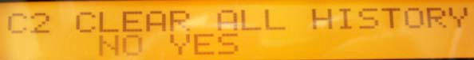

Alarm History/Clearing

All codes can be viewed and cleared in this section.

Y38

How to get to VCM Active test

A1 SPEED SEN 0.0km/h
01 OIL PRES 0.000MPa

AO 1. VCM 3. MP
2. ECM
A2 ENG.REV 0rpm
01 IDLE SW ON

A3 PKB SW ON
01 BRAKE OIL LOW OFF

OO A. MONITOR C. ALARM
B. SET D. TEST

BO 1. VCM
2. MP

B1 CONT TYPE MC
01 T/M TYPE ATM

B2 SER REMIND MANU
01 MANU HOUR

CO 1. HISTORY
2. CLEAR ALL
NO

YES
C1 NO ALARM HISTORY

C1 02. F-3 XXXXX
02 CLEAR? NO YES

DO CAUTION TO MOVE ! EXE? NO YES
C2 CLEAR ALL HISTORY
01 NO YES

D0 1.VCM 3. MP 2.ECM

Y39

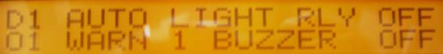

VCM Active test D1

Y40
AUTO LIGHT RELAY
WARNING 1 BUZZER
WARNING 2 BUZZER
NEUTRAL SIGNAL
ENGINE STOP RELAY
FC RELAY
AUXILIARY (OUT1)
STARTER RELAY
GLOW RELAY
UNLOAD/C1 SOLENOID
LIFT LOCK SOLENOID
TILT LOCK SOLENOID
POWER STEERING SOLENOID
TRANSMISSION SOLENOID (FORWARD)

VCM Active test D1 (cont.)

Y41
TRANSMISSION SOLENOID (REVERSE)
TRANSMISSION SOLENOID 2 (FORWARD)
FC LIFT (UP) SOLENOID
FC LIFT (DOWN) SOLENOID
FC TILT (FORWARD) SOLENOID
FC TILT BACKWARD) SOLENOID
FC ATTACHMENT 1 (A) SOLENOID
FC ATTACHMENT 1 (B) SOLENOID
FC ATTACHMENT 2 (A) SOLENOID
FC ATTACHMENT 2 (B) SOLENOID
FC ATTACHMENT 3 (A) SOLENOID
FC ATTACHMENT 3 (B) SOLENOID
AUXILIARY (D/A1)
AUXILIARY (D/A2)

ECM / MP Active test D2 / D3

IDLE AIR VOL. LEARN (NORMAL)
AIR-FUEL RATIO ADJUSTS
LEARNED AIR-FUEL RATIO VALVE
CLEAR
IGNITION TIMING ADJUSTS
SPARK PRESSUR REMOVAL
POWER BALANCE
SELF-DIAGNOSTIC RESULTS CLEAR

YTurn signal relay off is the
YOnly MP test.

Y42

Questions ?

Y43

YExperience the difference.

YThank you

Y44

