Service Information System
Tuesday, January 26, 2016
7:00 PM

Systems Operation
953C Track-Type Loader
Media Number -SENR1875-05 | Publication Date -01/07/2002 | Date Updated -09/07/2002

i01692963
Calibration Operation
SMCS - 4800
In order to calibrate the Hydrostatic Transmission Electronic Control System, service personnel can place the Caterpillar Monitoring System in calibration mode (mode 5). The Electronic Technician (ET) may be used instead of the Caterpillar Monitoring System. The Electronic Technician requires additional equipment. The calibration mode provides access to the hydrostatic transmission ECM. Calibration information for the hydrostatic transmission is shown in the display area of the monitor.
Caterpillar Monitoring System
The hydrostatic transmission ECM uses the main display module on the Caterpillar Monitoring System for showing calibration information to service personnel. Calibration information concerning the Hydrostatic Transmission Electronic Control System is sent on the CAT data link to the Caterpillar Monitoring System. Service personnel must be familiar with the Caterpillar Monitoring System in order to calibrate the Hydrostatic Transmission Electronic Control System.

View Image
Illustration 1 | g00693926
Caterpillar Monitoring System contains the following components:
- Four gauges (1)
- Nine alert indicators (2)
- Display area (3)
Note: See the Systems Operation/Testing and Adjusting, RENR2014, "Caterpillar Monitoring System" for additional information on the Caterpillar Monitoring System.

View Image
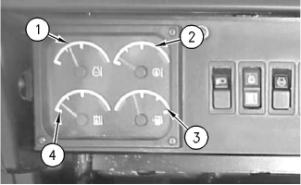
Illustration 2 | g00658810
The gauge display contains the following components:
- Engine coolant temperature
- Oil temperature in pump drive gear box
- Fuel level
- Hydraulic oil temperature

Engine Coolant Temperature (1) - The engine coolant temperature gauge indicates the temperature of the engine coolant. The red area indicates excessive engine coolant temperature.

Oil Temperature in the Pump Drive Gear Box (2) - The oil temperature gauge indicates the oil temperature in the pump drive gear box (splitter box). The red area indicates excessive oil temperature.

Fuel Level (3) - The fuel level gauge indicates the amount of fuel in the fuel tank. The red area indicates a low fuel level.

Hydraulic Oil Temperature (4) - The hydraulic oil temperature gauge indicates the temperature of the hydraulic oil. The red area indicates excessive hydraulic oil temperature.

View Image
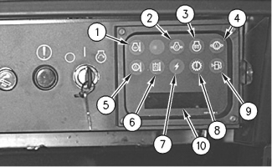
Illustration 3 | g00735559

Coolant Temperature (1) - This indicator indicates excessive coolant temperature.

Engine Oil Pressure (2) - This indicator indicates low oil pressure.

Air Inlet Heater (3) - This indicator shows that the air inlet heater is active. The indicator should flash while the engine is starting. The indicator should stop flashing when the engine starts.

Override Pressure (4) - This indicator indicates low override pressure in the transmission during travel. Also, this indicator indicates high override pressure in the transmission in NEUTRAL.

Oil Temperature in Pump Drive Gear Box (5) - This indicator indicates excessive oil temperature in the pump drive gear box.

Hydraulic Oil Temperature (6) - This indicator indicates excessive hydraulic oil temperature.

Alternator (7) - This indicator indicates a malfunction in the alternator.

Hydrostatic Transmission (8) - This indicator indicates that a problem exists in the hydrostatic transmission system.

Fuel Level (9) - This indicator indicates when the fuel level reaches ten percent of tank capacity.
Display area (10) provides specific machine information to the operator and the service technician.

View Image
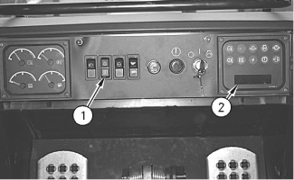
Illustration 4 | g00735577
The Caterpillar Monitoring System also contains the following components:
- Operator mode scroll switch (1)
- Display area (2)
The operator mode scroll switch (1) allows personnel to view specific machine information. Press the bottom of the rocker switch in order to scroll through the parameters. The display area (2) provides a readout of six digits that show the following items.
- Operational hours (service hours)
- Engine speed (tachometer)
- Override pressure
- Diagnostic codes
Diagnostic scrolling provides service codes that have been detected. The service code indicator indicates that a diagnostic code problem may exist. The diagnostic code may be active. Press the bottom of the rocker switch. This function will scroll through the units of measurement. These units of measure display the diagnostic codes. When the SERV CODE indicator is ON, an active fault exists. If the fault is not present, the SERV CODE indicator is OFF. If no faults are detected, this symbol "---" is shown.
Note: The technical term "diagnostic code " replaces the former technical term "service code". Diagnostic codes cannot be cleared and calibration procedures cannot be performed by using the operator mode scroll switch.
Diagnostic Code Identifiers

View Image
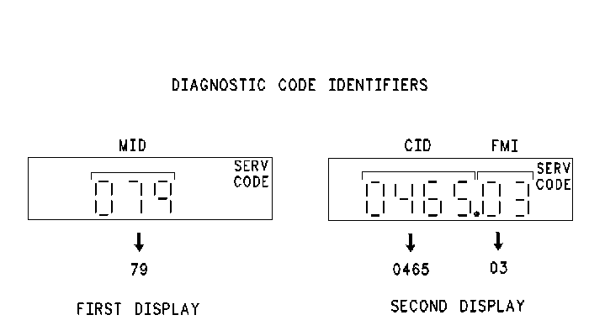
Illustration 5 | g00694788
The diagnostic code consists of three identifiers:
Module Identifier - The MID is a three digit code that is shown approximately one second before the diagnostic code is shown in the display area. The MID shows the electronic control which diagnoses the component that has failed. The MID for the 953C transmission ECM is "79". The MID for the Caterpillar Monitoring System is "030".
Component Identifier CID - The CID is a four digit number. This number indicates the circuit component that has failed.
Failure Mode Identifier FMI - The FMI tells the type of failure that has occurred. The FMI is a two digit code. The decimal point · is placed before the FMI.
The failures may be any of the following codes:
F02 - Error
F03 - Voltage above normal or high short circuit
F04 - Voltage below normal or low short circuit
F05 - Current below normal or open circuit
F06 - Current above normal or grounded circuit
F07 - The mechanical system is not responding.
F08 - Abnormal frequency of pulse width modulation or period
F11 - Failure mode that is not identifiable
F12 - Bad device or component
F13 - Out of calibration
The diagnostic code "79" is displayed for approximately one second before the diagnostic code "0465.03" is shown in the same area. The Module Identifier MID is "79" which is the transmission ECM. The Component Identifier CID is "465" which is the switch for the governor lever position. The Failure Mode Identifier is "F03" which means that the voltage is above normal or shorted high.
Service Mode Operation

View Image
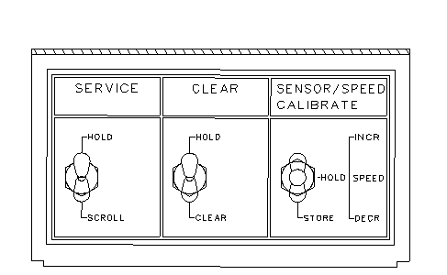
Illustration 6 | g00695165
Service switches
(1) Service switch
(2) Clear switch
(3) Calibrate switch
The service switches allow access to service information for the service personnel. The switches are located under a secured panel beneath the operator's right armrest. These switches are intended to be used by service personnel only. The switches connect to the Caterpillar Monitoring System which communicates with the hydrostatic transmission ECM.

View Image
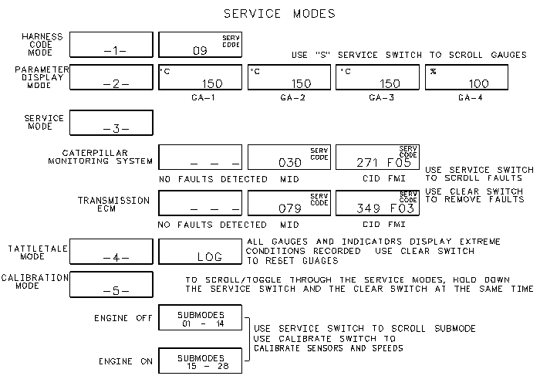
Illustration 7 | g00871629
A unique mode number is used to represent each mode of operation for the Caterpillar Monitoring System. The mode number is shown in the display area. Depress the service switch and hold the service switch. Also, depress the clear switch and hold the clear switch in order to scroll through the five modes. The display will show the following service modes: -1, -2, -3, -4 and -5.
The modes are listed below:
Normal Mode - A mode number is not shown. Normal mode can be recognized when the display area is showing information for the hour meter.
Mode 1 - This is the Harness Code Mode. This mode shows the code for the machine model which is installed in the monitoring system. The 953C code is "09".
Mode 2 - This is the Numeric Readout Mode. This mode allows the service technician to scroll through the individual gauges. Use the service switch to scroll to the next gauge.
Mode 3 - This is the Service Mode. This mode shows the diagnostic codes that are stored in the system. Three dashes --- will be displayed if no diagnostic codes are present. If the SERV CODE indicator is ON, the diagnostic code is present. (The fault is active.) Use the SERVICE switch in order to scroll to the next code. After the diagnostic code (fault) has been repaired, use the CLEAR switch in order to remove the logged code.
Mode 4 - This is the Telltale Mode. The monitor stores the worst case condition of the gauge needles. The status of the indicator in the worst case condition is also logged. In the Telltale Mode, the Caterpillar Monitoring System will record the extreme value for each machine condition that is monitored. Each gauge displays the highest condition or the lowest condition that is recorded. The numeric value is displayed on the message display. Use the CLEAR switch to reset the gauges. When the value is cleared, the message display will flash a value that is outside of the expected range. Also, the value that flashes may be at the end of the expected range.
Mode 5 - This is the Calibration Mode. This mode has 28 submodes. Submodes 01 to 14 are used with engine OFF. Submodes 15 to 28 are used with engine ON. Use the CALIBRATE switch (3) in order to calibrate the various components.
The Service Mode (Mode 3) and the Calibration Mode (Mode 5) allow the service technician to access the hydrostatic transmission ECM.
Note: Changing modes on the Caterpillar Monitoring System does not change the operation of the Hydrostatic Transmission Electronic Control System except when Calibration Mode (Mode 5) is entered. The Calibration Mode is a special mode that adjusts certain parameters of the hydrostatic transmission ECM.
Calibration Mode

Calibration Submodes
The Caterpillar Monitoring System is in the Calibration Mode in order to access. The Calibration Mode is Mode 5.
Submode Number ⁽¹⁾ | Engine Status | Description of Calibration Submode
01 | OFF | Left Pedal (Full Up)
02 | OFF | Left Pedal (Full Down)
03 | OFF | Center Pedal (Full Up)
04 | OFF | Center Pedal (Full Down)
05 | OFF | Right Pedal (Full Up)
06 | OFF | Right Pedal (Full Down)
07 | OFF | Speed/Direction Control Lever (Forward)
08 | OFF | Speed/Direction Control Lever (PARK)
09 | OFF | Speed/Direction Control Lever (Reverse)
10 | OFF | Throttle Limit Switch (Check)
11 | OFF | "- -" ⁽²⁾
12 | OFF | Parking Brake Limit Switch (Check)
13 | OFF | Machine Application Software (Software Part Number), and Reset of Calibration
14 | OFF | Speed Mode Switch (Check) ⁽³⁾
15 | ON | Minimum Track Speed Calibration
16 | ON | Track Speed Synchronization Calibration
17 | ON | Maximum Track Speed Calibration
18 | ON | Engine Speed Display
19 | ON | Display of Override Pressure
20 | ON | Transmission Stall Test
21 | ON | Parking Brake Status (Check)
22 | ON | Left Track Speed Display
23 | ON | Right Track Speed Display
24 | ON | Fuel Flow (Measurement)
25 | ON | Implement Pilot Pressure Switch for Tilt (Check)
26 | ON | Signal Pressure for the Left Motor
27 | ON | Signal Pressure for the Right Motor
28 | ON | Sensitivity of the Steering Pedals
Table 1
⁽ ¹ ⁾ | Only the submodes for the current engine status (ON or OFF) are accessible. The engine OFF submodes are 1 - 14. The engine ON submodes are 15 - 28.
⁽ ² ⁾ | Calibration submode 11 is active for the 953C Track-Type Loader (S/N: 2ZN1-1749) only.
⁽ ³ ⁾ | The Speed Mode Switch is optional on the 953C Track-Type Loader(S/N: 2ZN1750-UP).
Calibration Mode is used to make several adjustments to the Hydrostatic Transmission Electronic Control System. The system will not function well without these adjustments. The best performance will result only after these adjustments are made. Status information which may be helpful during troubleshooting is also provided. The submodes of calibration mode are listed in the preceding chart. The service switches select the submode. The service switches make any adjustments.
Refer to the Systems Operation/Testing and Adjusting, SENR8314, " 953C 963C 973C Track-Type Loaders Transmission Electronic Control System", "Accessing Calibration Submodes" for the procedures and a complete description of calibration submodes.

View Image
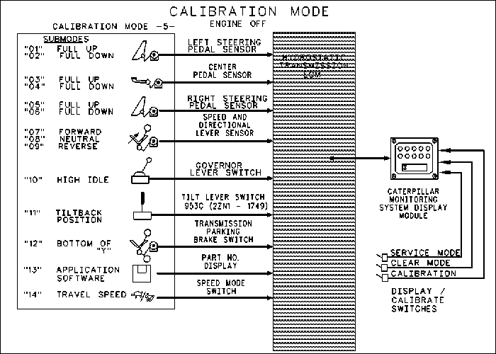
Illustration 8 | g00735908
The hydrostatic transmission ECM uses the main display module on the Caterpillar Monitoring System in order to show the calibration information to the service technician.
Calibration Mode 5 has a total of 28 submodes. Submodes01 to 14 are performed with the ENGINE OFF.

View Image
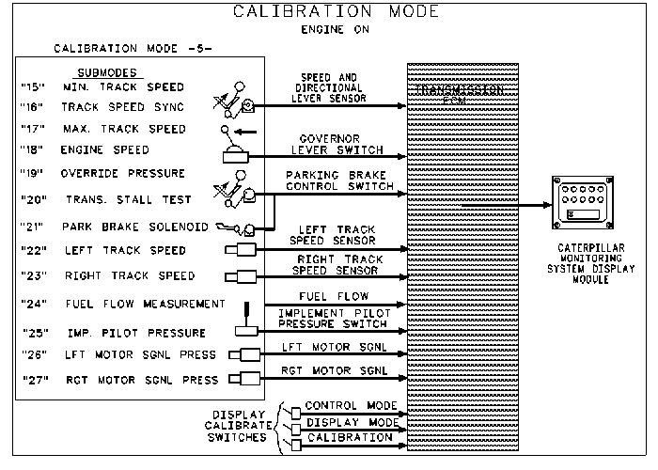
Illustration 9 | g00769168
Calibration Mode 5 has a total of 28 submodes. Submodes 15 to 28 are performed with the ENGINE ON.
When the technician performs the ENGINE ON calibrations, a minimum travel distance of 45.75 m (150 ft) is required.
Note: When submodes 15 through 28 are selected, the ECM automatically de-energizes the synchronizing solenoid. This closes the synchronizing valve. The ports are blocked.

View Image
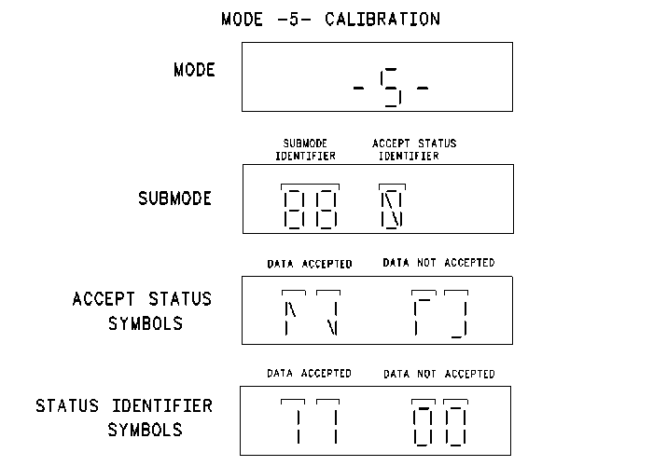
Illustration 10 | g00696146
The service technician can calibrate the various components in Mode 5. The display will show the submode identifier.
When the service technician calibrates a component, the accept status identifiers indicate whether the position (data) of the component is accepted or the data is not accepted.
The service technician uses the "store position" of the CALIBRATE switch when the technician calibrates the position of the component. If the accept status identifier ( "data accepted") does not appear, the component has a problem and/or a problem with the sensor has occurred.
Other submodes use a different accept status identifier. As the lever is moved from one position to another position, the "11" and "00" are used to indicate that the component is changing states.

Copyright 1993 - 2016 Caterpillar Inc.  All Rights Reserved.  Private Network For SIS Licensees. | Tue Jan 26 2016 18:59:00 GMT-0600 (Central Standard Time)

Inserted from <https://sis.cat.com/sisweb/sisweb/techdoc/content.jsp?calledpage=/sisweb/sisweb/mediasearch/mediaheaderinfoframeset.jsp&relcalledpage=/sisweb/mediasearch/mediaheaderinfoframeset.jsp#004>

