236B 246B 252B 262B SKID STEER LOADER, Powered By 3044C Engine(SEBP3769 - 61) - Documentation
Wednesday, February 03, 2016
2:11 PM

Welcome: d430btm1
Product: SKID STEER LOADER
Model: 236B SKID STEER LOADER HEN
Configuration: 236B 246B 252B 262B SKID STEER LOADER HEN00001-06749 (MACHINE) POWERED BY 3044C Engine
Systems Operation
247B, 257B, 267B, 277B and 287B Multi Terrain Loaders and 216B, 226B, 232B, 236B, 242B, 246B, 248B, 252B, 262B and 268B Skid Steer Loaders Interlock Electronic Control System
Media Number -RENR6417-01 | Publication Date -01/08/2005 | Date Updated -03/08/2005

i01995441
Relays
SMCS - 4493

The relays have five terminals. Two of the terminals (85, 86) are for the coil. One of the terminals (30) is common. One of the terminals (87) is for a normally open contact and one of the terminals (87a) is for a normally closed contact.
Relay (Start)
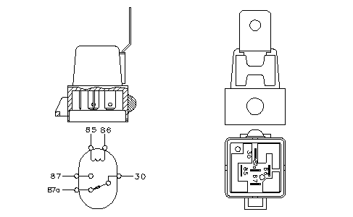
Illustration 1 | g00780225
Relay (start)
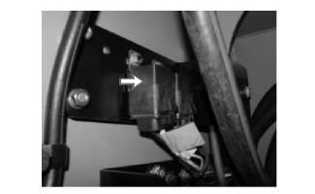
Illustration 2 | g01032817
Location of the relay for the starter
The start relay is located in the engine compartment above the air cleaner.
The interlock ECM controls the start relay. The relay connects to the connector contact J1-64. The relay closes a set of normally open contacts in order to engage the solenoid for the starting motor.
There are no diagnostics that are associated with the relay.
Relay (Fuel Shutdown)
Illustration 3 | g00780225
Relay (fuel shutdown)
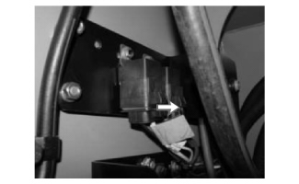
Illustration 4 | g01032822
Location of the relay for the fuel shutdown relay
The fuel shutdown relay is located in the engine compartment above the air cleaner.
The interlock ECM controls the relay. The relay is on the same circuit as the start relay. The relay connects to the connector contact J1-64. The relay closes a set of normally open contacts in order to energize the fuel shutdown solenoid.
There are no diagnostics that are associated with the relay.

Copyright 1993 - 2016 Caterpillar Inc.  All Rights Reserved.  Private Network For SIS Licensees. | Wed Feb 3 14:11:21 CST 2016  d430btm1

Inserted from <https://sis.cat.com/sisweb/sisweb/techdoc/techdoc_print_page.jsp?returnurl=/sisweb/sisweb/mediasearch/mediaheaderinfoframeset.jsp&calledpage=/sisweb/sisweb/techdoc/techdoc_print_page.jsp>

