Question 31 of 40 | 2.5 Points
A researcher wishes to estimate the mean amount of money spent per month on food by households in a certain neighborhood. She desires a margin of error of $30. Past studies suggest that a population standard deviation of $248 is reasonable. Estimate the minimum sample size needed to estimate the population mean with the stated accuracy.

A. 274
B. 284
C. 264
D. 272

Question 32 of 40 | 2.5 Points
The scatter plot and best-fit line show the relation among the number of cars waiting by a school (y) and the amount of time after the end of classes (x) in arbitrary units. The correlation coefficient is -0.55. Determine the amount of variation in the number of cars not explained by the variation time after school.
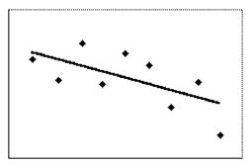

A. 55%
B. 70%
C. 30%
D. 45%

Question 33 of 40 | 2.5 Points
The scatter plot and best-fit line show the relation among the number of cars waiting by a school (y) and the amount of time after the end of classes (x) in arbitrary units. The correlation coefficient is -0.55. Use the line of best fit to predict the number of cars at time 4 after the end of classes.
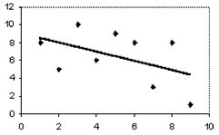

A. 7.0
B. 6.0
C. 8.0
D. 3.5

Question 34 of 40 | 2.5 Points
Of the 6796 students in one school district, 1537 cannot read up to grade level. Among a sample of 812 of the students from this school district, 211 cannot read up to grade level. Find the sample proportion of students who cannot read up to grade level.

A. 0.14
B. 0.26
C. 211
D. 0.23

Question 35 of 40 | 2.5 Points
The scatter plot and best-fit line show the relation among the data for the price of a stock (y) and employment (x) in arbitrary units. The correlation coefficient is 0.8. Predict the stock price for an employment value of 6.
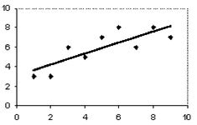

A. 8.8
B. 6.2
C. 8.2
D. None of the values are correct

Question 36 of 40 | 2.5 Points
A researcher wishes to estimate the proportion of college students who cheat on exams. A poll of 490 college students showed that 33% of them had, or intended to, cheat on examinations. Find the margin of error for the 95% confidence interval.

A. 0.0432
B. 0.0434
C. 0.0425
D. 0.0427

Question 37 of 40 | 2.5 Points
Eleven female college students are selected at random and asked their heights. The heights (in inches) are as follows:
67, 59, 64, 69, 65, 65, 66, 64, 62, 64, 62
Estimate the mean height of all female students at this college. Round your answer to the nearest tenth of an inch if necessary.

A. It is not possible to estimate the population mean from this sample data
B. 64.3 inches
C. 64.9 inches
D. 63.7 inches

Question 38 of 40 | 2.5 Points
Suggest the cause of the correlation among the data.
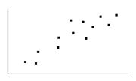
The graph shows strength of coffee (y) and number of scoops used to make 10 cups of coffee (x). Identify the probable cause of the correlation.

A.
The variation in the x variable is a direct cause of the variation in
the y variable.
B. There is no correlation between the variables.
C. The correlation is due to a common underlying cause.
D. The correlation between the variables is coincidental.

Question 39 of 40 | 2.5 Points
Among a random sample of 500 college students, the mean number of hours worked per week at non-college related jobs is 14.6. This mean lies 0.4 standard deviations below the mean of the sampling distribution. If a second sample of 500 students is selected, what is the probability that for the second sample, the mean number of hours worked will be less than 14.6?

A. 0.5
B. 0.6179
C. 0.6554
D. 0.3446

Question 40 of 40 | 2.5 Points
Write possible coordinates for the single outlier such that it would no longer be an outlier.
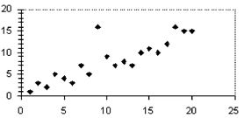

A. (23, 18)
B. (20, 5)
C. (15, 15)
D. (12, 15)

