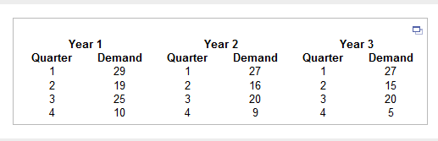

Forecast the demand for each quarter in Year 4 using seasonal dummy variables and a best subsets regression.​ (Let the first dummy variable be equal to 1 for
Quarter 2, and so​ on, following the order of the seasonal categories in the given​ table.)
The demand

- forecast for the first quarter in Year 4 is ____units.
​(Round to one decimal place as​ needed.)

