ABC COMPANY CYBERSECURITY POLICY

Project Plan
ABC Company
Technology Project

Author: Abraham Brotsky
Creation Date: 1/26/17
Last Revised: 1/26/17
Version: 1.0

TABLE OF CONTENTS
INTRODUCTION 2
Purpose of Plan 2
Background Information/Available Alternatives 2
Project Approach 2
GOALS AND OBJECTIVES 3
Business Goals and Objectives 3
Project Goals and Objectives 3
SCOPE 4
Scope Definition 4
Items Beyond Scope 4
Projected Budget 4
Risk Assessment 5
Initial Project Risk Assessment 5
Milestones 7
PROJECT MANAGEMENT APPROACH 7
Project Timeline 7
Project Roles and Responsibilities 8
Communications Plan 9
APPROVALS 11
Sign-off Sheet 11

INTRODUCTION

Purpose of Plan

The ABC Company Technology Project Plan will provide a definition of the project, including the project’s goals and objectives. Additionally, the Plan will serve as an agreement between the following parties: Project Sponsor, CTO, Project Manager, Project Team, and other personnel associated with and/or affected by the project.

The Project Plan defines the following:

- Project purpose
- Business and project goals and objectives
- Scope and expectations
- Roles and responsibilities
- Project management approach
- Project budget
- Project timeline

Background Information/Available Alternatives

To date, I have outlined a Project Proposal which gives a broad overview of what to expect within the confines of the project, without delving into too many fine details. In working as an IT Specialist, particularly, a Cybersecurity Analyst along with my PM, Karl Rove, and two other stakeholders, my goal is to develop and implement a defined, workable cybersecurity policy for ABC Company. There will be three milestones, of which reports will be completed and delivered, that explain the key issues as pertaining to the cybersecurity policy.

Project Approach

Phase I: Secure agreement with vendors (ABC Company)
Phase II: Research Project Deliverables
Phase III: Deliver Milestones as Planned
Phase IV: Conduct Acceptance Testing
Phase V: Conduct Training
Phase VI: Implement Final User Acceptance Policy (UAP)

GOALS AND OBJECTIVES

Business Goals and Objectives

The business goals and objectives for this project will focus on implementing a cybersecurity policy that:

- Considers physical grounds security.
- Facilitates coordination and information sharing both internal and external to the participating companies.
- Enhances the ability and effectiveness of staff to perform their jobs.
- Facilitates coordinated cybercrime prevention and reduction.
- Provides high levels of data security.
- Provides an open, flexible, reliable security policy for the future.
- Is easy to understand, implement and use.
- Eliminate holes in the physical and technological infrastructure that could put the company at risk for attack.

Project Goals and Objectives

- Ensure that end users have input into the design process.
- Accomplish project business goals and objectives within defined budget and time parameters.
- Minimize impact to standard business operations within the affected units.
- Craft a favorable and secure agreement between the Department and the selected vendor.

SCOPE

Scope Definition

The Project will introduce a new cybersecurity policy; including the following: Next Generation Firewalls
- Intrusion Detection and Prevention Systems (IDPS)
- Remote Access Management and Policies
- BYOD (Bring Your Own Device) Policies
- Business Continuity and Disaster Recovery (BC/DR) Planning

Items Beyond Scope

The project does not include the following:

Actual, physical security devices mentioned above or video security cameras, biometric scanning devices, employee monitoring software, etc.
- Physical hardware/software upgrade or replacement
- Collaboration with outside vendors pertaining to the project

Projected Budget
 |  | Quantity per Week
Expense | Cost per Unit | Week 2 | Week 3 | Week 4 | Week 5 | Week 6 | Sub Total | Total
Labor by hour | $ 35.00 | 10 | 10 | 10 | 10 | 15 | 55 | $ 1,925.00
Consultation fees | $ 40.00 | 1 | 2 | 1 | 2 | 1 | 7 | $ 280.00
Interviews | $ 45.00 | 6 | 4 | 2 | 0 | 0 | 12 | $ 540.00
Workshops | $ 65.00 | 0 | 0 | 2 | 3 | 4 | 9 | $ 585.00
Training | $ 100.00 | 0 | 0 | 2 | 3 | 4 | 9 | $ 900.00
Policy Implementation | $ 5,500.00 | 0 | 0 | 0 | 0 | 1 | 1 | $ 5,500.00
 |  |  |  |  |  | Grand Total |  | $ 9,730.00

The Budget includes hourly labor fees for the time spent researching the subject matter which will be presented in each of the three milestone reports. The Consultation fees are for the Consultations that will transpire between the IT Specialist, Abraham Brotsky, and ABC Company. During these consultations, Abraham Brotsky will brief the sponsor, ABC Company on the nature of the technology being researched and how these technologies may be applied to ABC Company. Interviews and Workshops will be carried out. Interviews will be towards the beginning of the project with the CTO, in order to gain a thorough understanding of where ABC Company stands presently and what policies need to be updated and revamped. Workshops will involve Abraham Brotsky and the Manager of Employees in which the topics covered in the milestones reports will be explained on the level of the Manager, minus the technical jargon. Training will be conducted for the CTO and Manager towards the second half of the project when the milestones are being implemented into the security policy. Finally, the User Acceptance Policy (UAP), the finalized cybersecurity policy, will be delivered before the Closing of the project to ABC Company.

Risk Assessment

The initial Risk Assessment attempts to identify, characterize, prioritize and document a mitigation approach relative to those risks which can be identified prior to the start of the project.

The Risk Assessment will be continuously monitored and updated throughout the life of the project, with Weekly assessments included in the status report (see Communications Plan) and open to amendment by the Project Manager.

Initial Project Risk Assessment

Risk | Risk Level  L/M/H | Likelihood of Event | Mitigation Strategy
Project Size
Person Hours | H: Over 55 | Certainty | Assigned Project Manager, engaged IT Specialist, comprehensive project management approach and communications plan
Estimated Project Schedule | M: Over 3 weeks | Likely | Created comprehensive project timeline with frequent baseline reviews
Project Definition
Project Scope Creep | L: Scope generally defined, subject to revision | Unlikely | Scope intially defined in project plan, reviewed Weekly by Project Manager and CTO to prevent undetected scope creep
IT Specialist Project Deliverables unclear | L: Well defined | Unlikely | Included in project plan, subject to amendment
Cost Estimates Unrealistic | L: Thoroughly predicted by industry experts using proven practices to 15% margin of error | Unlikely | Included in project plan, subject to amendment as new details regarding project scope are revealed
Timeline Estimates Unrealistic | M: Timeline assumes no derailment | Somewhat likely | Timeline reviewed Weekly by Project Manager and CTO to prevent undetected timeline departures
Policy Creator
Number of Times Team Has Done Prior Work with Vendor Creates Foreign Relationship | H: Never | Certainty | A comprehensive vendor evaluation and selection process (incorporated into Project Plan) will be employed to predict and define the relationship between the department and the vendor
Team’s Lack of Knowledge of Package | M: Conceptual understanding | Somewhat likely | Comprehensive vendor evaluation and selection process incorporated into Project Plan will assist the team in better understanding the package offering(s)
Poor Functional Match of Package to Initial System Requirements | L: Minimal customization required | Unlikely | Although a package has not yet been selected, the IT Specialist has compared the initial requirements with available functionality and determined that a functional match to the initial requirements is very likely. Vendor selection will be based, in part, on how well the proposed application matches defined functional specifications.
Team’s Involvement in Package Selection Impacts Success of Implementation | L: High involvement in selection | Unlikely | Comprehensive vendor evaluation and selection process incorporated into Project Plan

Milestones

The following represent key project milestones, with estimated completion dates:

Milestone Estimated Completion Date
Report on Next Generation Firewalls and IDPS 01/31/2017
Report on Remote Access and BYOD 02/07/2017
Report on BC/DR Planning 02/14/2017

PROJECT MANAGEMENT APPROACH

Project Timeline
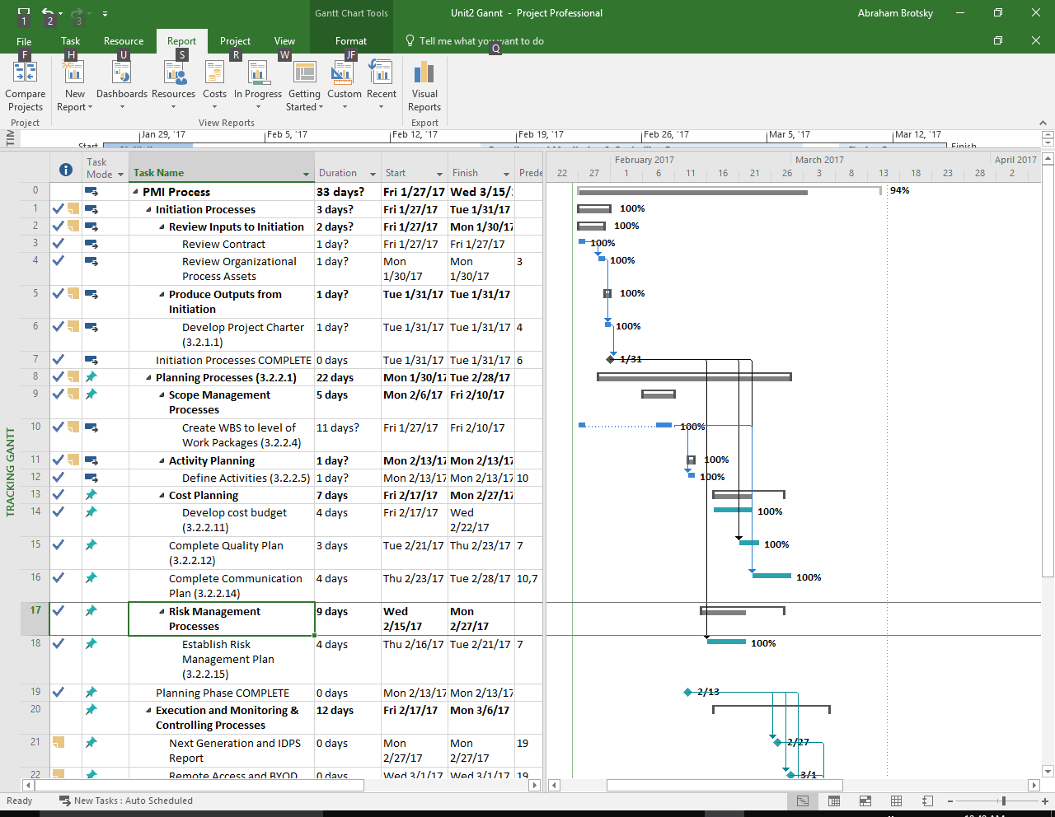
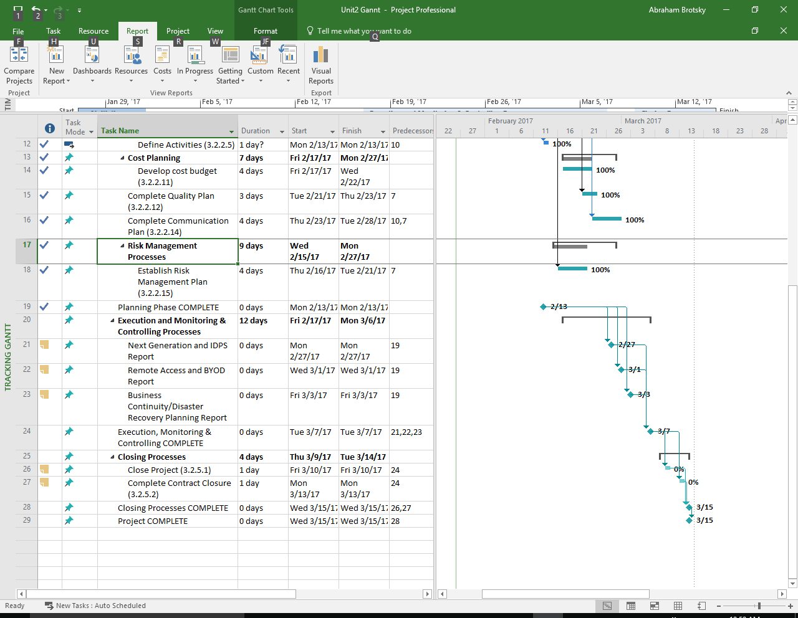
Project Roles and Responsibilities

Role | Responsibilities | Participant(s)
Project Sponsor | - Ultimate decision-maker and tie-breaker  - Provide project oversight and guidance  - Review/approve some project elements | ABC Company
Corporate Technology Officer | - Commits department resources  - Approves major funding and resource allocation strategies, and significant changes to funding/resource allocation  - Resolves conflicts and issues  - Provides direction to the Project Manager  - Review project deliverables | Allison Sweeney
Project Manager | - Manages project in accordance to the project plan  - Serves as liaison to the CTO  - Receive guidance from CTO  - Supervises IT Specialists  - Supervise vendor(s)  - Provide overall project direction  - Direct/lead team members toward project objectives  - Handle problem resolution  - Manages the project budget | Karl Rove
IT Specialist | - Understand the user needs and business processes of their area  - Act as consumer advocate in representing their area  - Communicate project goals, status and progress throughout the project to personnel in their area  - Review and approve project deliverables  - Creates or helps create work products  - Coordinates participation of work groups, individuals and stakeholders  - Provide knowledge and recommendations  - Helps identify and remove project barriers  - Assure quality of products that will meet the project goals and objectives  - Identify risks and issues and help in resolutions | Abraham Brotsky
Manager of Employees | - Lend expertise and guidance as needed | Rick Springfield

Communications Plan

This plan provides a framework for informing, involving, and obtaining buy-in from all participants throughout the duration of the project.

Audience This communication plan is for the following audiences:

- Project Sponsor
- CTO
- Project Manager
- Manager of Employees
- IT Specialist

Communications Methodology The communications methodology utilizes three directions for effective communication:

Top-Down It is crucial that everyone involved in the project gets their fair share of air time and input regarding the deliverables of the project and their implementation. To facilitate direct involvement from all levels of the company, it is very important that executives make themselves available, open and amenable to managers, employees, all stakeholders and their ideas. This project is not the result of an individual or group of individuals, but a result of the entire company processing the information together to the best of their abilities. As such, executives must see to it that they can have open communication with all levels of the company and they do not block out anyone in the company who may in any way have a stake in the success and outcomes of the project.

Bottom-Up To ensure that employees at all levels of the company will adapt to and welcome the changes of the intended project, it is important to communicate to every employee that their input is important and makes a difference. It cannot seem like the executives made all the decisions and left the rest of the company in the dark. In order to accomplish across-the-board implementation and adaption of the project, the end-users and lower level employees must approve of the changes and understand that their combined input and insights are what drives the project.

Middle-Out For the company to fully grasp and accept the project output, it is necessary that the core of the company’s functioning be up-to-date with changes being made. It is not enough for executives to be open-minded and available and for lower level employees to be on-board, barring the approach that a communal exchange must occur. At the end of the day, the company as a whole must jointly adopt the new system and work on it together as a team.

APPROVALS

Sign-off Sheet

I have read the above Project Plan and will abide by its terms and conditions and pledge my full commitment and support for the Project Plan.

Project Sponsor:
Date
Project Manager:
Date

CTO:
Date
IT Specialist:
Date

