Applications of Discrete Mathematics and Statistics in IT (ITCO341-1502A-01)
Unit 2 – Individual Project
Convert Decimal, Binary and Hexadecimal
May 10, 2015
Keith R. Johnson
AIU

- Consider the following graph:
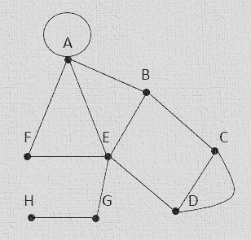

- Complete this table by finding the degree of each vertex, and identify whether it is even or odd:
Vertex | Degree | Even/Odd
A
B
C
D
E
F
G
H

b. What is the order of the graph?
c. Construct the 10 x 10 adjacency matrix for the graph.

- The graph below illustrates a switching network. The weights represent the delay times, in nanoseconds, travelled by a data packet between destinations, represented by the vertices.
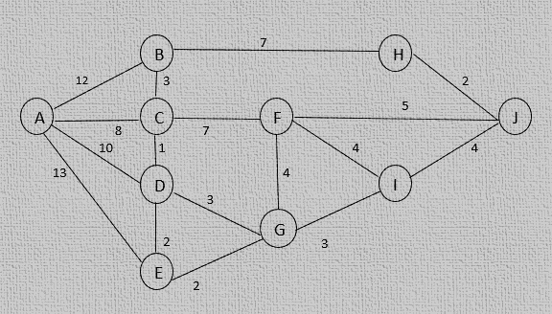
- Complete the following table by finding the shortest distance and the path for that distance from vertex A to the other vertices:
Vertex | Shortest Distance from A | Path from A
B
C
D
E
F
G
H
I

- What are the shortest distance between A and J and the path for that distance?

- The following graph represents a portion of the subway system of a city. The vertices on the graph correspond to subway stations, and the edges correspond to the rails. Your job is to write a program for a cleaning car to efficiently clean this portion of the subway system.
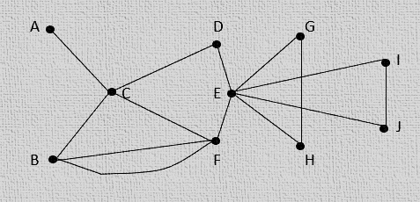

a. Using Euler’s theorem, explain why it is possible to pass through all of the stations by traversing every rail only once.
b. Using Fleury’s algorithm, provide an optimal path to clean all the rails by passing through them only once.
c. Is it possible to find an optimal path described in question 3-b that starts on any station? Explain your answer.
d. Is it possible to find an optimal path described in question 3-b that starts and ends at the same station? Explain why or why not.

- A network engineer lives in City A, and his job is to inspect his company’s servers in various cities. The graph below shows the cost (in U.S. dollars) of travelling between each city that he has to visit.
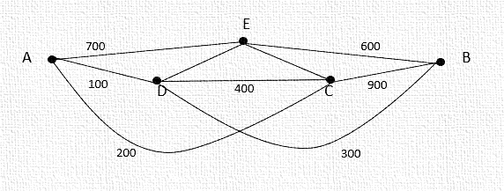
a. Find a Hamiltonian path in the graph.
b. Find a Hamiltonian circuit that will allow the engineer to inspect all of the servers. How much will the cost be for his trips?
c. Is there another Hamiltonian circuit that will allow the engineer to inspect all of the servers other than your answer in question 4-b? If so, calculate the cost.

- Consider the following binary tree:
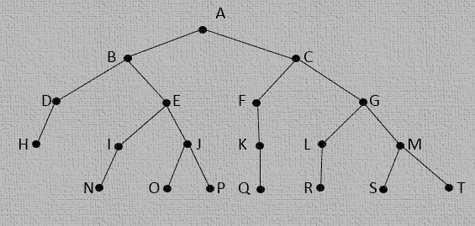
a. What is the height of the tree?
b. What is the height of vertex H?
c. Write the preorder traversal representation of the tree.
d. Write the array representation of the tree by completing the following table:
Vertex | Left Child | Right Child
A
B
C
D
E
G
H
I
J
K
L
M
N
O
P
Q
R
S
T

References

Celine. (May 14, 2011). Difference Between Graph and Tree. Retrieved May 04, 2015, from:
http://www.differencebetween.net/science/nature/difference-between-graph-and-tree/

Daly, K. (Mar 14, 2013). Graph Theory. Retrieved May 04, 2015, from:
https://www.youtube.com/watch?v=C5Xjts910IA

Doty, S. & Todd, M. (n.d.). Euler Paths and Circuits. Retrieved May 04. 2015, from:
http://www.geom.uiuc.edu/~doty/front.html

Herke, S. (Sept 27, 2014). Graph theory 37. Which Graph are Trees. Retrieved May 04, 2015, from:
https://www.youtube.com/watch?v=BptJFixSseM

JMT, P. (Nov 12, 2010). Graph Theory – An Introduction! Retrieved May 04, 2015, from:
https://www.youtube.com/watch?v=HmQR8Xy9DeM

Mike B. (Dec 02, 2012). Basic Graph Theory. Retrieved May 04, 2015, from:
https://www.youtube.com/watch?v=Vfm2h1MZJNM

Mitchell, S. (March 2004). An Extensive Examination of Data Structures. Retrieved May 04, 2015, from:
https://msdn.microsoft.com/en-us/library/aa289152(v=vs.71).aspx

Sheard, T. (2009). Graphs in Computer Science. Retrieved May 04, 2015, from:
http://web.cecs.pdx.edu/~sheard/course/Cs163/Doc/Graphs.html

