OPM500 EMC Additional Information
A. EMC—Background Information
B. Product Brochure
C. Plasti-Brack Information
D. Manufacturing Processes
E. Basic Financial Information about EMC
F. Financial Information
G. Organizational Chart
H. Plant Layout

A. Module 1 - EMC - Background Info

The Excellent Manufacturing Company
Corporate information:
- Established: February, 1995, Columbus, Ohio
- President/CEO: Jack Walker (original founder)
- Division of National Building Supply
- Subsidiary of RexMag - an international conglomerate of diversified products
Size and customer info:
- Gross Sales: Approximately $13,000,000
- Total Employees: Approx. 105
- Customers: National and regional home improvement centers and building supply outlets
Products: Construction and building items:
- FASTENERS
  - screws, bolts, nails
- CONSTRUCTION
  - Flanges
  - Brackets – Plasti-Brack
- CABINET HARDWARE
  - Hinges
  - Knobs
  - Pulls
- DECORATIVE HARDWARE
  - Towel Bars
  - Towel Rings
  - Soap Dishes
  - Switch Plates
  - Outlet Plates

B. Module 1 - EMC - Product Brochure

Productivity & Process Improvement

Products: Construction and building items:
- FASTENERS
  - screws, bolts, nuts, nails
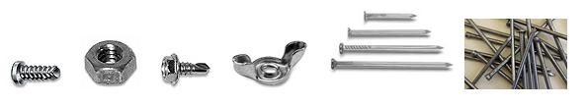
- CONSTRUCTION
  - Flanges
  - Brackets – Plasti-Brack
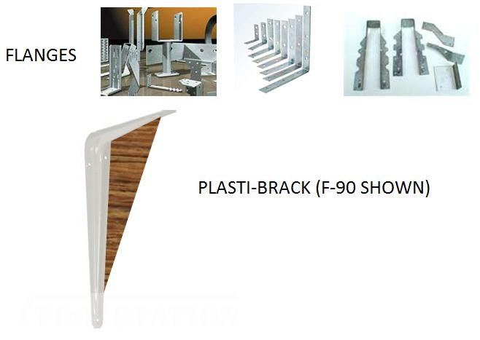
- CABINET HARDWARE
  - Hinges
  - Knobs
  - Pulls
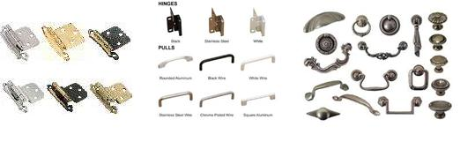
- DECORATIVE HARDWARE
  - Towel Bars
  - Towel Rings
  - Robe Hooks
  - Switch Plates
  - Outlet Plates
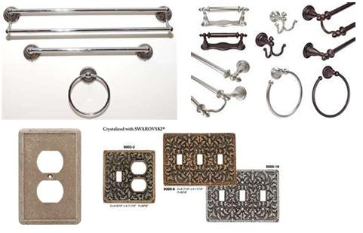

C. Module 1 - EMC - Plasti-Brack Info

Productivity & Process Improvement

The Plasti-Brack Product Line: combination metal / plastic supports
Description of the products:
- Six products, different angles. F90, F100, F120A, F120B, F130, F135
- Novel item patented by Excellent
- Unique design includes a simulated wood finish and color in the plastic insert
- Allows it to be used both for internal and external construction
- Very popular in deck, fence, and shed construction, as well as in home construction.
Part number system. Each part, component, or raw material is numbered for ID purposes. This system uses the format: XnnnA.
X is a prefix that denotes the type of part or material: R: Raw, S: steel, P: Plastic, F: Finished product, B-F: Bulk Packed Finishe product.
nnn is the body of the part number and can be three to five digits
A is the suffix which denotes different variations of the same or similar parts.
For example, F120A is a finished, assembled part, 120 is the number for this specific part, the 120 degree Plasti-brack, and A is the small version (B is the larger version).
SAMPLE DRAWING & SAMPLE PROCESS FLOW CHART
Figure 1 shows a sample drawing of the F90. The P90 is the plastic insert, the S90 is the steel bracket and the F90 is the assembly of the P90 and S90. Figure 2 shows the process flow chart for the B-F90, which is the bulk packed F90.
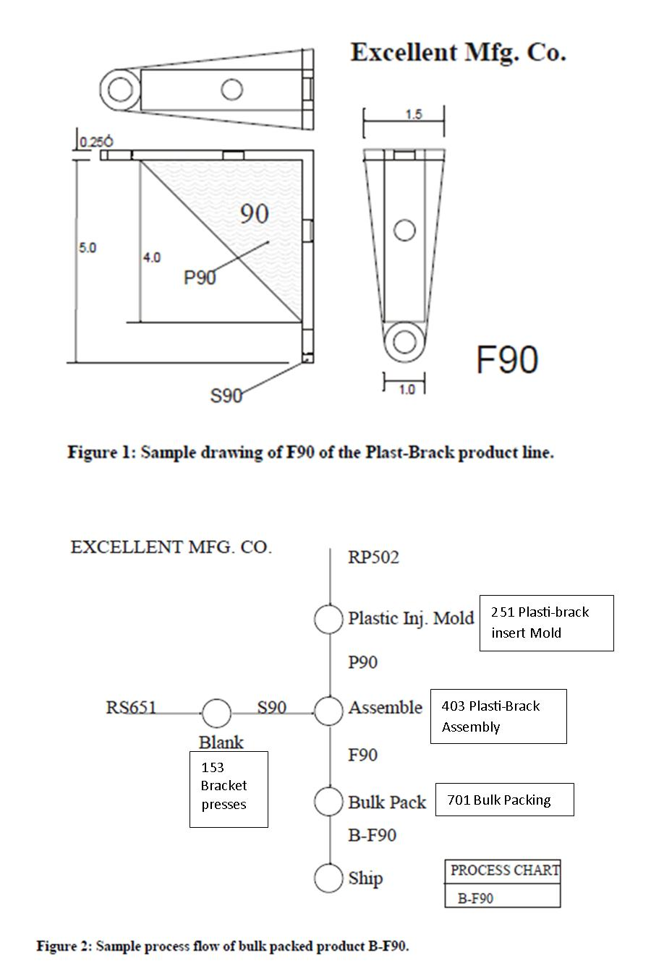

Plasti-Brack processes and descriptions
Machine group 153 Bracket presses.
- Two 400-ton presses
- machine speed is 40 strokes per minute, or 2400 pieces per hour
- Progressive die process, so that one bracket part is produced per stroke
- Six progressive dies, one for each part.
- setup (die change over), approx. 3.5 hours
Machine group 251 Plasti-Brack insert Mold
- Four 250-ton plastic injection molding machines
- There are six dies, one for each plastic insert
- Cavities per die
  - P90 die 6 cavities
  - P100 die 5 cavities
  - P120A die 8 cavities
  - P120B die 4 cavities
  - P130 die 7 cavities
  - P135 die 8 cavities
- Machine speeds: Plastic injection molding speed is from 18 - 22 seconds/shot
  - see table below for Pieces/hr.
- Setup (die change over), approx. 4 hours
Machine group 403 Plasti-Brack Assembly
- Eight assembly stations – tables for operators
- One operator per station
- The rate for the manual assembly operation is 8 pieces per minute or 480 pieces per hour
- The assembly process consists of:
- grasp a plastic insert (P90)
- visually inspect insert
  - if defective, toss into scrap bin and go to step 1, OR
  - keep for next step
- grasp a bracket (S90)
- move the insert to the assembly point
- push insert into place
- check assembly
  - if insert will not assemble properly, toss into scrap bin, go to steps 1, 2, 4, & 5, OR
  - if insert does assemble properly, then
- drop assembly into 10 cu. ft. Tub at the side of the table.
- Operators are trained to also do Hinge Assembly, Towel Bar, Towel Ring and Soap Dish assembly
Machine group 701 Bulk Packing
- Three operators work together on this line
- Plasti-bracks move here from 403 Plasti-Brack Assembly
- Each Plasti-brack is dumped in bulk into a cardboard box
- Each box holds 100 of one of the items.
- Measuring the number in the box is accomplished by “weigh counting”
- A lid assembled to the full box
- A label is attached to the box
- The closed container is banded by a banding machine on the conveyer line
- The completed container is sent to the warehouse
- The speed of this line is 4 containers per minute (400 pieces/min.), or 240 containers/hour (24000 pieces/hr.)
- NOTE: There are other products that are bulk packed besides Plasti-bracks
  - Other construction hardware is Bulk Packed
  - Hinges are also “bare” bulk packed for cabinet makers. Otherwise hinges are bag packed first, then bulk packed to be sent to home supply stores.
  - % of Bulk Pack time: Plasti-Brack, 18%, Other Constr. Hdwe, 36%, and Hinges, 46%
Machine group 251 Plasti-Brack insert Mold Production Rates
MACH. GRP. 251
PIECES PER HOUR
Part number | M101 | M102 | M103 | M104
P135 | 1309.1 | 1600.0 | 1440.0 | 1440.0
P120A | 1309.1 | 1600.0 | 1440.0 | 1440.0
P130 | 0.0** | 1260.0 | 1145.5 | 1145.5
P100 | 818.2 | 0.0** | 900.0 | 900.0
P90 | 1080.0 | 1350.0 | 1200.0 | 1200.0
P120B | 640.0 | 800.0 | 720.0 | 720.0
** This part does not run on this machine - there are minor issues with the mold/tool, that makes the fit unacceptable to run it.
This table shows the average amount of piecies that are contained/transported in the 10 cu. ft. tubs used for material handling. The same number of the S brackets are contained as the F part.
MATERIAL HANDLING DATA:
PIECES PER 10 CU. FT. TUB
P135 | 1937 |  | F135 | 1191
P120A | 1581 |  | F120A | 1030
P130 | 1678 |  | F130 | 1075
P100 | 1305 |  | F100 | 891
P90 | 1369 |  | F90 | 924
P120B | 816 |  | F120B | 609

D. Module 1 - EMC - Mfg Processes

Productivity & Process Improvement

Manufacturing processes
These processes are shown on the Plant Layout. You should become familiar with those that are used for the Plasti-brack Product line.
- 100 Heading
  - 101 small headers
  - 105 large headers
- 150 Blanking & Stamping
  - 151 small presses
  - 153 Bracket presses
  - 157 large presses
- 200 Zinc Die Cast Molding & Trimming
  - 201 small zinc molders
  - 203 trim, small
  - 206 large zinc molders
  - 208 trim,large
- 250 Plastic Injection Molding
  - 251 Plasti-brack insert molding
  - 253 Hinge insert molding
  - 255 Soap dish molding
- 300 Plating
  - 301 Barrel Plating – nickel
  - 303 Barrel Plating – chromium
  - 305 Rack Plating
- 330 Brushing
  - 331 Straight line brushing
  - 333 Circular line brushing
- 360 Lacquer
  - 361 Spray lacquer line
  - 363 Brush lacquer line
- 390 Painting
  - 391 Paint line 1
  - 393 Paint line 2
  - 395 Paint booth
- 400 Assembly
  - 401 Hinge Assembly
  - 402 Hinge Assembly - auto
  - 403 Plasti-brack Assembly
  - 404 Towel Ring Assembly
  - 406 Soap Dish Assembly
- 500 Packaging
  - 501 Bag Packaging
  - 503 Bar, Ring, Dish Packaging
- 700 Packing
  - 701 Bulk Packing

E. Basic Financial Information about EMC

Module 1 - EMC - Financial Info.
The following is the Income Statement from the year just completed.
 | Gross Income |  | COGS |  | Gross Margin
PRODUCT LINE | (000s) |  | (000s) |  | (000s)
Fasteners | $1,010 | 7.30% | $646 | 4.68% | $364 | 2.64%
Cabinet Hardware | $3,243 | 23.50% | $1,783 | 12.91% | $1,460 | 10.58%
Construction Hardware | $4,165 | 30.20% | $2,038 | 14.76% | $2,127 | 15.41%
Decorative Hardware | $5,388 | 39.00% | $2,586 | 18.73% | $2,802 | 20.30%
TOTALS | $13,806 | 100.00% | $7,053 | 51.1% | $6,753 | 48.91%
OPERATING EXPENSES
Marketing and Advertising |  |  | $850 | 6.20%
Commissions, Wages & Salaries |  |  | $1,750 | 12.70%
Benefits |  |  | $770 | 5.60%
Office Expenses |  |  | $175 | 1.30%
Depreciation |  |  | $734 | 5.30%
Insurance |  |  | $943 | 6.80%
Fixed Energy & Utility Expenses |  |  | $268 | 1.90%
Miscellaneous |  |  | $132 | 1.00%
TOTAL OPERATING EXPENSES |  |  |  |  | $5,622 | 40.72%
Net Income Before Taxes |  |  |  |  | $1,295 | 9.38%

The following is the Statement of Inventories (from the Balance Sheet) for the year just ending:
 | Beginning | Ending
Inventories | (000s) | (000s)
Raw | $ 205 | $ 167
Purch Parts | $ 148 | $ 151
WIP | $ 389 | $ 322
Fin. Goods | $ 242 | $ 243
TOTAL INVEN | $ 984 | $ 883

F. Module 1 - EMC - Org Charts

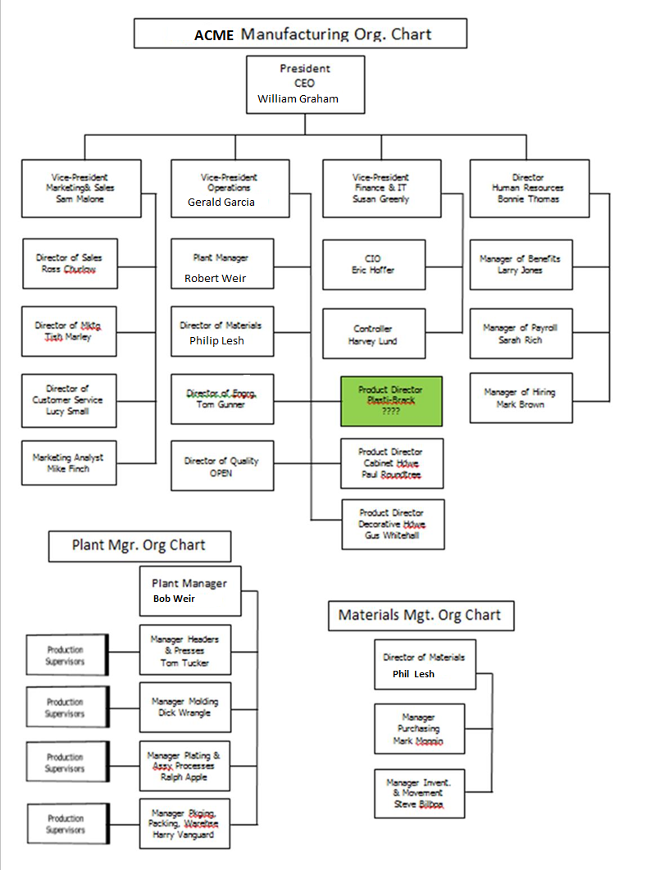

G. EMC Plant Layout
