Coolant Pump - 3.5L

REMOVAL
CAUTION: During engine repair procedures, cleanliness is extremely important. Any foreign material, including any material created while cleaning gasket surfaces, that enters the oil passages, coolant passages or the oil pan can cause engine failure.
- Remove the engine front cover. For additional information, refer to ENGINE - 3.5L .
- Remove and discard the engine oil filter.
- Rotate the crankshaft clockwise and align the timing marks on the variable camshaft timing (VCT) assemblies as shown.
Fig 1: Aligning Timing Marks On Variable Camshaft Timing (VCT) Assemblies
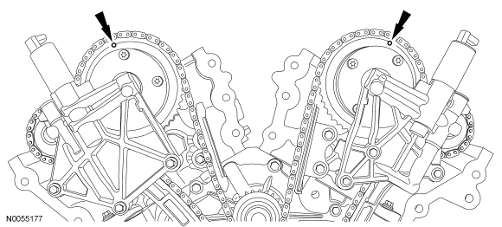Courtesy of FORD MOTOR CO.
NOTE: The special tool will hold the camshafts in the top dead center (TDC) position.
- Install the special tool onto the flats of the LH camshafts.
Fig 2: Installing Special Tool Onto Flats Of LH Camshafts
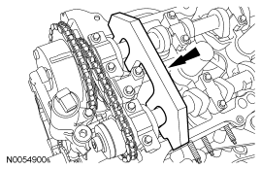Courtesy of FORD MOTOR CO.
NOTE: The special tool will hold the camshafts in the TDC position.
- Install the special tool onto the flats of the RH camshafts.
Fig 3: Installing Special Tool Onto Flats Of RH Camshafts
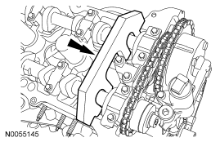Courtesy of FORD MOTOR CO.
- Remove the 3 bolts and the RH VCT housing.
Fig 4: Locating RH VCT Housing
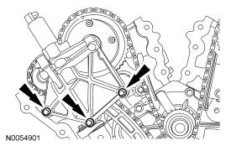Courtesy of FORD MOTOR CO.
- Remove the 3 bolts and the LH VCT housing.
Fig 5: Locating LH VCT Housing
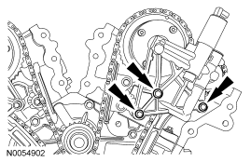Courtesy of FORD MOTOR CO.
- Remove and discard the VCT housing seals.
Fig 6: Locating VCT Housing Seals
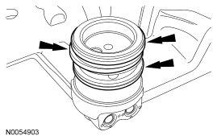Courtesy of FORD MOTOR CO.
- Remove the 2 bolts and the primary timing chain tensioner.
Fig 7: Locating Primary Timing Chain Tensioner Bolts
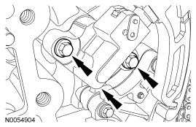Courtesy of FORD MOTOR CO.
- Remove the primary timing chain tensioner arm.
Fig 8: Locating Primary Timing Chain Tensioner Arm
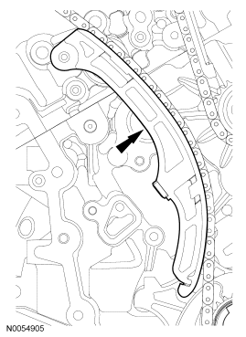Courtesy of FORD MOTOR CO.
- Remove the 2 bolts and the lower LH primary timing chain guide.
Fig 9: Locating Lower LH Primary Timing Chain Guide Bolts
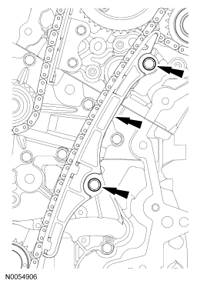Courtesy of FORD MOTOR CO.
- Remove the primary timing chain.
Fig 10: Locating Primary Timing Chain
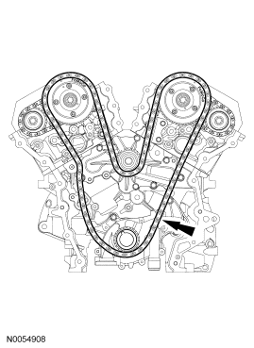Courtesy of FORD MOTOR CO.
- Remove the 2 bolts and the upper LH primary timing chain guide.
Fig 11: Locating Upper LH Primary Timing Chain Guide Bolts
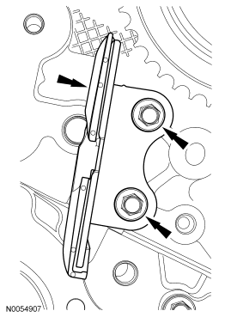Courtesy of FORD MOTOR CO.
- Remove the RH primary timing chain guide lower bolt.
Fig 12: Locating RH Primary Timing Chain Guide Lower Bolt
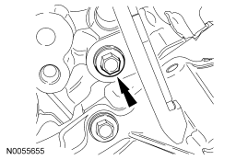Courtesy of FORD MOTOR CO.
NOTE: The RH primary timing chain guide must be repositioned to allow the coolant pump to be removed.
- Loosen the RH primary timing chain guide upper bolt.
  - Rotate the guide and tighten the bolt.
Fig 13: Locating RH Primary Timing Chain Guide Upper Bolt
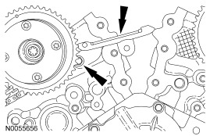Courtesy of FORD MOTOR CO.
- Place clean lint-free shop towels in the oil pan opening to prevent coolant from entering the oil pan during coolant pump removal.
- Remove the 8 bolts and the coolant pump.
Fig 14: Locating Coolant Pump Bolts
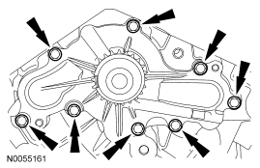Courtesy of FORD MOTOR CO.

INSTALLATION
NOTE: Clean and inspect all sealing surfaces.
- Install the coolant pump and the 8 bolts.
  - Tighten in the sequence shown to 10 Nm (89 lb-in).
Fig 15: Identifying Coolant Pump Bolts Tightening Sequence
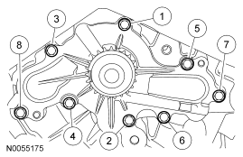Courtesy of FORD MOTOR CO.
- Remove all of the shop towels from the oil pan opening.
CAUTION: Any coolant that has accumulated in the oil pan must be drained from the pan and any residual coolant cleaned from the front of the engine and oil pan. Failure to remove all traces of the coolant can result in oil contamination and severe engine damage.
- Remove the oil pan drain plug and allow any accumulated coolant to drain.
  - Remove any residual coolant from the front of the engine and the oil pan using regulated compressed air and clean lint-free shop towels.
  - Install the oil pan drain plug and tighten to 27 Nm (20 lb-ft).
- Loosen the RH primary timing chain guide upper bolt.
  - Position the RH primary timing chain guide and install the lower bolt.
  - Tighten the 2 bolts to 10 Nm (89 lb-in).
Fig 16: Locating RH Primary Timing Chain Guide Lower Bolt
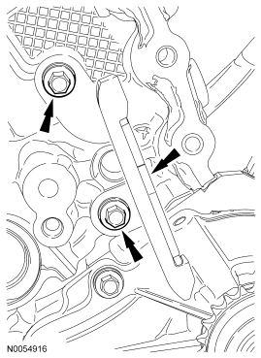Courtesy of FORD MOTOR CO.
- Install the primary timing chain with the colored links aligned with the timing marks on the VCT assemblies and the crankshaft sprocket.
Fig 17: Aligning Timing Marks On VCT Assemblies & Crankshaft Sprocket
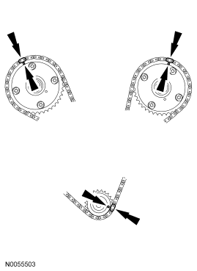Courtesy of FORD MOTOR CO.
- Install the upper LH primary timing chain guide and the 2 bolts.
  - Tighten to 10 Nm (89 lb-in).
Fig 18: Locating Upper LH Primary Timing Chain Guide Bolts
Courtesy of FORD MOTOR CO.
- Install the lower LH primary timing chain guide and the 2 bolts.
  - Tighten to 10 Nm (89 lb-in).
Fig 19: Locating Lower LH Primary Timing Chain Guide Bolts
Courtesy of FORD MOTOR CO.
- Install the primary timing chain tensioner arm.
Fig 20: Locating Primary Timing Chain Tensioner Arm
Courtesy of FORD MOTOR CO.
- Reset the primary timing chain tensioner.
  - Rotate the lever counterclockwise.
  - Using a soft-jawed vise, compress the plunger.
  - Align the hole in the lever with the hole in the tensioner housing.
  - Install a suitable lock pin.
Fig 21: Compressing Plunger Using A Soft-Jawed Vise
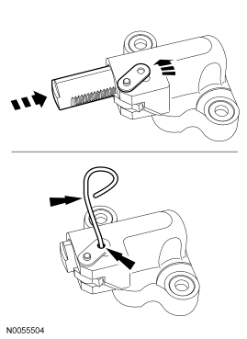Courtesy of FORD MOTOR CO.
NOTE: It may be necessary to rotate the crankshaft slightly to remove slack from the timing chain and install the tensioner.
- Install the primary tensioner and the 2 bolts.
  - Tighten to 10 Nm (89 lb-in).
  - Remove the lock pin.
Fig 22: Locating Primary Tensioner Bolts
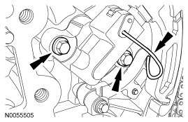Courtesy of FORD MOTOR CO.
- As a post check, verify correct alignment of all timing marks.
Fig 23: Verifying Correct Alignment Of All Timing Marks
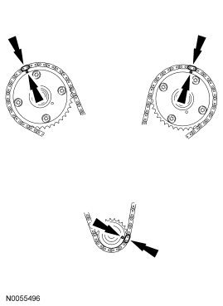Courtesy of FORD MOTOR CO.
- Install new VCT housing seals.
Fig 24: Locating VCT Housing Seals
Courtesy of FORD MOTOR CO.
CAUTION: Make sure the dowels on the variable camshaft timing (VCT) housing are fully engaged in the cylinder head prior to tightening the bolts. Failure to follow this process will result in severe engine damage.
- Install the LH VCT housing and the 3 bolts.
  - Tighten in the sequence shown to 10 Nm (89 lb-in).
Fig 25: Identifying LH VCT Housing Bolts Tightening Sequence
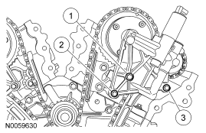Courtesy of FORD MOTOR CO.
CAUTION: Make sure the dowels on the variable camshaft timing (VCT) housing are fully engaged in the cylinder head prior to tightening the bolts. Failure to follow this process will result in severe engine damage.
- Install the RH VCT housing and the 3 bolts.
  - Tighten in the sequence shown to 10 Nm (89 lb-in).
Fig 26: Identifying RH VCT Housing Bolts Tightening Sequence
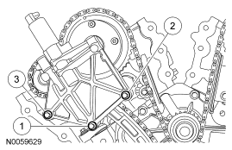Courtesy of FORD MOTOR CO.
NOTE: Lubricate the engine oil filter gasket with clean engine oil prior to installing the oil filter.
- Install a new engine oil filter.
  - Tighten to 5 Nm (44 lb-in) and then rotate an additional 180 degrees.
- Install the engine front cover. For additional information, refer to ENGINE - 3.5L .

Identifying Coolant Pump Bolts Tightening Sequence
Fig 27: Identifying Coolant Pump Bolts Tightening Sequence

