Sarerra Electric Oven SK313X/2
Neither the oven or the grill will heat The lights, display and fan all work ok. Simon Reynolds
This wire was broken so I replaced the connector and refitted but still not luck..

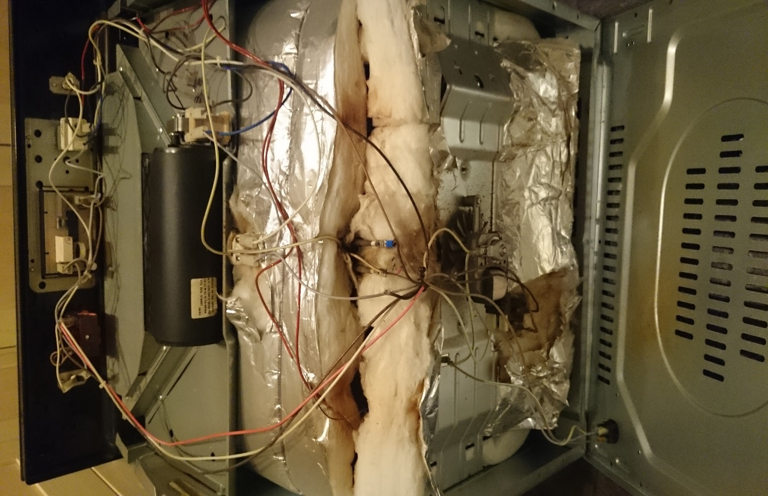
There is a black wire that is not connected to anything and I cannot see anywhere it should be… It feeds from the temperate dial …?

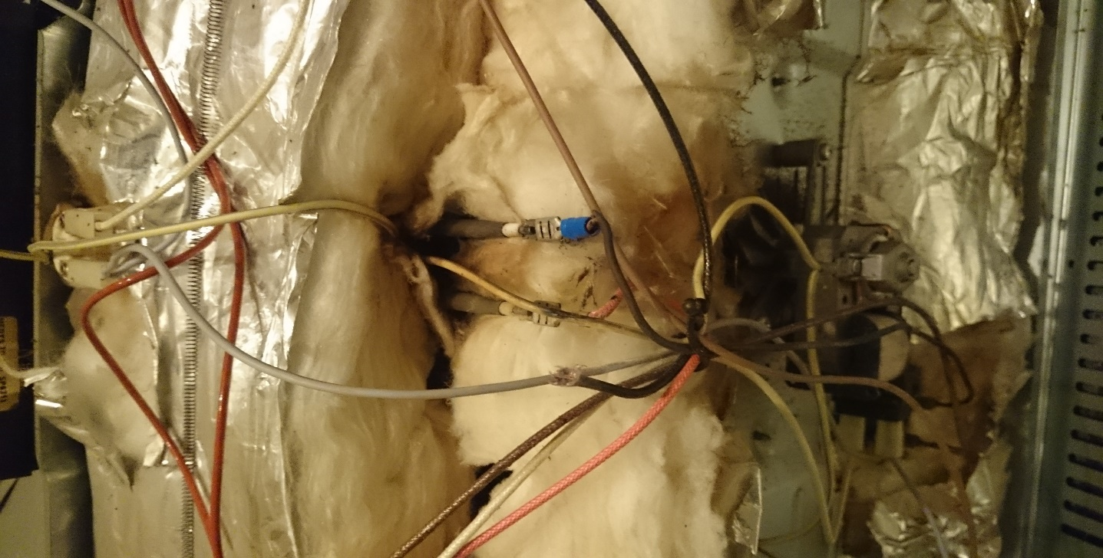
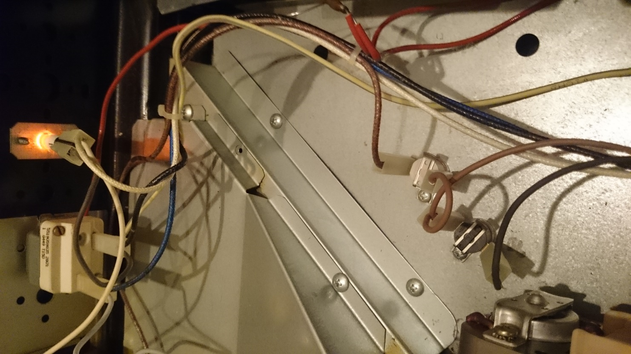

But the black one does not pass – neither the new or old part.. ?

The cream coloured thermostat passes a continuity test

