Upper Intermediate Steering Shaft Replacement

Tools Required
J 42640 Steering Column Anti-Rotation Pin
Removal Procedure
Notice: With wheels of the vehicle facing straight ahead, secure the steering wheel utilizing steering column anti-rotation pin, steering column lock, or a strap to prevent rotation. Locking of the steering column will prevent damage and a possible malfunction of the SIR system. The steering wheel must be secured in position before disconnecting the following components:
  - The steering column
  - The intermediate shaft(s)
  - The steering gear
After disconnecting these components, do not rotate the steering wheel or move the front tires and wheels. Failure to follow this procedure may cause the SIR coil assembly to become un-centered and cause possible damage to the SIR coil. If you think the SIR coil has became un-centered, refer to your specific SIR coil’s centering procedure to re-center SIR Coil.
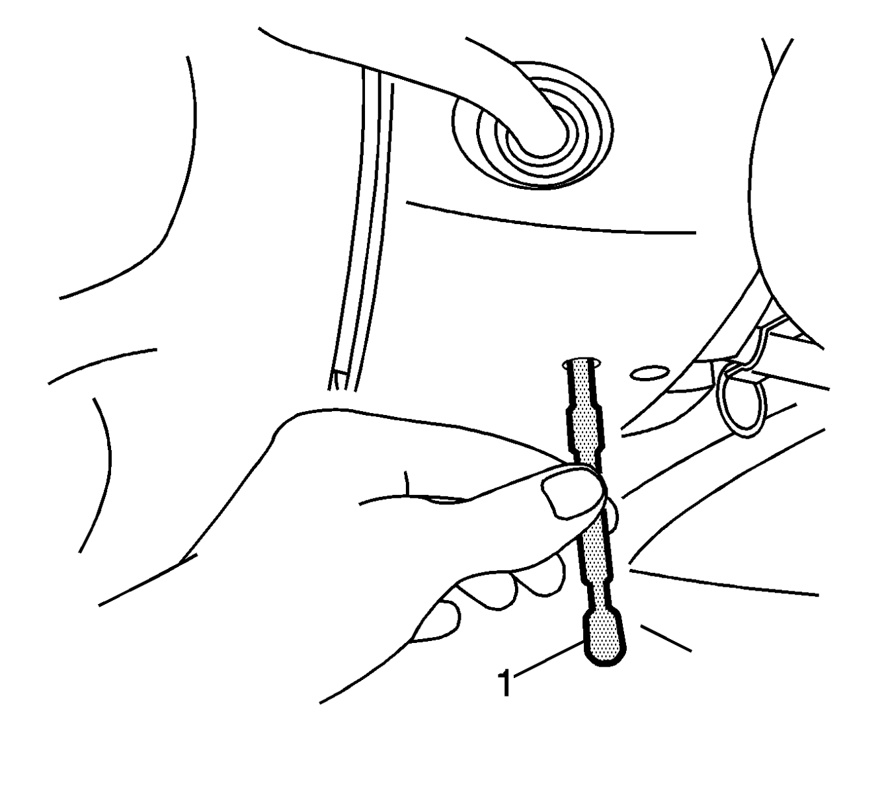
- Install the J 42640 in the steering column lower access hole.
Important: Mark the relationship of the intermediate shaft components in order to assure proper installation.
- Mark the relationship of the bolt and the clamp at both ends of the upper intermediate shaft.
- Mark the relationship of the upper intermediate shaft to the lower intermediate shaft.
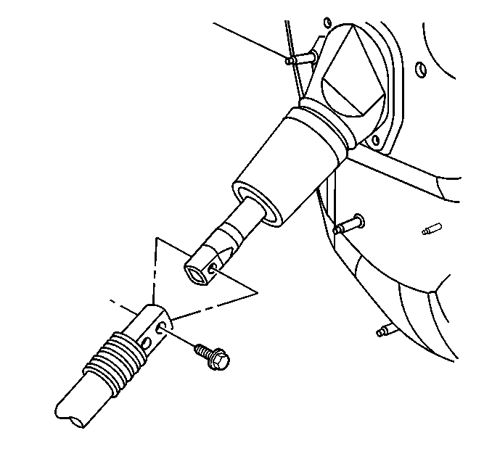
- Remove the nut and the bolt from the lower shaft to the upper shaft connection.
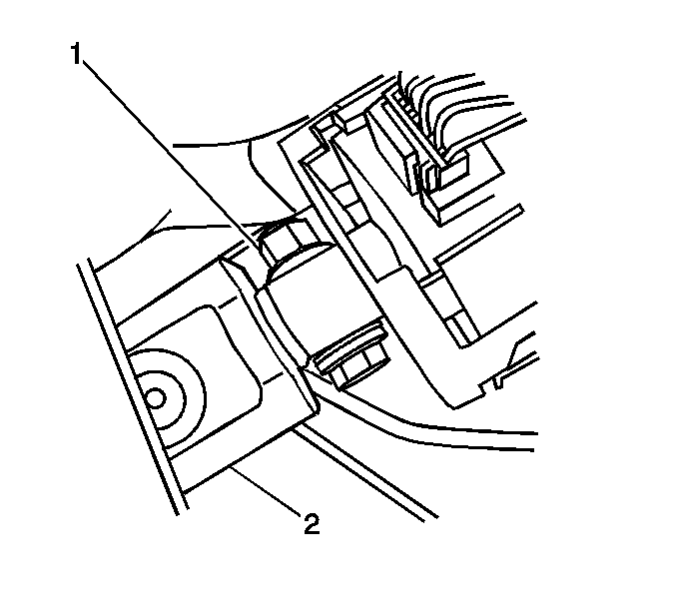
- Remove the nut and the bolt (1) from the upper shaft (2) to the steering column connection.
- Slide the intermediate shaft down, out of the steering column connection.
- Remove the accelerator pedal position sensor, if equipped. Refer to the following procedures:
  - Accelerator Pedal Position Sensor Replacement in Engine Controls – 4.3L, 5.3L, and 6.0L
  - Accelerator Pedal Position Sensor Replacement in Engine Controls – 8.1L
  - Accelerator Pedal Position Sensor Replacement in Engine Controls – 6.6L
- Slide the upper intermediate shaft towards the instrument panel, out of the lower intermediate shaft, and remove the shaft from the vehicle.
Installation Procedure
Important: If you are installing the same shaft, align the marks and the relationship of the bolt and the clamp made during the removal procedure.
- Install the lower end of the upper intermediate shaft through the bulkhead, into the lower shaft.
- Install the upper end of the upper intermediate shaft (2) to the steering column.
Notice: Refer to Fastener Notice.
- Install the bolt and the nut (1) at the connection of the upper intermediate shaft to the steering column.
Tighten
Tighten the nut to 62 Y (46 lb ft).
- Install the accelerator pedal position sensor, if equipped. Refer to the following procedures:
  - Accelerator Pedal Position Sensor Replacement in Engine Controls – 4.3L, 5.3L, and 6.0L
  - Accelerator Pedal Position Sensor Replacement in Engine Controls – 8.1L
  - Accelerator Pedal Position Sensor Replacement in Engine Controls – 6.6L
- Install the bolt and nut at the connection of the upper intermediate shaft to the lower intermediate shaft.
Tighten
Tighten the nut to 50 Y (37 lb ft).
- Remove the J 42640 from the steering column lower access hole.
© 2016 General Motors. All rights reserved.

