Lower Intermediate Steering Shaft Replacement

Tools Required
J 42640 Steering Column Anti-Rotation Pin
Removal Procedure
Notice: With wheels of the vehicle facing straight ahead, secure the steering wheel utilizing steering column anti-rotation pin, steering column lock, or a strap to prevent rotation. Locking of the steering column will prevent damage and a possible malfunction of the SIR system. The steering wheel must be secured in position before disconnecting the following components:
  - The steering column
  - The intermediate shaft(s)
  - The steering gear
After disconnecting these components, do not rotate the steering wheel or move the front tires and wheels. Failure to follow this procedure may cause the SIR coil assembly to become un-centered and cause possible damage to the SIR coil. If you think the SIR coil has became un-centered, refer to your specific SIR coil’s centering procedure to re-center SIR Coil.
- Set the front wheels in the straight-ahead position.
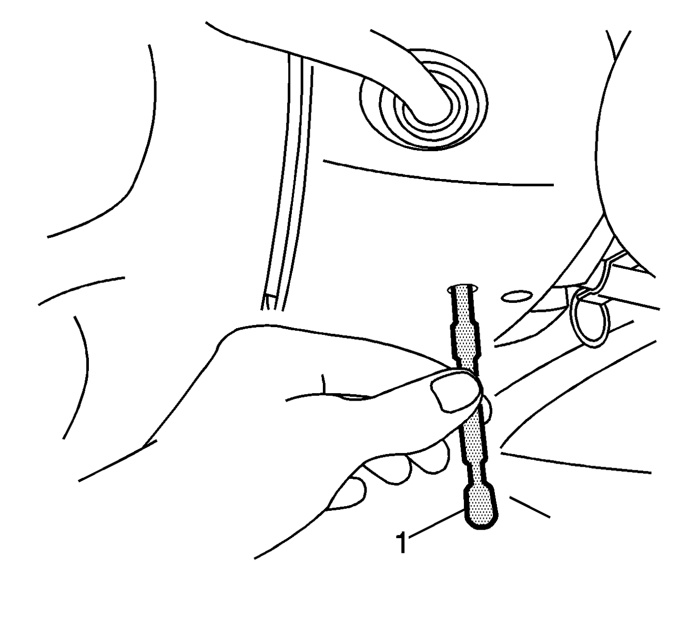
- Install the J 42640 in the steering column lower access hole.
- Mark the relationship of the intermediate shaft components in order to assure proper installation.
  - Mark the relationship of the upper intermediate shaft to the lower intermediate shaft.
  - Mark the relationship of the lower shaft coupler to the steering gear input shaft.
- For vehicles equipped with a 6.6L Diesel, remove the left charge air cooler hose. Refer to Charge Air Cooler Inlet and Outlet Duct Replacement in Engine Mechanical – 6.6L.
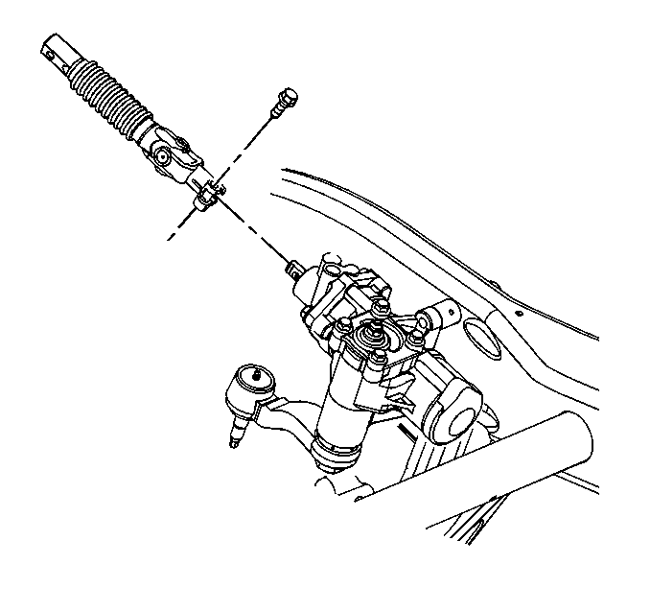
- Remove the bolt from the upper to lower shaft connection.
- Remove the bolt from the lower shaft coupler.
- Remove the intermediate shaft assembly.
Slide the shaft towards the dash in order to get the lower shaft coupler clear of the steering gear input shaft.
- Slide the intermediate shaft down out of the upper shaft.
Installation Procedure
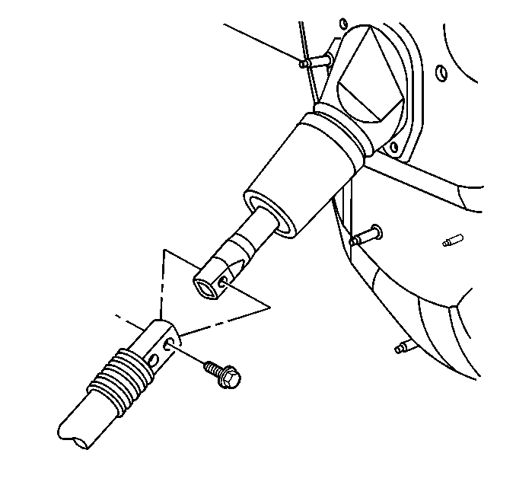
- Install the upper end of the intermediate shaft into the upper shaft.
- Install the lower end of the intermediate shaft coupler.
  - If you are reinstalling the same shaft, align the marks made during the removal procedure.
  - Install the lower end of the intermediate shaft coupler onto the steering gear worm shaft.
- Install the bolt to the lower shaft coupler.
Notice: Refer to Fastener Notice.
- Install the bolt to the upper end of the shaft.
Tighten
  - Tighten the upper bolt to 47 Y (35 lb ft).
  - Tighten the coupler pinch bolt to 50 Y (37 lb ft).
- For vehicles equipped with a 6.6L Diesel, install the left charge air cooler hose. Refer to Charge Air Cooler Inlet and Outlet Duct Replacement in Engine Mechanical – 6.6L.
- Remove the J 42640 from the steering column lower access hole.
© 2016 General Motors. All rights reserved.

