Range Selector Lever Cable Adjustment

Caution: Refer to Automatic Transaxle Range Selector Cable Caution in Cautions and Notices.
Notice: Adjust the automatic transaxle range selector cable while the transaxle and while the gear selector are in the Neutral position only. Failure to do so may cause mis-adjustment.
- Set the parking brake.
- Block the wheels.
- Disconnect the shift cables at both ends with the system in Neutral.
Notice: Do NOT attempt to separate the metal couplings. Replace both cable pieces if the metal couplings are separated. Both of the cable section will be damaged if the two metal couplings are disconnected.
- Push up to the adjustment position to release the adjuster until the cable housings separate.
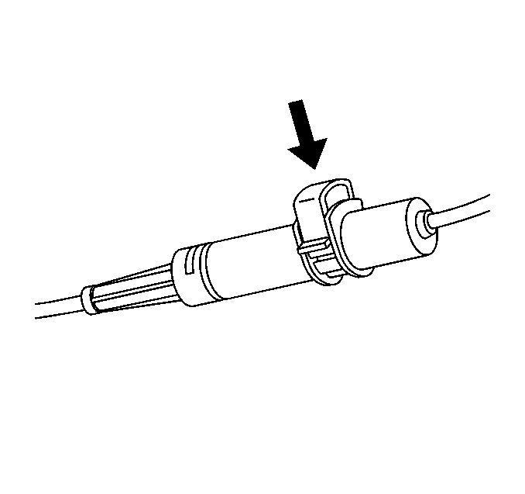
- Depress the adjuster clip once. This mobilizes the adjuster housing toward the transaxle end fitting.
- Line up the end fittings so they slide together until you feel the parts cam together and lock.
- Depress the adjuster clip completely. This locks the cable into its adjusted service position.
- Pull the conduit in the opposite direction to assure full system adjustment of the shift cable.
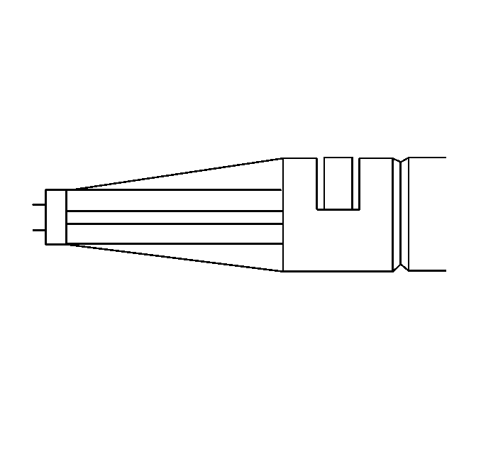
Important: The horseshoe clip with the tab is flush when fully engaged.
- Ensure the conduit is fully engaged.
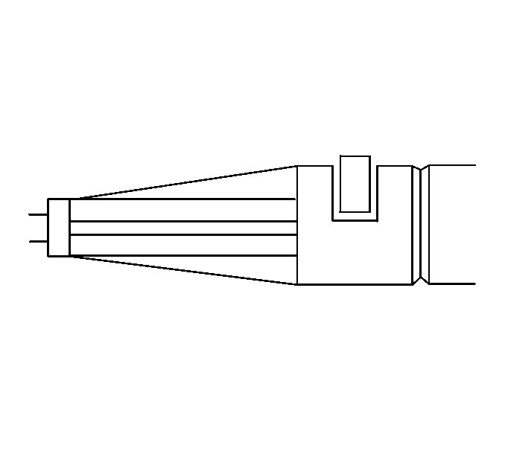
- The horseshoe clip with the tab is not flush when not fully engaged.
- Install the shift cable retainer and the wiring harness clip or wiring harness strap.
© 2016 General Motors. All rights reserved.

