Subject: | Service Engine Soon Light Illuminated and DTC P0011, P0016, P0300
Models: | 2006 - 2007 Buick Terraza
 | 2006 - 2007 Chevrolet Impala, Monte Carlo, Malibu, Uplander
 | 2006 - 2007 Pontiac G6, Montana SV6
 | 2006 - 2007 Saturn Aura, Relay
 | Equipped with 3.5L LZE, LZ4 (VIN Codes K, N)
 | 3.9L LZ9, LZ8, LGD Engine (VIN Codes 1, R, W)

The following diagnosis might be helpful if the vehicle exhibits the symptom(s) described in this PI.
Condition/Concern:
Some customers may comment that the Service Engine Soon (SES) light has come on. When checking for Diagnostic Trouble Codes (DTC) in the Powertrain Control Module (PCM), code P0011, P0016 or P0300 may be found.
Recommendation/Instructions:
Follow the appropriate diagnostic procedure in SI. If the diagnostics lead you to replace the camshaft actuator, perform the following procedure before doing so. Follow the procedures in SI when disassembling or removing components in the following steps.
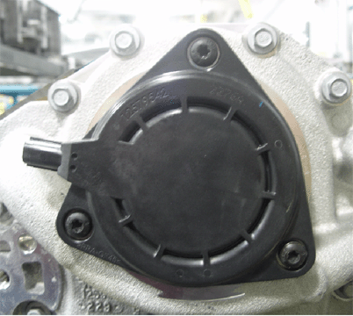
- With the ignition in the OFF position, disconnect the electrical connector from the camshaft position actuator magnet.
- Remove the three screws attaching the camshaft position actuator magnet assembly.
- Remove the assembly.
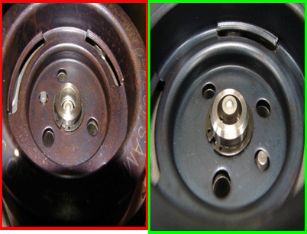
- Verify that the spool valve is properly positioned. With the camshaft position actuator magnet removed the spool valve should be slightly sticking out (proud) of the bore in the cam actuator as shown on the picture on the right. If the spool valve is not sticking out of the bore as shown in the picture on the left, then the spool valve is stuck.
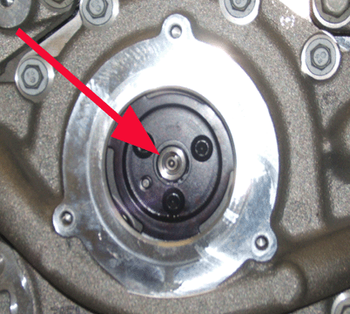
If the spool valve IS slightly sticking out of (proud) of the bore, then using your finger attempt to press it inwards and then release it. If you can push it inwards and then when released it returns to the original position and is slightly sticking out of the bore, then it is operating correctly. Proceed to the next step.
If the spool valve is NOT slightly sticking out (proud) of the bore or is stuck in the bore, then the camshaft actuator (which includes the spool valve) must be replaced. Use the procedure in SI when replacing the camshaft actuator.
Please follow this diagnostic or repair process thoroughly and complete each step. If the condition exhibited is resolved without completing every step, the remaining steps do not need to be performed.

