Brake Pedal Position Sensor Replacement

Removal Procedure
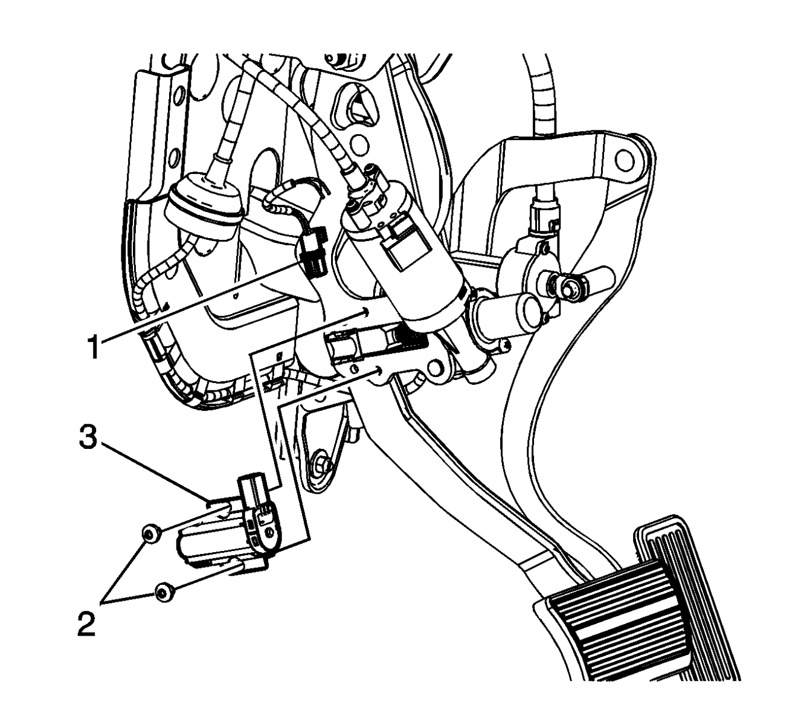
- Remove the fuse block cover.
- Disconnect the brake pedal position sensor electrical connector (1).
- Remove the brake pedal position sensor bolts (2).
- Remove the brake pedal position sensor (3) from the vehicle.

Installation Procedure
- Install the brake pedal position sensor (3) to the vehicle.
Notice: Refer to Fastener Notice in Cautions and Notices.
- Install the brake pedal position sensor bolts (2).
Tighten
Tighten the bolts to 9 Y (80 lb in).
- Connect the brake pedal position sensor electrical connector (1).
- Install the fuse block cover.

