Cruise Control Module Replacement

Removal Procedure
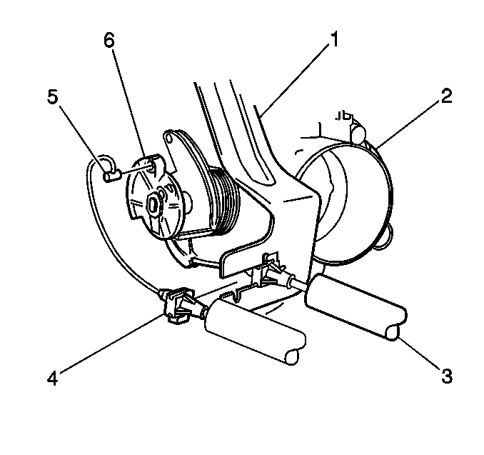
- Open the hood.
- Disconnect the cruise control cable tab (5) from the throttle body cam (6). Rotate the cam (6)to ¼ open throttle in order to release the tab (5).
- In order to release the cable (4), push the locating fitting inward and pull the unit free from he throttle bracket (1).
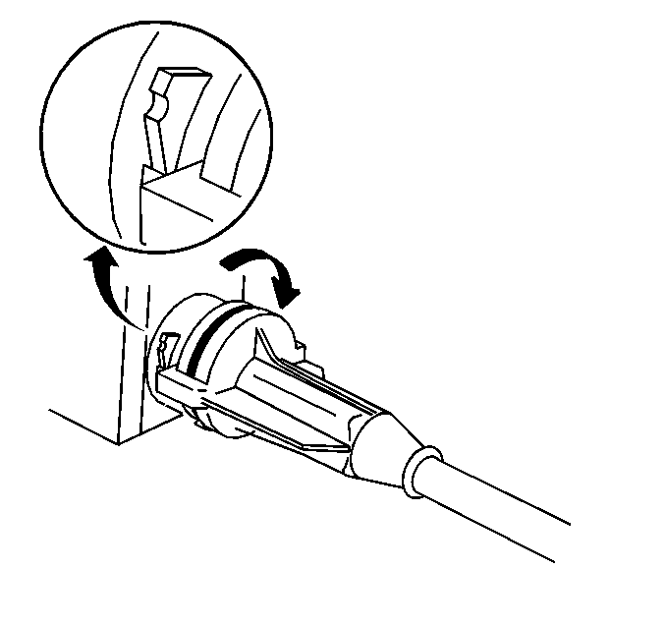
- Remove the cruise control cable from the module by turning the cable assembly ¼ turn counterclockwise.
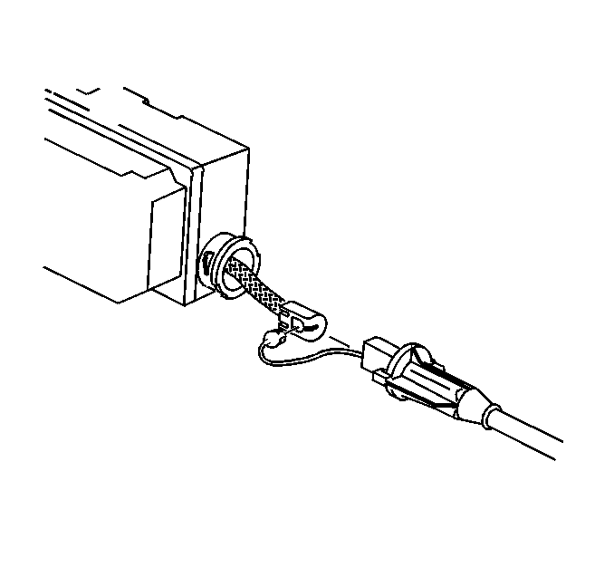
- Remove the cable from the ribbon.
- Disconnect the electrical connector from the module assembly.
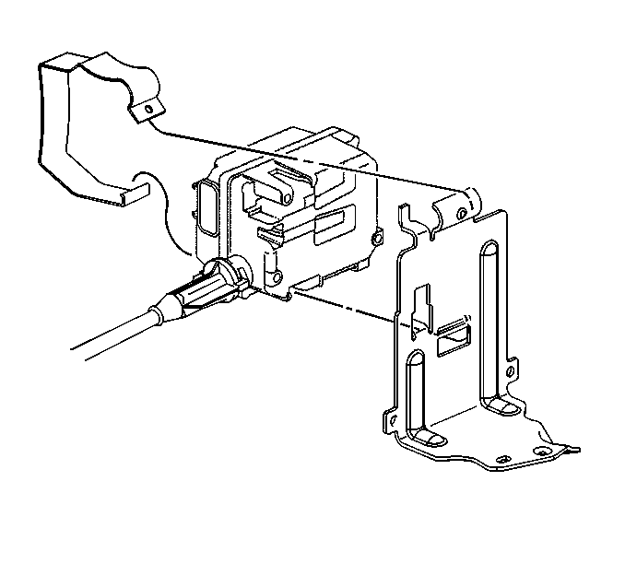
- Unclip the hinged retaining strap from the bracket at the top of the module.
- Remove the module from the mounting bracket.
Installation Procedure
- Install the module assembly to the mounting bracket.
- Connect the electrical connector to the module.
- Connect the cruise control cable to the module ribbon.
- Install the cruise control cable to the module assembly by turning the cable assembly ¼ turn clockwise.
- Install the cruise control cable tab (5) to the throttle body cam (6).
- Align the cruise control cable fitting to the throttle body bracket (1). Snap the fitting into place. Ensure that the fitting is retained.
- Close the hood.
- Perform A Diagnostic System Check. Refer to Diagnostic System Check - Cruise Control.
© 2016 General Motors. All rights reserved.

