Cruise Control Cable Replacement

Removal Procedure
- Open the hood.
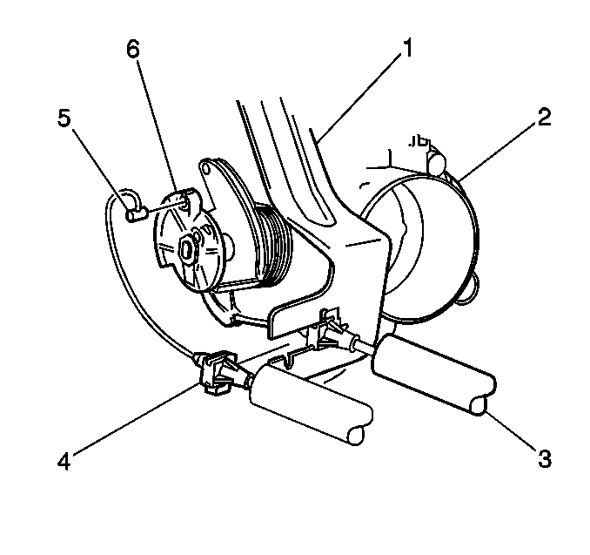
- Disconnect the cruise control cable tab (5) from the throttle body cam (6). Rotate the throttle to ¼ open throttle in order to release the tab (5).
- In order to release the cable (4), push the locating fitting inward and pull the unit free from the throttle bracket (1).
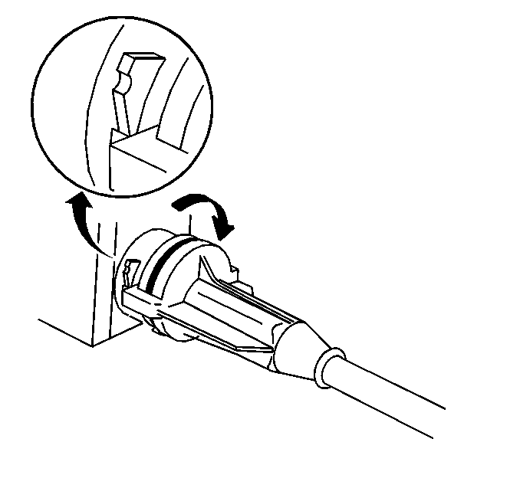
- Remove the cable assembly from the module by turning the cable assembly ¼ turn counterclockwise.
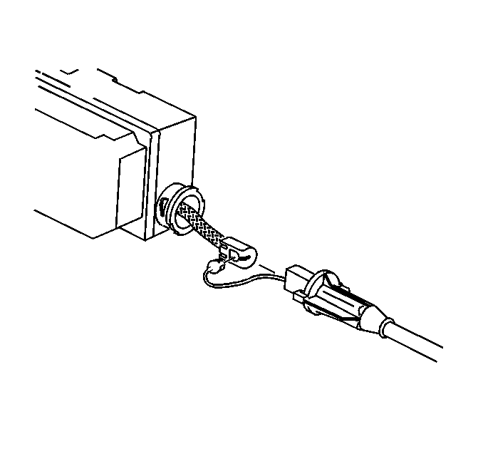
- Remove the cable from the ribbon.
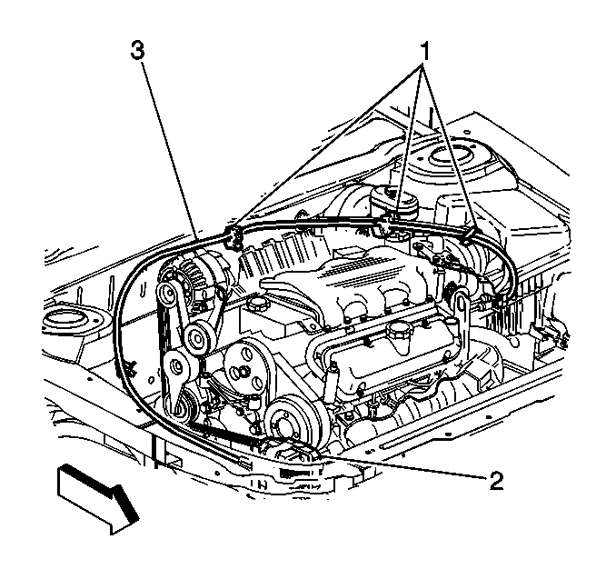
- Remove the cable (3) from the retaining clips (1).
Installation Procedure
- Install the cable (3) to the retaining clips (1).
- Install the cable to the ribbon.
Important: Ensure that the ribbon does not become twisted when connecting the cable to the module.
- Connect the cable assembly to the module by turning the cable assembly ¼ turn clockwise.
- Install the cruise control cable tab (5) to the throttle body cam (6).
- Align the cruise control cable fitting (4) to the throttle body bracket (1). Snap the fitting into place. Ensure that the fitting is retained.
- Close the hood.
© 2016 General Motors. All rights reserved.

