Steering Column Replacement

Tools Required
J 42640 Steering Column Anti-Rotation Pin
Removal Procedure
Caution: Refer to SIR Caution in Cautions and Notices.
- Disable the supplemental inflatable restraint (SIR) system. Refer to SIR Disabling and Enabling in SIR.
- Remove the knee bolster. Refer to Knee Bolster Replacement in Instrument Panel, Gauges and Console.
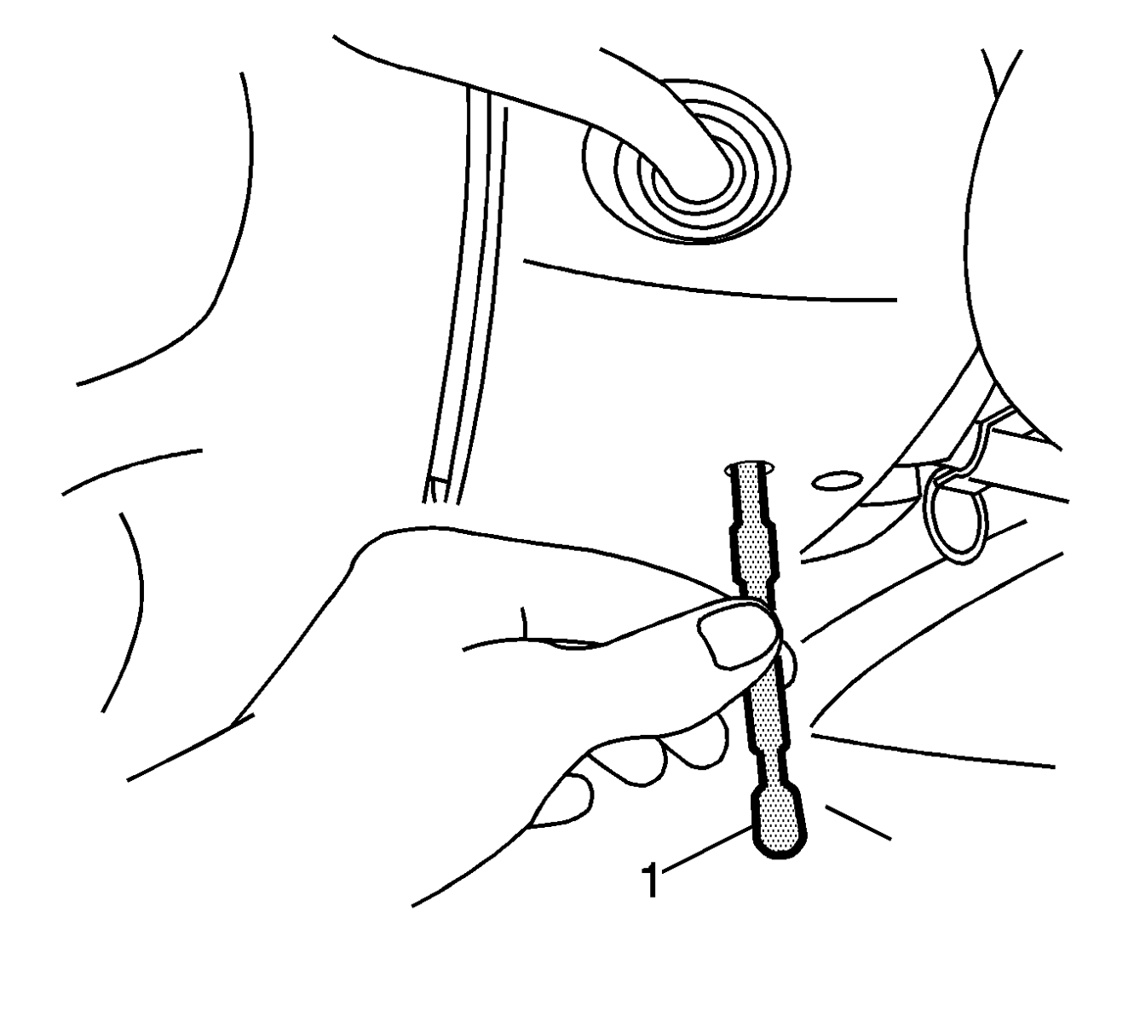
Notice: With wheels of the vehicle facing straight ahead, secure the steering wheel utilizing steering column anti-rotation pin, steering column lock, or a strap to prevent rotation. Locking of the steering column will prevent damage and a possible malfunction of the SIR system. The steering wheel must be secured in position before disconnecting the following components:
  - The steering column
  - The intermediate shaft(s)
  - The steering gear
After disconnecting these components, do not rotate the steering wheel or move the front tires and wheels. Failure to follow this procedure may cause the SIR coil assembly to become un-centered and cause possible damage to the SIR coil. If you think the SIR coil has became un-centered, refer to your specific SIR coil’s centering procedure to re-center SIR Coil.
- Lock the steering column through the access hole in the lower trim cover using J 42640.
- Remove the body control module bracket. Do not disconnect the harness from the body control module. Refer to Body Control Module Replacement in Body Control System.
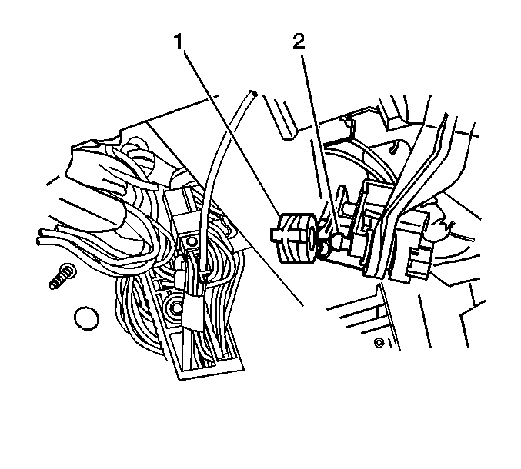
- Disconnect the transmission shift cable (1) from the column.
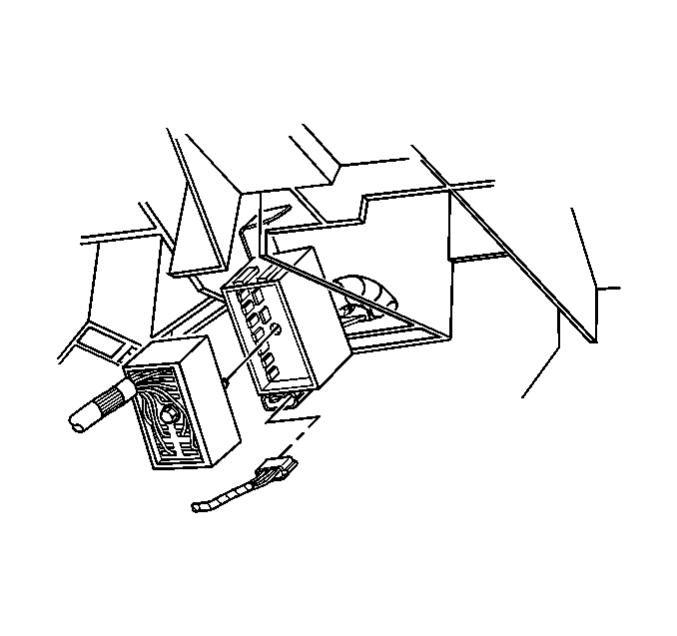
- Disconnect the steering column electrical connectors.
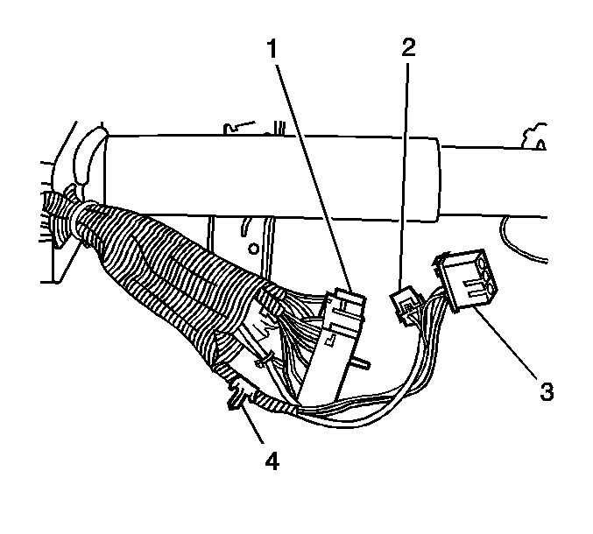
Notice: During removal of the steering column the wire harness retaining clip must be removed and reinstalled after installing the steering column or damage may occur to the wire harness.
- Remove the wiring harness retaining pin (4) from the instrument panel.
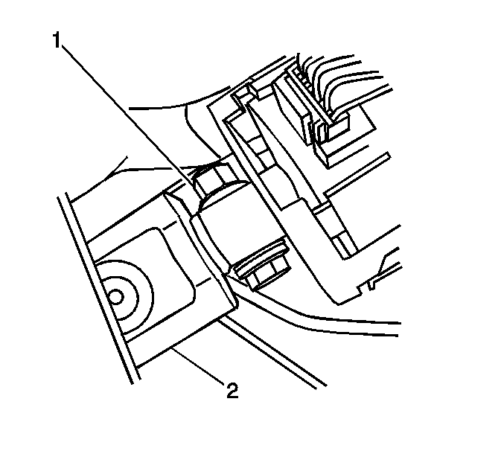
- Remove the upper intermediate shaft pinch bolt (1) from the steering column, and remove the shaft from the steering column.
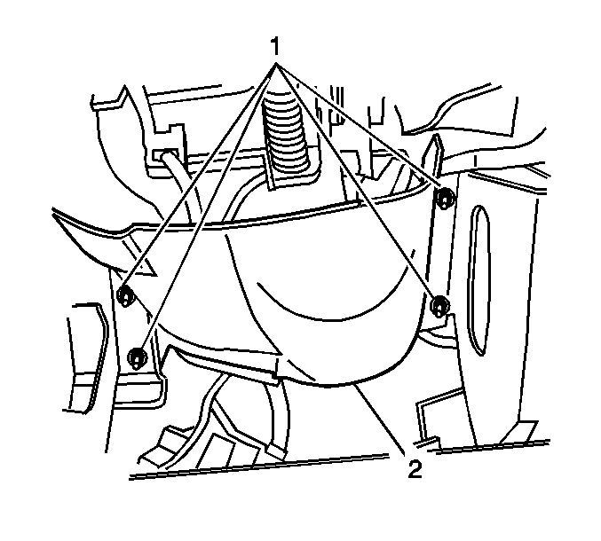
- Remove the nuts (1) from the knee bolster deflector.
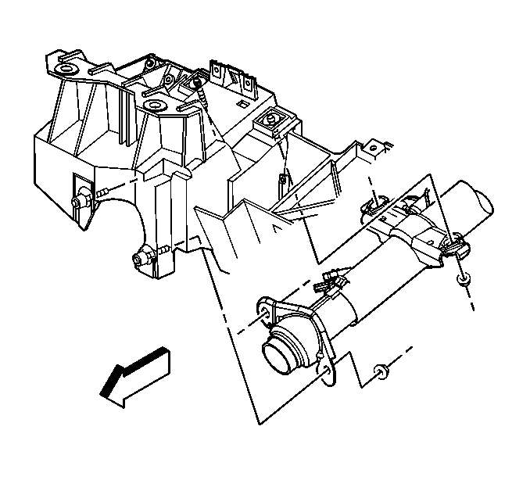
- Remove the nuts from the upper support brackets.
- Remove the nuts from the lower support brackets.
Notice: Once the steering column is removed from the vehicle, the column is extremely susceptible to damage. Dropping the column assembly on the end could collapse the steering shaft or loosen the plastic injections, which maintain column rigidity. Leaning on the column assembly could cause the jacket to bend or deform. Any of the above damage could impair the columns collapsible design. Do NOT hammer on the end of the shaft, because hammering could loosen the plastic injections, which maintain column rigidity. If you need to remove the steering wheel, refer to the Steering Wheel Replacement procedure in this section.
- Remove the steering column from the vehicle.
Installation Procedure
Caution: In order to ensure the intended function of the steering column in a vehicle during a crash and in order to avoid personal injury to the driver, perform the following:
  - Tighten the steering column lower fasteners before you tighten the steering column upper fasteners. Failure to do this can damage the steering column.
  - Tighten the steering column fasteners to the specified torque. Overtightening the upper steering column fasteners could affect the steering column collapse.
- Install the steering column to the vehicle.
Notice: Refer to Fastener Notice in Cautions and Notices.
- Install the lower column nuts.
Tighten
Tighten the nuts to 30 Y (22 lb ft).
- Install the nuts to upper support brackets.
Tighten
Tighten the nuts to 30 Y (22 lb ft).
- Install the nuts (1) which retain the knee bolster deflector to the instrument panel.
Tighten
Tighten the retaining nuts to 9 Y (80 lb in).
- Install the wiring harness retaining (4) pin to the instrument panel.
- Connect the steering column electrical connectors to the vehicle wiring harness.
Tighten
Tighten the connector to 6 Y (53 lb in).
- Connect the transmission shift cable (1) to the steering column.
- Install the body control module bracket. Refer to Body Control Module Replacement in Body Control System.
- Install the knee bolster. Refer to Knee Bolster Replacement in Instrument Panel, Gauges, and Console.
- Enable the SIR system. Refer to SIR Disabling and Enabling in SIR.
- Remove J 42640 from the steering column.
© 2016 General Motors. All rights reserved.

