Turn Signal Cancel Cam and Upper Bearing Thrust Washer

Tools Required
- J 23653-SIR Steering Column Lock Plate Compressor
- J 42137 Cam Orientation Plate Adapter
Removal Procedure
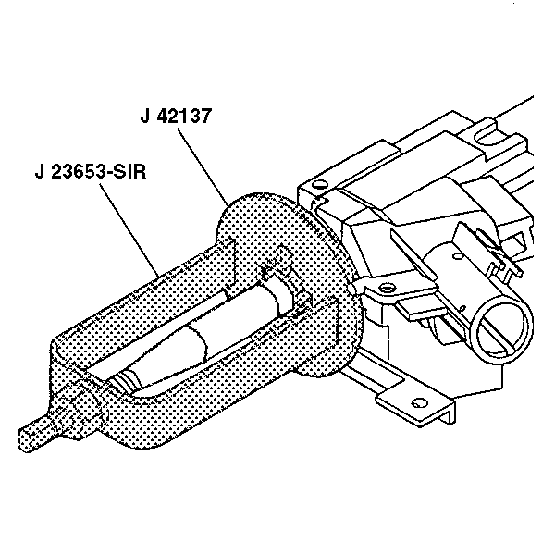
Caution: Refer to SIR Caution in Cautions and Notices.
- Disable the SIR system. Refer to SIR Disabling and Enabling in SIR.
Important: Let the SIR coil hang freely after removal.
- Remove the SIR coil. Refer to Steering Wheel Airbag Coil Replacement in SIR.
- Remove and discard the bearing retainer using J 23653-SIR and J 42137.
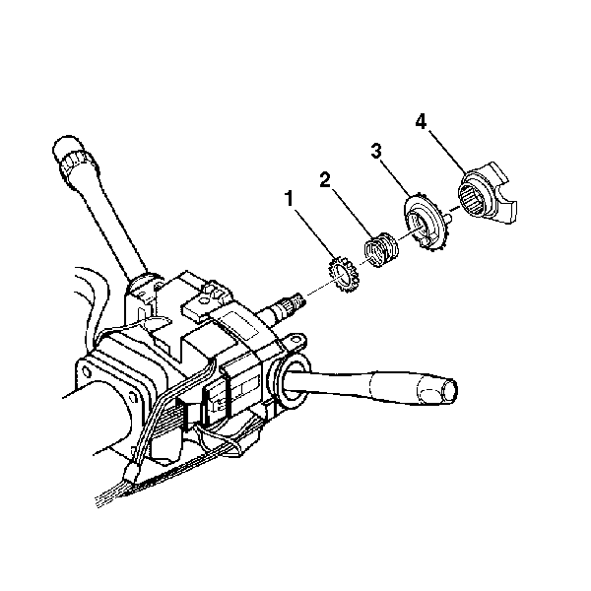
- If standard column, remove the following parts from the steering shaft assembly:
  - The cam orientation plate (4)
  - The turn signal cancel cam assembly (3)
  - The upper bearing spring (2)
  - The thrust washer (1)
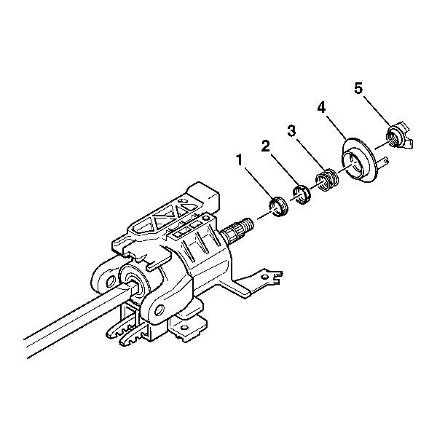
- If tilt column, remove the following parts from the steering column shaft assembly:
  - The cam orientation plate (5)
  - The turn signal cancel cam assembly (4)
  - The upper bearing spring (3)
  - The upper bearing inner race seat (2)
  - The inner race (1)
Installation Procedure
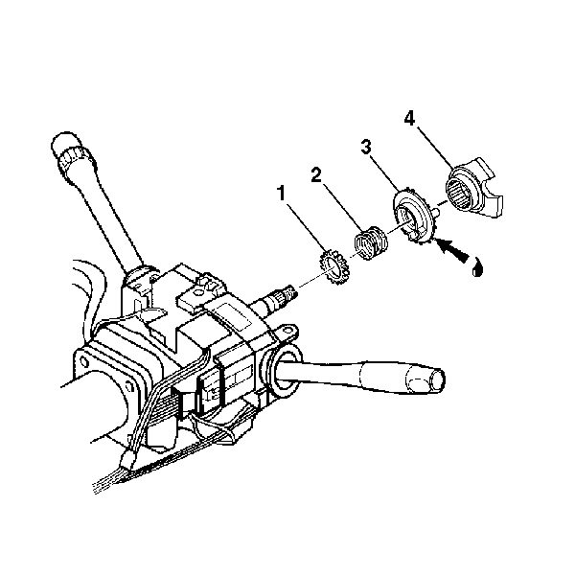
- If standard column, install the following parts onto the steering shaft assembly:
  - The thrust washer (1)
  - The upper bearing spring (2)
  - Lubricate the turn signal cancel cam assembly (3) with GM P/N 12377900 (Canadian P/N 10953529).
  - The turn signal cancel cam assembly (3) onto the steering shaft assembly
  - The cam orientation plate (4) onto the steering shaft assembly
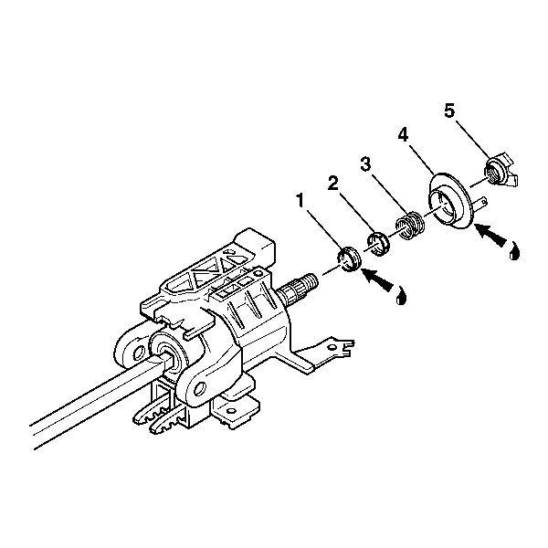
- If tilt column, install the following parts onto the steering column shaft assembly:
  - Lubricate the inner race (1) with GM P/N 12345718 (Canadian P/N 10953516)
  - The inner race (1)
  - The upper bearing inner race seat (2)
  - The upper bearing spring (3)
  - Lubricate the turn signal cancel cam assembly (4) with GM P/N 12377900 (Canadian P/N 10953529).
  - The turn signal cancel cam assembly (4) onto the steering shaft assembly
  - The cam orientation plate (5)

- Install the new bearing retainer onto the steering shaft assembly.
- Compress the cam orientation plate using J 23653-SIR and J 42137.
- Firmly seat the bearing retainer into the groove on the steering shaft assembly.
- Remove J 23653-SIR.
- Install the SIR coil. Refer to Steering Wheel Airbag Coil Replacement in SIR.
- Enable the SIR system. Refer to SIR Disabling and Enabling in SIR.
© 2016 General Motors. All rights reserved.

