Customer Question
1. Assume you have a data set from a normally distributed random variable. Answer the following questions about it.
a.Will the random variable be discrete, continuous, or neither? How do you know?
Answer:
Normal distribution is a kind of continuous distribution since the random variable can take any values within 2 integral (whole number) values.
If any given random variable can have a decimal values and not only restricted to counting numbers.

b. Will the data be qualitative or quantitative?
How do you know?
Answer:
Data in any Normal distribution are always quantitative since only numerical values are measured and considered in any normal distribution. We easily know if it is quantitative, if we see numbers in the data and not words or letters.

3. A university has been tracking the percentage of alumni giving to its annual fund each year for the past 10 years. The data is given here. 14%, 13%, 15%, 21%, 19%, 24%, 25%, 28%, 25%. 31% Answer the following questions about this data.
a.what are its mean and median?
Answer:
Mean = (Σx) / n
= (14% + 13% + 15% + 21% + 19% + 24% + 25% + 28% + 25% + 31%) / 10
= 215% / 10
= 21.5%

Median = (21% + 24%)/2 = 22.50%

b.What is the procedure for using mean and median to determine whether the data is skewed, and if so, in what direction?
Answer:
To determine whether the distribution is skewed to the left, we just compare the mean and the median, if the mean is smaller than the median, then the distribution is skewed to the left or negatively skewed, but if the mean is greater than the median, then the distribution is skewed to the right or positively skewed. If the mean and median are equal, then the distribution is normal, or no skewness.

5. In the diagram below, events A, B and C are shown with numbers in various regions of the graph indicating
how many sample points lie in each. For example, the number 3 in the top left of the diagram indicates that there are 3 sample points in B that are not also in either A or C. A= 9, 0, 10,12 B= 3, 1, 10, 12 C= 5, 1, 0, 10 Out of all A, B and C= 15
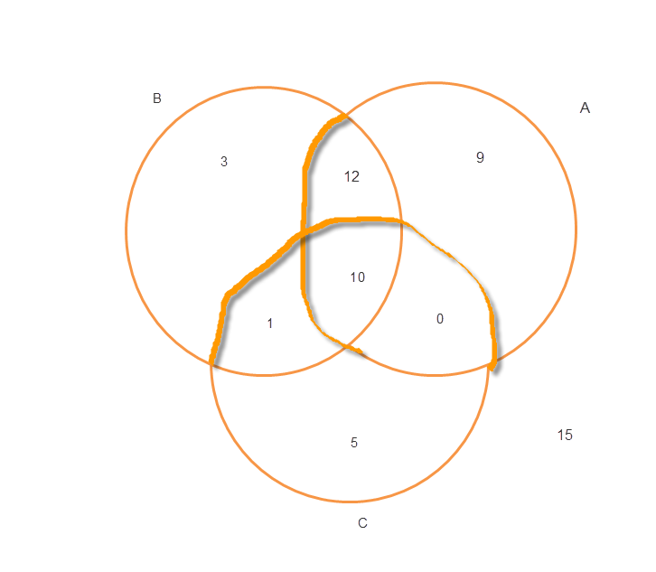
a. Are the
events A and B independent?
Answer:
NO since P(A and B) is not equal to P(A) * P(B)
b. Are the events for the intersection of A and Bc, intersection of C and Bc mutually exclusive?
Answer:
NO since P(A and B) is not zero
7. The mean time for a racecar driver’s crew to perform a pit stop is 13.2 seconds, with a standard deviation of 0.9 seconds. To maintain
his current lead, the driver needs a pit stop in 12.5 seconds or less. Assuming this random variable is normally distributed, what is the probability of the driver getting the pit stop in a short enough time to maintain is lead?
Answer:
P(x ≤ 12.5)
Convert 12.5 to z-score:
Z = (12.5 – 13.2) / 0.9
Z = -0.77778

Then P(x ≤ 12.5) = P(z ≤ -0.77778)
Using normal distribution table:

P(z ≤ -0.77778) = 0.2184

9. A random sample from the
population of registered voters in California is to be taken and then surveyed about an upcoming election. What sample size should be used to guarantee a sampling error of 3% or less when estimating p at the 95%confidence level?
n = p*q*z²/e²
= p(1 – p)1.96²/0.03²
= p(1 – p) 4268.4444 or if we want to assume p = 0.5 then
= 0.5²*4268.4444
= 1067.11 or rounded up to 1068

10. a. Explain the two conditions
required for a valid large-sample test of hypothesis for a mean.
Answer:
We use Z test for a large sample test of hypothesis for a mean if either or both of these conditions are met, the sample size is sufficiently large or at least 30, or the population variance/standard deviation is known.

B. Explain the two different possible outcomes of a test of hypothesis.
Answer:
The two possible outcomes of a test of hypothesis are reject the null hypothesis which means that there is sufficient statistical evidence to prove that the difference is significant, and the second outcome is to failed to reject the null hypothesis, which means that there is no sufficient statistical evidence to prove that the difference is significant

