- Before starting AdwCleaner, close all open programs and internet browsers, then double-click on the AdwCleaner icon.
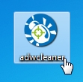
If Windows prompts you as to whether or not you wish to run AdwCleaner, please allow it to run.
- When the AdwCleaner program will open, click on the “Scan” button as shown below.
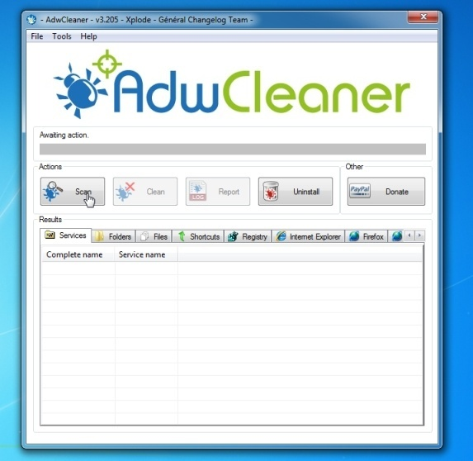
AdwCleaner will now start to search for the “The proxy server isn’t responding” adware that may be installed on your computer.
- To remove the “The proxy server isn’t responding” malicious files that were detected in the previous step, please click on the “Clean” button.
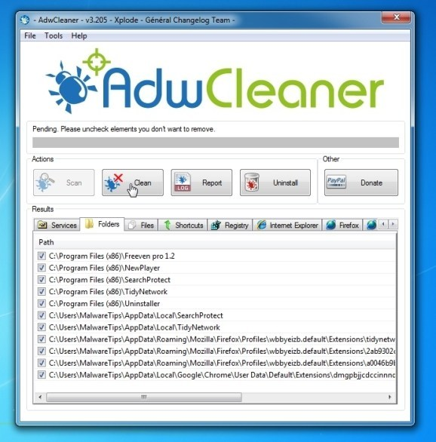
- AdwCleaner will now prompt you to save any open files or documents, as the program will need to reboot the computer. Please do so and then click on the OK button.
