1. Install the lower paper tray.

- Turn the Brother machine off using the power switch on the right side of the machine.

- Disconnect the power cord and all interface cables from the back of the Brother machine.

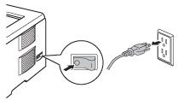

- Carefully lift the Brother machine with both hands and place it on top of the optional tray unit so that the alignment pins on the top of the optional tray unit are inserted into the guide holes on the bottom of the Brother machine.

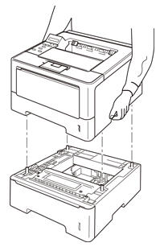

- Reconnect all cables and cords that were disconnected in STEP b.

- Turn the Brother machine on using the power switch located on the right side of the machine.

2. Load paper in the paper trays.

Verify the paper size and type you wish to print on can be used in the paper tray you are loading the paper in. Refer to the solution - What size and type of paper is recommended for use in my Brother machine?

3. Set the Paper Size on the control panel for each paper tray.

- Press the UP or DOWN ARROW key to select Paper Tray. Press OK.

- Press the UP or DOWN ARROW key to select Tray1 Size or Tray2 Size* and press OK.

NOTE: Tray2 Size is only available if the second paper tray has been installed.

- Press UP or DOWN ARROW key to select the paper size that is loaded in the tray and then press OK to save the setting. The display will read "Accepted".

- Press CANCEL to exit the menu.

- Repeat STEP 3 for each paper tray.

4. Setup the paper tray in the printer driver.

Windows

- Open the Printers folder. Refer to the following solution for instructions if needed - How do I open the Printers folder in Windows?

- Open the Printer Properties:

Windows 7, 8, 8.1, Server 2008 R2, Server 2012: Right-click on the Brother Printer and select Printer Properties.

Windows XP, Vista, Server 2003, Server 2008: Right-click on the Brother Printer and selectProperties.

- Click the Accessories tab and click Auto Detect, once the lower tray has been detected then click Apply.

NOTE:

- If the Paper Size is undefined or the same size paper is defined for each tray, the printer will automatically print from the next available paper tray if the paper tray becomes empty.

- Under certain conditions Auto Detect may not be available. If this situation occurs, you can manually add the options you have installed. In Available Options, select the option you have installed, click Add and then Apply.

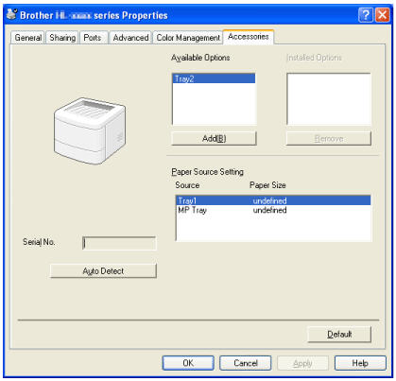

Macintosh
The printer driver is already configured for use with the lower paper tray. No additional steps are required. Continue to the next step.

5. If different size paper is configured for the paper trays, the printer will automatically print the document from the appropriate paper tray if Auto Select is set as the Paper Source. Auto Select is the default setting of the printer driver. You do not need to select to print from Tray 2 in the printer driver or application.

If printing a document with mixed paper sizes (ex. some pages letter and some pages legal),

For PDF document

Windows

- Open PDF document .Click File and Print.

- You may wish to select Fit for Size Options.

- Select Choose paper source by PDF page size.

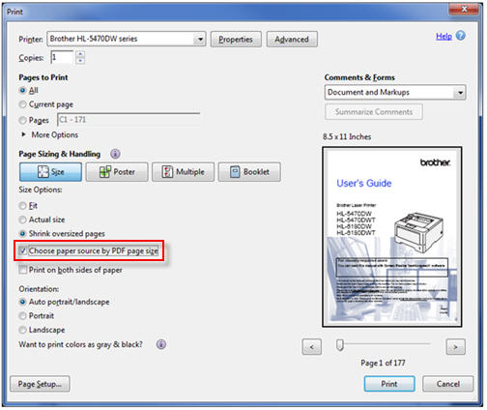

- Click Print or OK to print the document.

