First, start by booting your Windows 10 installation into the setup by changing the boot order in your BIOS to take priority with the CD, or use the ISO as a startup disk instead.
Once the setup begins, hit Shift+F10.
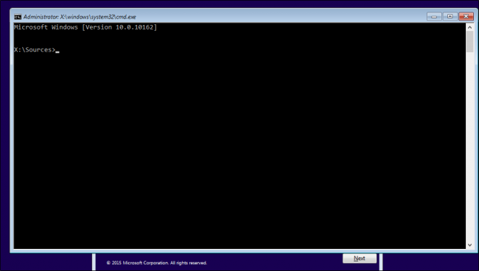
This will bring up a command prompt. From here, we’re going to use the command prompt to replace the Utility Manager at the login screen with cmd.exe with the following commands:
move d:\windows\system32\utilman.exe d:\windows\system32\utilman.exe.bak
copy d:\windows\system32\cmd.exe d:\windows\system32\utilman.exe
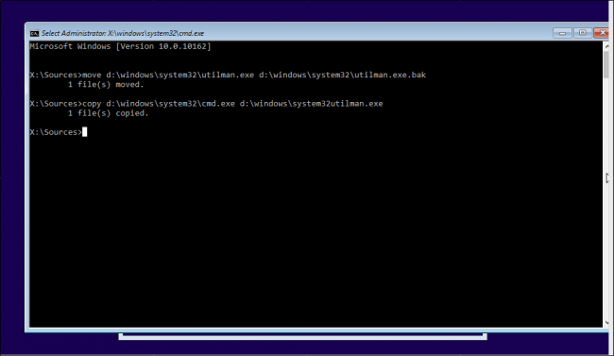
Once this is complete, use the command “wpeutil reboot” to restart the machine.
After you’re back at the login screen, click the Utility Manager. If everything went right, you should see a cmd.exe launch like the image below.
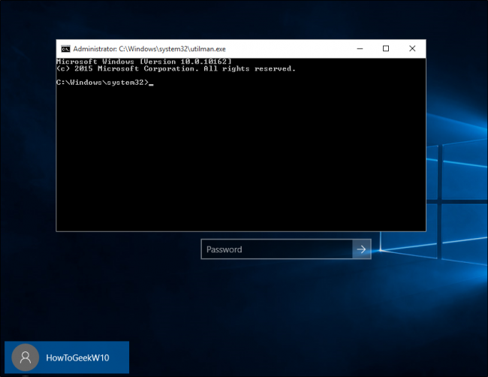
This is the prompt you’ll use to create a new administrative user from the login screen. Type in the following commands, replacing <username> with the name you’d like to assign to the new account (no carrots).
net user <username> /add
net localgroup administrators <username> /add
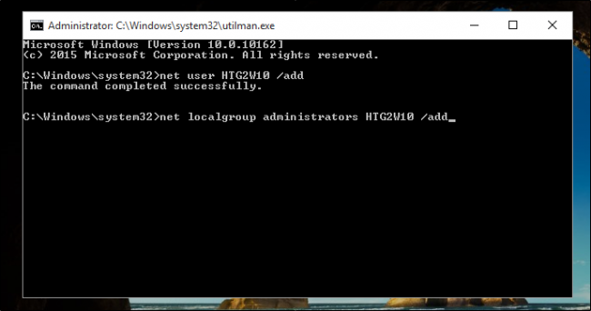
Now close the prompt, reboot, and you should see your new user in the login screen.
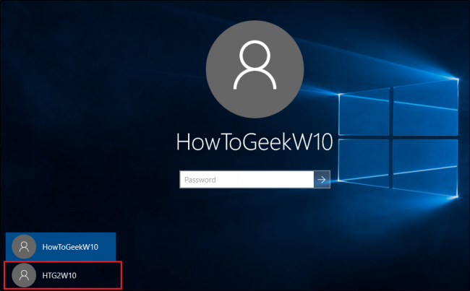
Click in here, and enter your fresh desktop. From the desktop, right click the Start menu in the bottom-right hand corner, and select “Computer Management”.
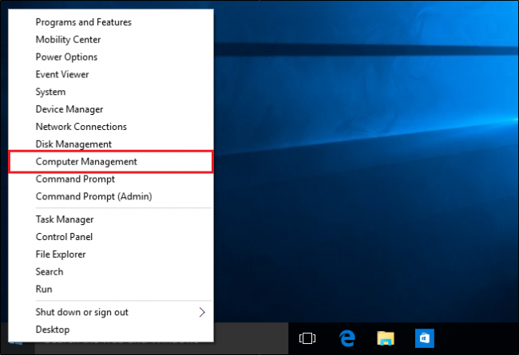
Navigate to “Local Users and Groups”, scroll down to the affected account, and right-click. Choose the “Set Password” option, and choose a new set of credentials to regain access to your locked account!

