Windows 10 - From the Start screen, right-click AOL Desktop and selectUninstall from the drop down menu.
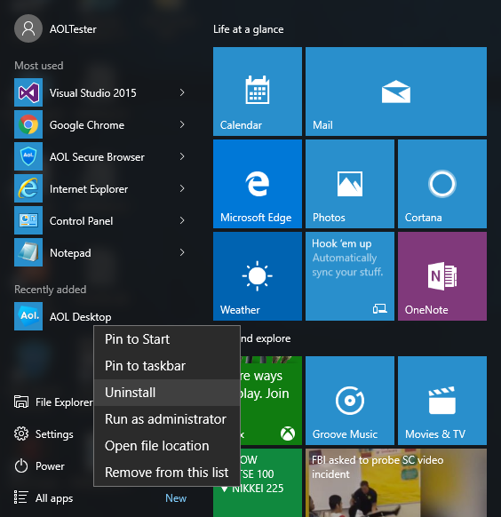
2. From the list of currently installed programs, double-click AOL Uninstaller to begin the uninstall process.
3. A window will appear, asking to perform a scan of your system for all AOL software. Click Yes. The scan may take some time to complete.
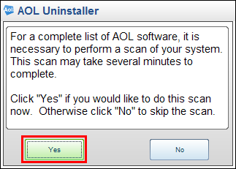
4. On the AOL Uninstaller screen, select all of the applications available by checking the corresponding check boxes.
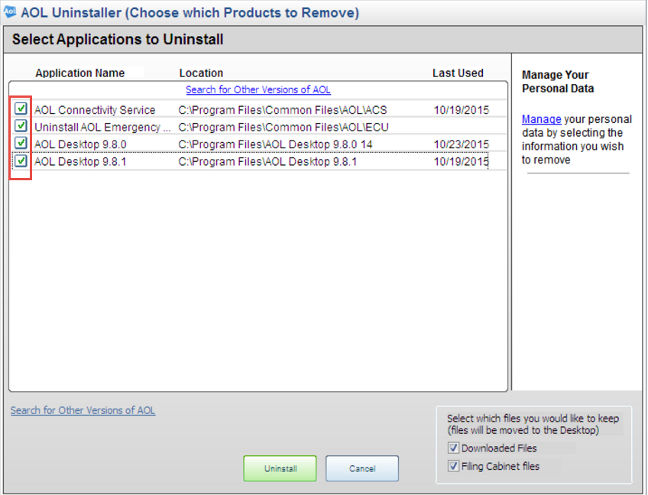
5. Click Uninstall. The uninstall process will begin.
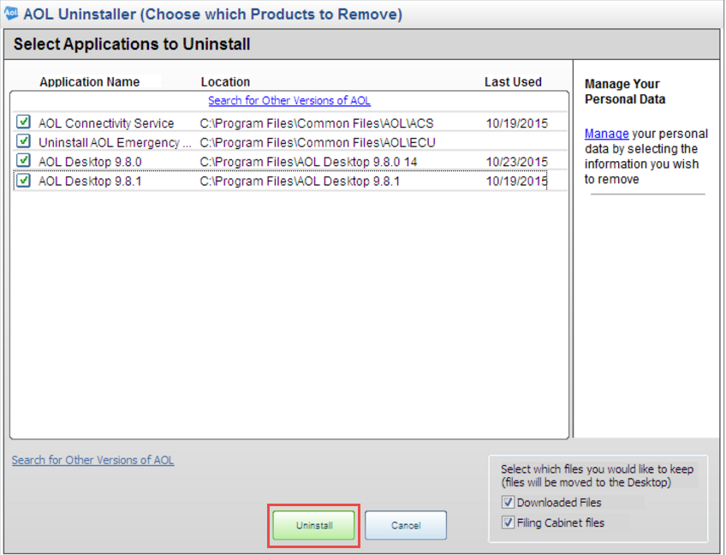
6. If you're asked if you want to keep your old files, check the Personal Data and Settings check box and click OK.
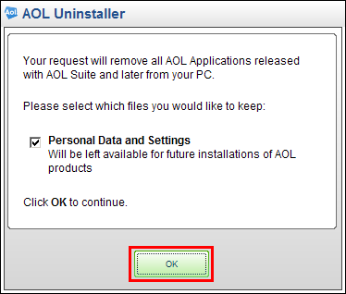
7. When the uninstall process completes, you will be asked to restart your computer. Make sure to save any documents or files you have open, and then click Restart.
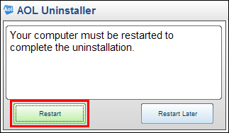
8. After you restart your computer, visit http://discover.aol.com/products-and-services/aol-desktop-for-windows.
9. Click Download for FREE.
10. Open the file and click Run. If you are prompted by the User Account Controlwindow, click Yes or Continue.
11. Next you'll be prompted to shut down any AOL applications you have open. To do this, click Continue Install.
12. Select Install New Version and click Continue.
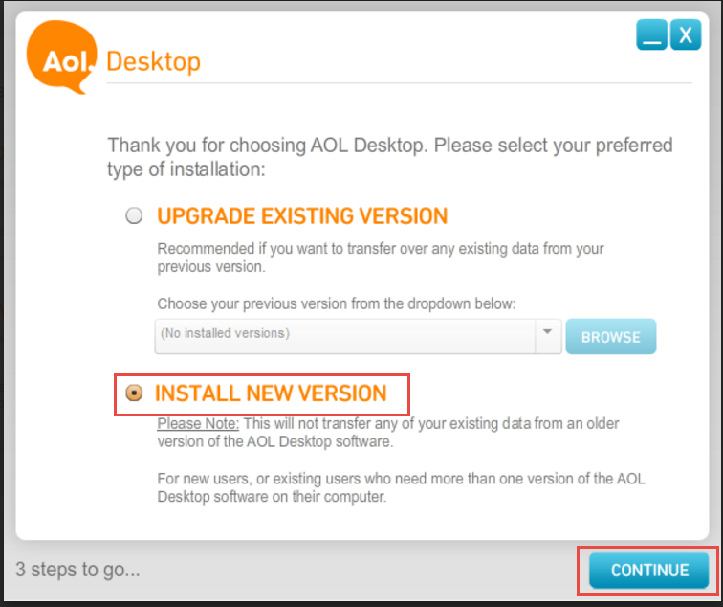
13. Select your preferred software settings by checking the corresponding check boxes and then click Continue. For more information on the available options, click the question mark bubbles.
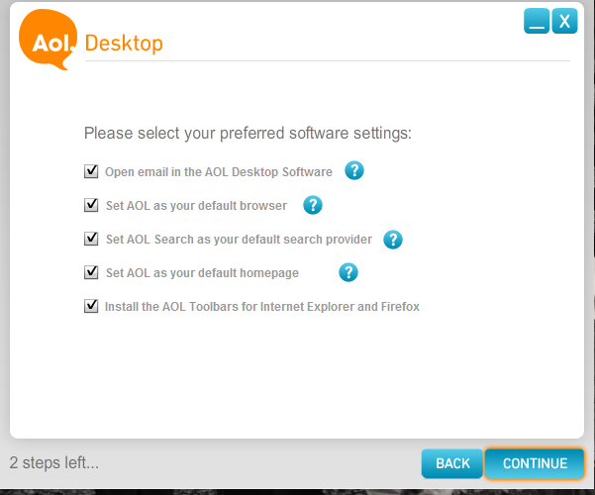
14. Review your selected settings.
15. Once you’re finished, click Install Now. Once installation completes, AOL Desktop will run.
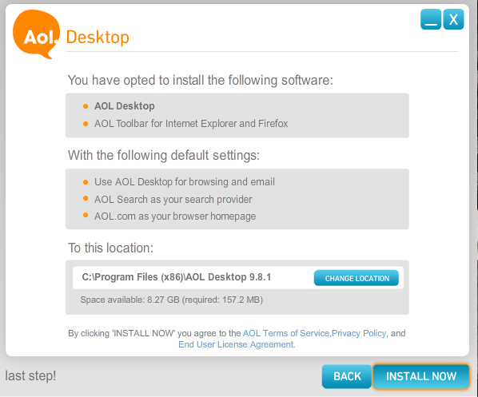
16. On the Let's Get Started window, select Use your existing AOL Screen Name.
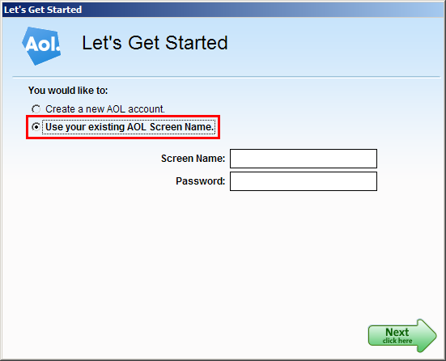
17. Enter your Screen Name and Password and click Next. You will then be signed into the AOL Desktop software.
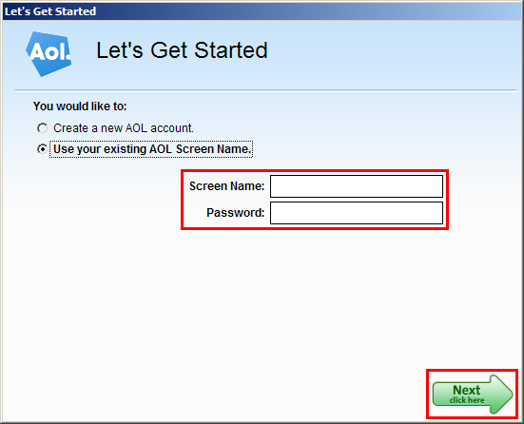
18. You've successfully reinstalled the AOL Desktop Software! Continue to use the software as you like.

