1
Insert the supplied DVD-ROM into the drive on the computer.
2
Click [Start Software Programs].
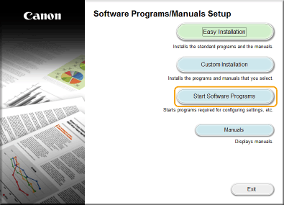
If the above screen does not appear Displaying the [Software Programs/Manuals Setup] Screen
If [AutoPlay] is displayed, click [Run MInst.exe].
3
Click [Start] for [MF/LBP Network Setup Tool].
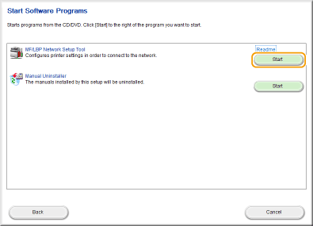
4
Follow the on-screen instructions to configure the wireless LAN settings.
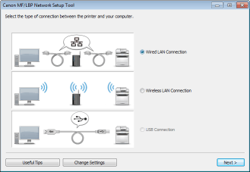
If there is something you do not understand
Click [Useful Tips] at the bottom left of the screen to display troubleshooting tips.
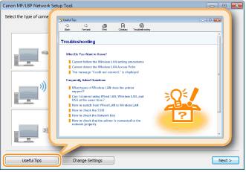

After switching the connection method from wired LAN to wireless LAN
You need to uninstall the currently installed printer driver, and then reinstall it.

