Finding a Backdoor Password

1
  - A "backdoor" password is a password built-in to the BIOS by the manufacturer. It is hidden, so you'll need some special software to find it.

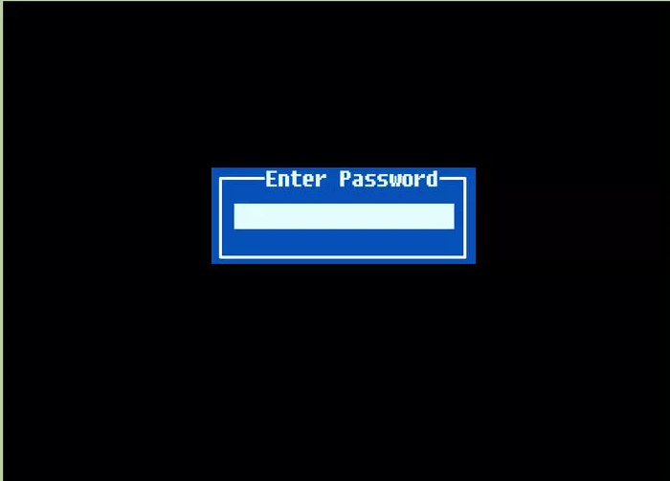
2
Turn on the computer and fail the password three times. This will lock the computer and display a "System Disabled" message. Don't worry, when you reset the computer it will go back to normal and no data will be lost. You need to do this in order to see the code required to find the backdoor password.

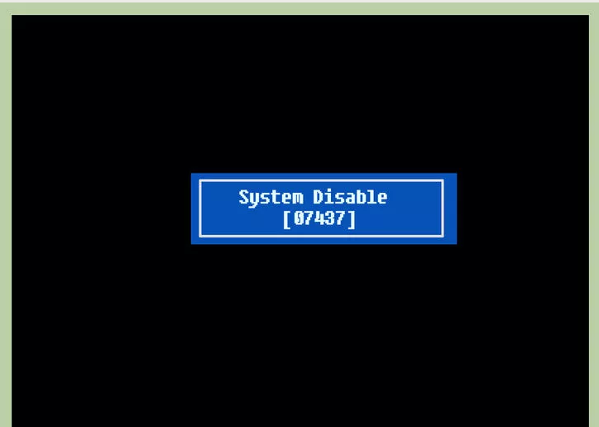
3
Note the code displayed when you are locked out of the computer. When you see the "System Disabled" message, you'll see a series of numbers and letters. Write this down, as you'll need it to find the password later.

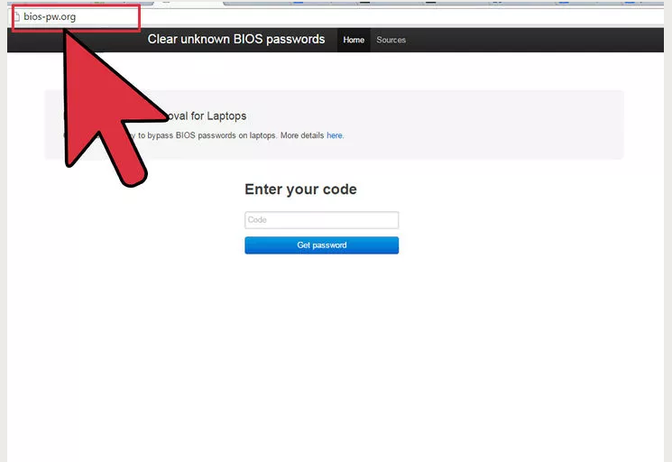
4
Visit the password generator website. Open bios-pw.org/ on another computer's web browser. This website can generate backdoor passwords based on the code that was displayed.^{[4]}

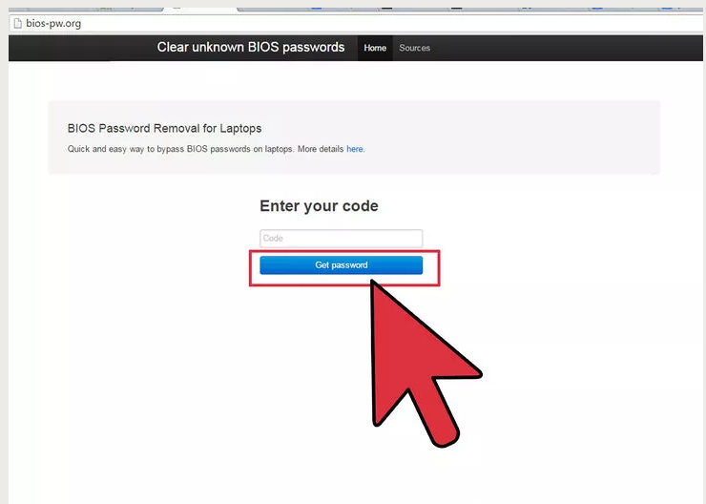
5
Enter the System Disabled code and click "Get password". The website will attempt to generate a password that matches your computer. You may be given several passwords to try.
  - Note: If you didn't get a code when the system was disabled, your computer may use its own serial number to generate a backdoor password. Click the "More details" link at bios-pw.org/ and follow the instructions to download and run the correct script for your computer's manufacturer.

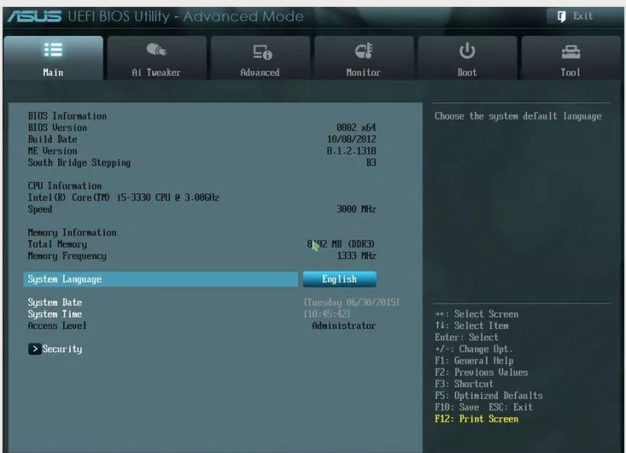

6
Change your BIOS settings. After entering the correct password, make sure that your BIOS settings are correct so that you won't be locked out again. Unlike the jumper and CMOS battery methods, entering the backdoor password will not reset your BIOS settings.

