To change payment method:
1. Go to the Manage My Account tab at the top of AOL Help's home page.
2. On the Manage My Account screen, click on Update Payment Details, located under AOL Account Settings.
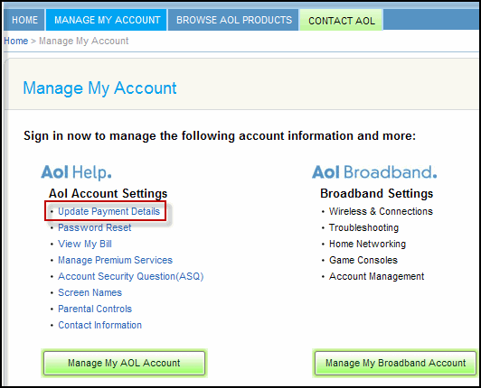
3. Enter your master Username, password and answer to your Account Security Question.
4. On the My Account Overview page, the Payment Method section gives you the option not only to change your payment method, but also view what additional methods are on file.
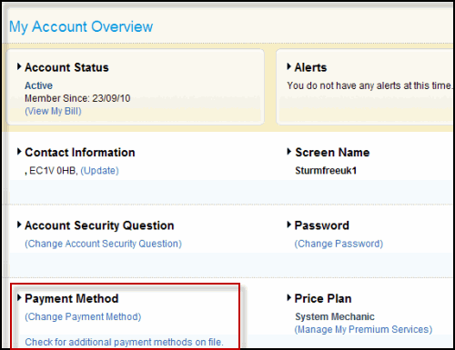
5. To change payment method, click Change Payment Method.
6. Once the Edit Payment Method screen appears, fill in the required information and clickSave at the bottom of the page.
Note: Please make sure to verify that all fields have been correctly updated before clicking the Save button.
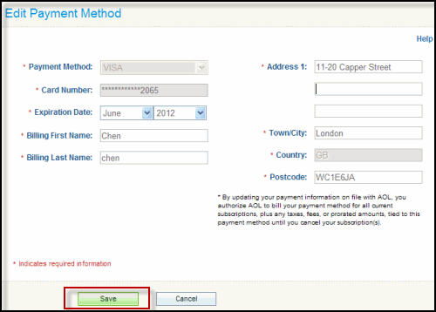
7. Once payment information has been updated, you will be routed back to your My Account Overview page with a message confirming that your payment method has been updated.
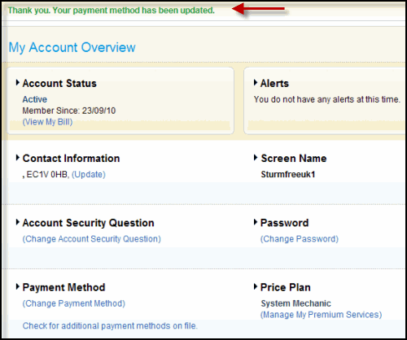
Ta-da! Your payment method is officially changed.

