If you use the Auto Select feature, the application will automatically pull from the appropriate tray based on the document's paper size. For this feature to work, the tray settings must be defined from the machine's control panel, the printer driver must be configured properly, and the paper size must be configured properly within the document's properties.

PART 1: ADJUST THE BROTHER MACHINE'S PAPER SIZE SETTING

To set the Paper Size:

1. Press MENU.

2. Press the UP OR DOWN ARROW key to display General Setup. Press General Setup.

3. Press the UP OR DOWN ARROW key to display Tray Setting. Press Tray Setting.

4. Do one of the following:
- To set the paper type for the MP Tray, press the UP OR DOWN ARROW key to display MP Tray. Press MP Tray.

- To set the paper type for Tray #1, press the UP OR DOWN ARROW key to display Tray #1. Press Tray #1.

- To set the paper type for Tray #2, press the UP OR DOWN ARROW key to display Tray #2. Press Tray #2.

NOTE: The option for Tray #2 will only be available if you installed Tray 2.

5. Press the LEFT OR RIGHT ARROW key to display the paper size options. Press Letter, A4, Legal, Executive, A5, A5L, A6, B5, B6, Folio or Any.

6. Press Thin, Plain, Thick, Thicker, Recycled Paper or Label.

7. Press Stop/Exit.

NOTE: The Any size option appears only when you choose the MP Tray.

- A5L and A6 size are not available for Tray #2.

- You can choose Label for the MP Tray.

PART 2: CONFIGURE THE PAPER SOURCE WITHIN THE DRIVER

WINDOWS USERS:

1. Ensure that your document's paper sizes are configured properly. If you are unsure how to verify this setting, please contact your application vendor for additional support.

2. From within your application, access the print dialog box. These steps will vary depending on the application, but can often be accessed by clicking File => Print.

3. Click Properties or Preferences.

4. Click on the BASIC tab.

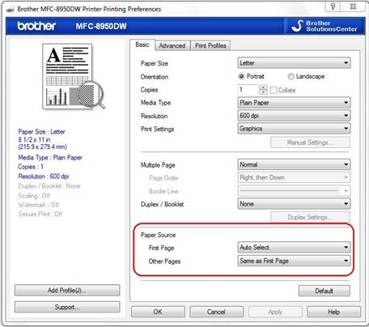

5. In the Paper Source dropdown choose Auto Select, Tray1, Tray2* or MP Tray.

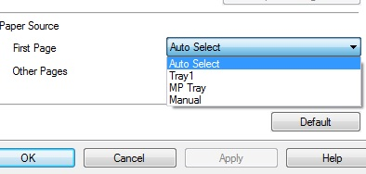

NOTE: Tray2 is only available if the optional paper tray has been installed.

6. Click APPLY => OK.

7. Click OK or PRINT, depending on your application. The document should print from the tray based on the selections you made.

