Step 1.
Download and install Adobe Acrobat Reader (formerly called Adobe Acrobat DC) from the App Store.
Step 2.
Open a document and tap and hold the location where you would like your signature to appear and select Signature. You can also select Freehand to draw your signature or make annotations on the document.
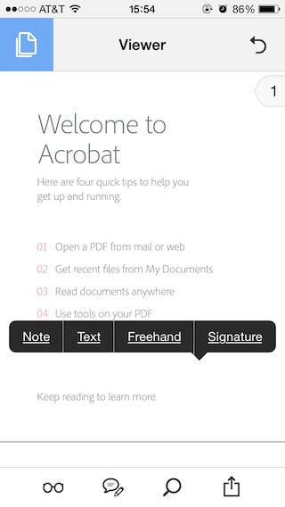
Step 3.
Once you tap Signature you will be taken to the signature creation screen. If you’ve already created a signature select Add Signature, and it will be added to the document.
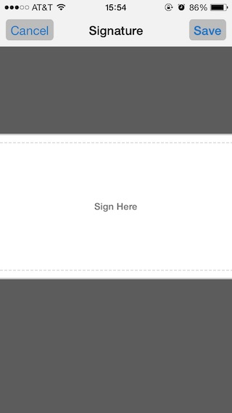
Step 4.
Use your finger or stylus to create your virtual signature. It may take a couple tries to get something legible, but it’s possible. Tap Save when you are happy with your signing and your signature will be added to the document.
Step 5.
Tap and hold the signature to bring up the options menu.
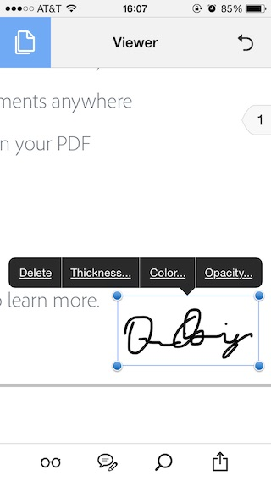
Here you can change the Color, Opacity, Thickness, or Delete the signature completely.
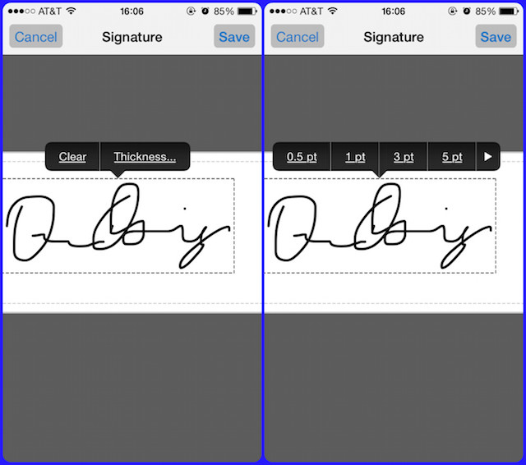
Step 6.
Tap and hold the signature to move it to another location on your document.
Step 7.
After signing the document you can send it to the necessary recipient; no fax or scanning needed.

