Cnanon Ink holders (Shown in white in the middle they contains ink cartraiges)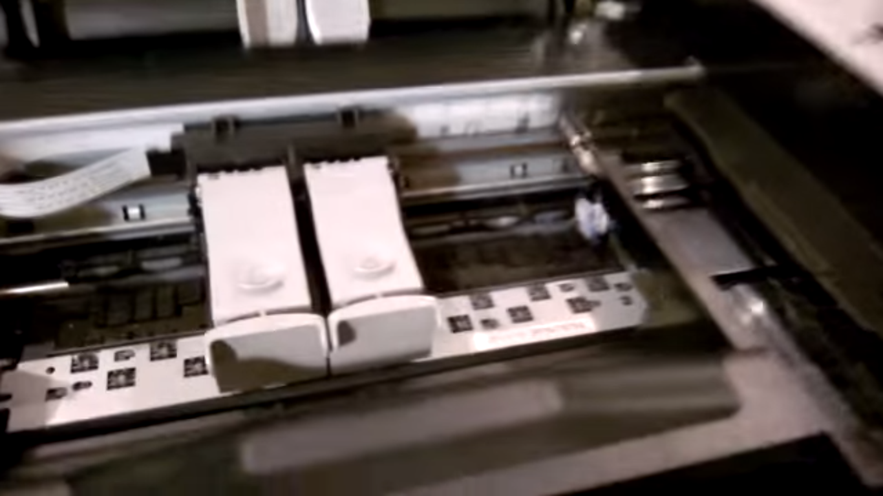
Look at the right side of it as shown using torch. These are the Ink pads.
