iTunes 12 – Option 1
- Connect your device to the computer.
- Select the icon for your device, located at the upper-left portion of the screen.
- Select the “Music” option on the left pane.
- Ensure the “Sync Music” check-box is selected.
- In the “Playlists” section, check the playlists you wish to sync with your iOS device.
- Select “Sync” and your playlist should sync.
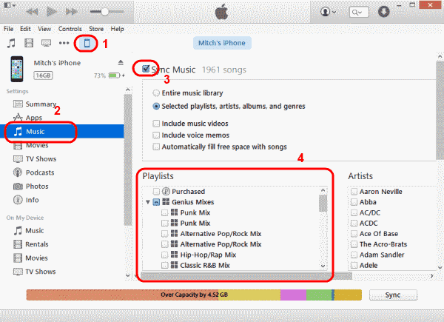

iTunes 12 – Option 2
- Connect your device to the computer.
- “Music Playlists” should be listed in the left pane. Select the playlist(s) you wish to sync, then drag them up to your device listed in the “Devices” section on the left pane. They will then sync to your device.
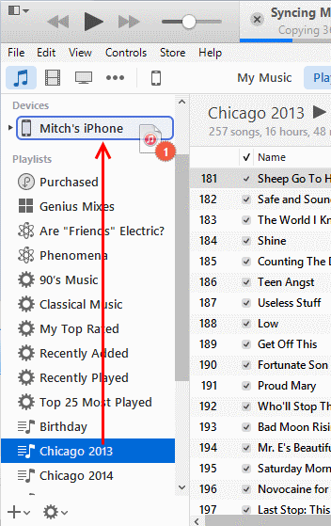

iTunes 11
- Connect your device to the computer. A button should appear for your device in the upper-right portion of the screen. Click it.
- Select Add To… This will make a contents menu available on the right side.
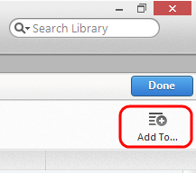
- Select “Playlists” at the top of the screen.
- Drag any playlist from the left side to the right side.
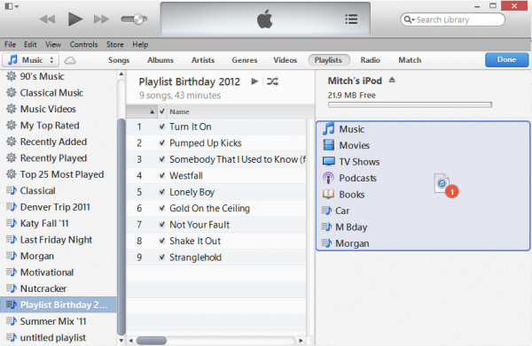
- Click “Done“, then select the “Sync” button in the lower right corner of the screen to sync your changes.
You have successfully transferred a playlist to your Apple device. If you liked the old way of doing things, you can always enable the left sidebar again.

