If you’re using Windows Live Admin Center (formerly Windows Live Custom Domains) then you need to select the option “Manual setup or additional server types”
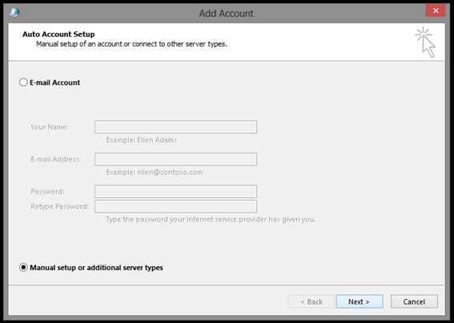

Click “Next” and choose “Exchange ActiveSync”.
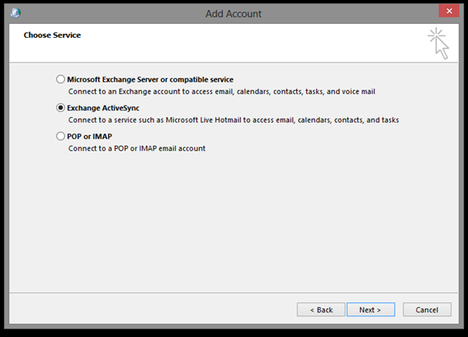
Now enter the Windows Live Admin Center (or Windows Live Custom Domains) account details which looks like.
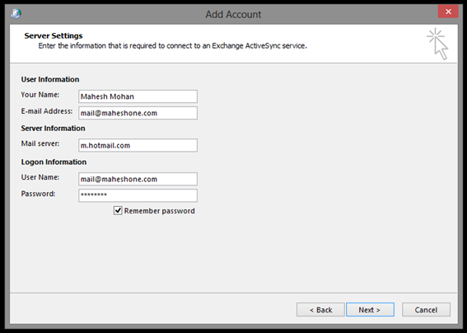
Note: The “Mail server” should be: m.hotmail.com
Click “Next” and then click “Close” to finish account setup.
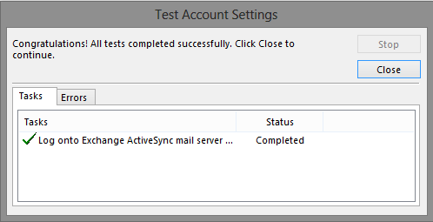
You’re all set!
