Erase Iphone Content with knowing Pass Code:-

1. Connect the original data cable's USB connector to the PC's USB port. (Do not connect the other end of the cable to the iPhone at this moment.
2. Make sure that the latest version of iTunes is installed on your computer.
3. Turn your iPhone off.
4. After this, press and hold down the Home button on your iPhone, and while holding down, connect the other end of the cable to the phone.
5. Wait until the iTunes icon appears on the screen, and then release the Home button.
Note: This is Recovery Mode.
6. On your computer, if iTunes doesn't start automatically, launch it manually.
7. When prompted, click the Restore button on the iTunes
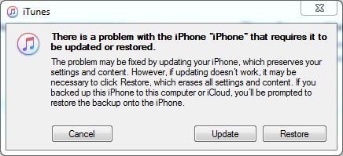
8. Wait until iTunes connects to the iPhone software update server.
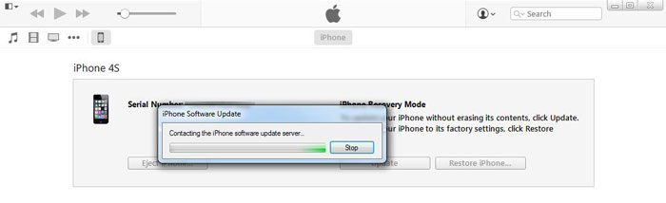
9. On the iTunes confirmation box, read the message carefully and click Restore and Update.
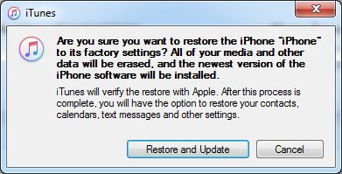
10. On the iPhone Software Update window, click Next.
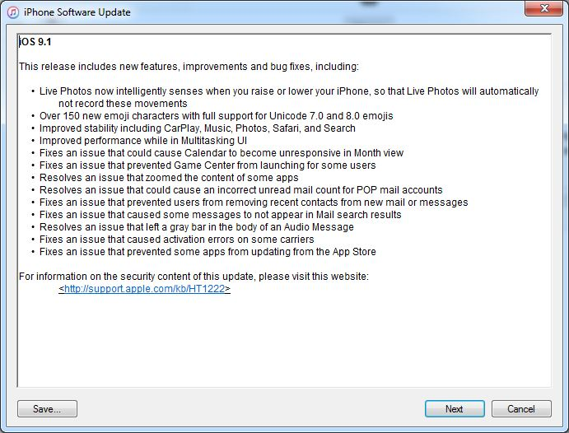
11. On the next window, click Agree to accept the license terms and to continue.
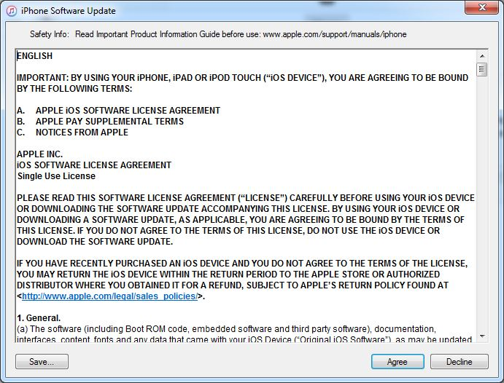
12. Wait until a copy of iOS compatible for your iPhone is downloaded, and iTunes uses it to restore your phone to the factory settings.
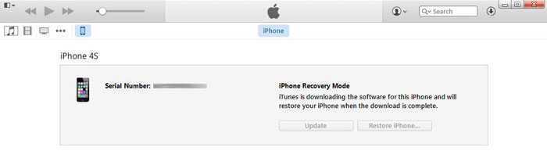
13. In the above process, the latest version of iOS is downloaded for your iPhone for restoration. However, if you have already downloaded a copy of iOS for your phone manually, you can follow the procedure given below to restore your locked iPhone using that file:
• Follow the steps given above from 1 to 6.
• When the iTunes box appears, left-click the Restore button while pressing and holding down the Shift key on the keyboard.
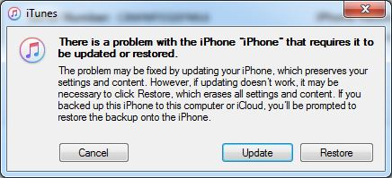
14. On the opened box, locate and select your preferred iOS file.
Note: Make sure that you use the correct iOS image file. Picking a wrong file would keep your iPhone from getting restored.
15. Click Open when done.
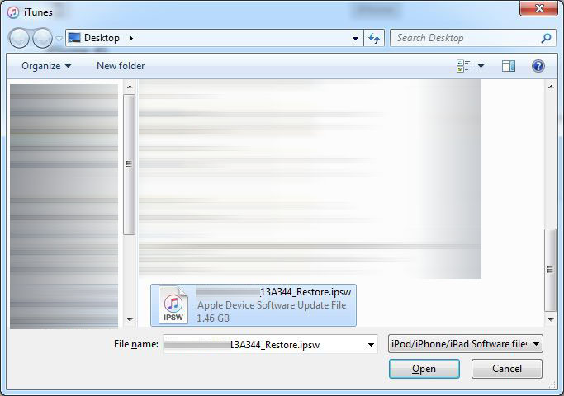
16. On the next box, click Restore.
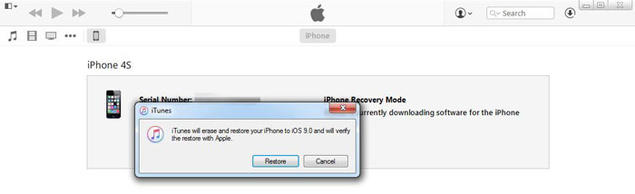
17. Wait until iTunes restores your iPhone using the selected iOS image.
