How to download El Capitan
Apple provides the El Capitan upgrade through its App Store. The download is a bit over 6GB, so you may want to download it at a time when you have other things to do—how long the download takes depends on your Internet connection and the amount of activity at the App Store. Or you can use your Mac while you wait, but be ready to save your work and quit when the download is done.
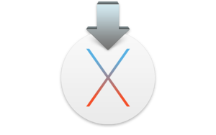
To download El Capitan, launch the App Store app in your Applications folder (or go to Apple menu > App Store). You’ll probably find El Capitan right away, especially if go to the App Store soon after the official release. Apple will probably have a banner at the top promoting El Capitan, but if you don’t see one, you can probably find it in the Free section in the far right column (you might have to scroll down to see it). And you can always do a search on El Capitan.
When you get to the El Capitan page in the App Store, click on the Download button. You may have to enter your Apple ID name and password, and after you do, the installer will download.
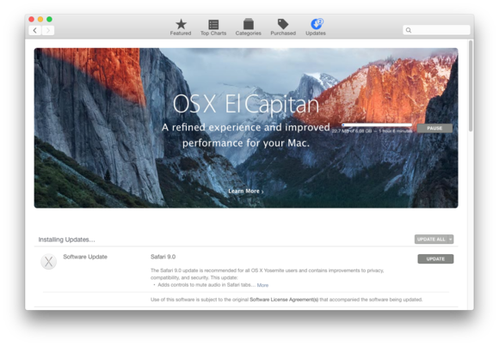

Apple is heavily promoting El Capitan in the App Store. This special banner appeared in the Updates section.

Copy the installer
When the download finishes, the installer automatically launches. Don’t click Continue in the installer just yet. What you may not know is that the installer is downloaded to your Applications folder and then deleted after the installation is done.
If you ever need the installer again, you can get it in the App Store. But I like to make a copy of the installer. I often have to perform OS installations, so I make a bootable flash drive that I can use; it’s a lot faster than waiting for the download.
To copy the installer, you need to hold down the Option key as you drag the Install OS X El Capitan app in your Applications folder to the copy destination. If you don’t hold down Option, you’ll create an alias, not a copy.

Install El Capitan
OK, now you can click that Continue button in the installer window. (If the installer isn’t running, go to your Applications folder and double click the Install OS X El Capitan app.) You’ll be asked to agree and then confirm that you agree to the license agreement.
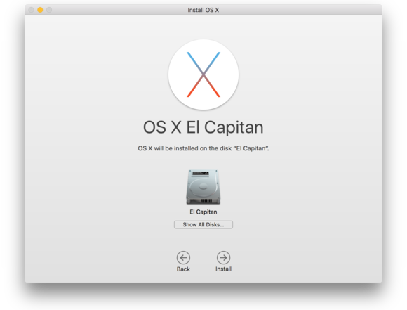

The next screen will ask you to select the disk for the El Capitan installation. If you have one storage device with one partition, you’ll see it in the installer window. But if you have multiple storage devices and/or multiple partitions, you can select the one you want by clicking the Show All Disks button. Make your selection and click Install.
To continue, you must enter your username and password. The install will prepare to install, restart your Mac, and perform the installation. The Mac may restart again during the installation process. The install will take several minutes, so you may want to go for a walk, call your mom, take a nap, or catch up on chores while the software does its thing.
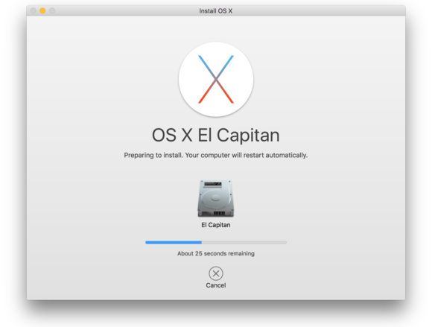

When the installation is finished, the Mac will restart and you’ll need to log in with your username and password. You may be asked if you want to send diagnostic data to Apple and that you need to log in with your Apple ID, and then a setting up screen will appear and go away. You’re done.

