Do a right click on your desktop and hover to view option and uncheck Auto arrange icons.
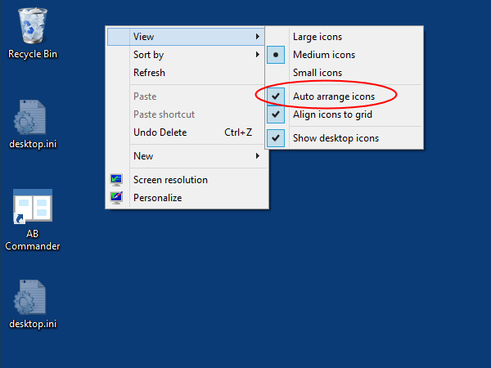
If the Auto-arrange icons option is checked, uncheck it. You should now be able to move the icons to their appropriate positions on the desktop and Windows should not get in the way.
Now you can press F5 on your desktop (which is a shorcut to refresh the destop folder) to see if the icons are staying at their place.

Regards,
Bhavik Joshi

