Enable iCloud — Tap Settings located on your device’s home screen once again. Afterward, tap the iCloud option found midway down the menu, enter the appropriate Apple ID and password you wish to use with iCloud and tap the blue Sign in option directly beneath the entry fields when finished. Although you likely already possess an Apple ID — it’s the same account you use to purchase items from the iTunes, App and, iBook stores — you can always create a new account by clicking the blue Get a Free Apple ID link at the bottom of the screen and following the resulting on-
screen instructions.

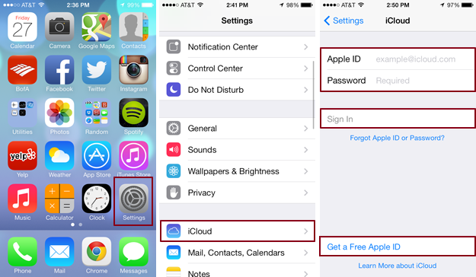

Select your iCloud services — iCloud will present you with over a dozen individual services, from mail and Safari to contacts and calendars, once signed in. Toggle the slider directly to the right of the applications to choose which ones you’d like to sync across your various devices. Syncing options vary from application to application, but you can typically fine-tune the process within the main settings of each service.
