How to Transfer Playlist from iTunes to iPhone via AnyTrans

Download Link:- http://dl.imobie.com/anytrans-mac.dmg
AnyTrans is said to be the most effective iTunes alternative tool to manage the whole iTunes library as well as the content on iPhone.
- It extracts your iTunes Library and displays the content in it like music, playlist, movies, TV Shows, audiobooks, ringtones, etc.
- It is safe and easy to transfer playlist from iTunes to iPhone, because AnyTrans won't erase any existing content on your iPhone.
- It allows you to transfer music, playlist, movies, ringtones, and more from iPhone to iTunes, to computer hard drive or to a USB flash drive.
- It helps copy songs from one iPhone to another directly.

Step 1. Open AnyTrans, and connect your iPhone to computer. Click on iTunes Library.
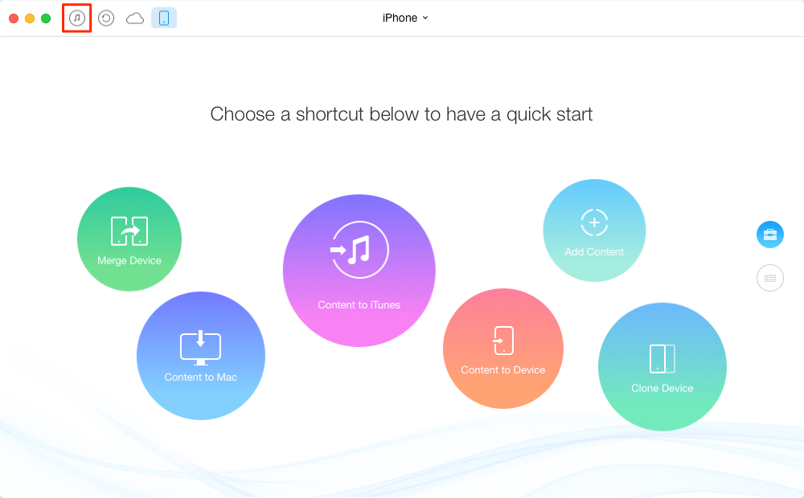
Transfer Playlist from iTunes to iPhone with AnyTrans
Step 2. Here you will see the content in iTunes Library, click on the Playlist button, and choose the playlist you want to transfer to your iPhone, then click the To Device button on the right hand corner.
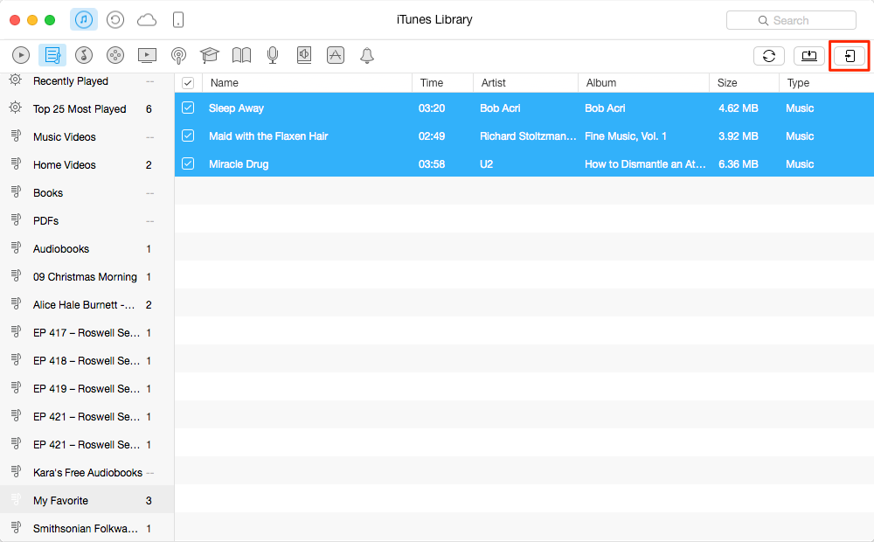
Transfer Playlist from iTunes to iPhone with AnyTrans
With the help of AnyTrans, it is easy enough to transfer playlist from iTunes to iPhone, and doesn't erase any previous iPhone data or files. Absolutely, AnyTrans can do more than this. It also can be used as an iPhone iPad data management tool to transfer iOS contents from iDevice to computer for backup in case of data loss

