Located on the bottom left of the Welcome screen is a Power The first thing you need to do is click on this button.
While holding down the Shift key on your keyboard, click on Restart from the menu that pops up above the Power button

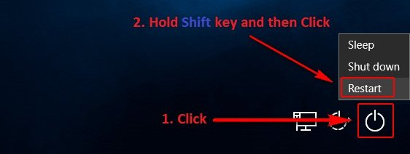

In the Advanced Recovery Options menu that appears on the screen, click on Troubleshoot.
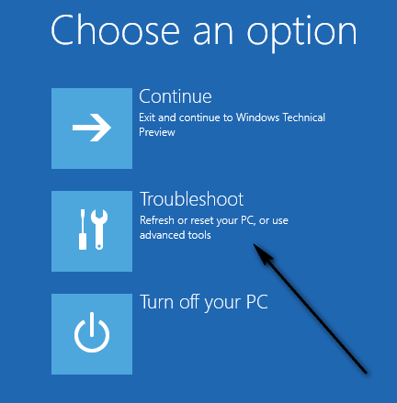
Click on Advanced Options.
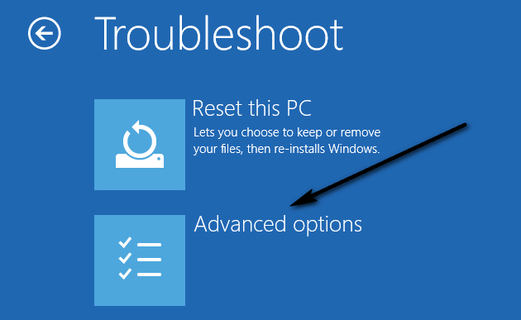

Finally, click on Startup Repair. Depending on the version of Windows 10 that your computer is running on, this option may be displayed as Automatic Repair.

