Reset Microsoft Edge Through Its Settings
Open the “Settings” menu by clicking the three horizontal dots in the upper right corner of the Edge window and choose “Settings.”
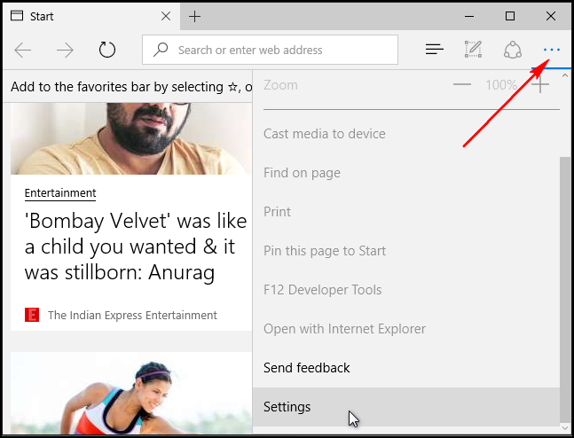
Under Clear browsing data, click “Choose what to clear” and then click “Show more.” There are a lot of data types here. Select them all and click “Clear.” Restart your PC and re-open Edge for a clean slate.
