- Exit Outlook and do one of the following:
  - Browse to C:\Program Files.
or
  - Browse to C:\Program Files (x86).

- In the Search box, type SCANPST.EXE.
NOTES: If the search doesn't find SCANPST.EXE in one folder, try searching in the other folder mentioned in step 1. Navigate to the folder location based on your version of Outlook.
  - Outlook 2016: C:\Program Files (x86)\Microsoft Office\root\Office16
  - Outlook 2013: C:\Program Files (x86)\Microsoft Office\Office15
  - Outlook 2010: C:\Program Files (x86)\Microsoft Office\Office14
  - Outlook 2007: C:\Program Files (x86)\Microsoft Office\Office12

- Open SCANPST.EXE.
- In the Enter the name of the file you want to scan box, enter the name of the .pst file you want the tool to check, or choose Browse to select the file.
NOTE: By default, a new log file is created during the scan. You can choose Options and opt not to have a log created, or you can have the results appended to an existing log file.
- Choose Start to begin the scan.
- If the scan finds errors, choose Repair to start the process to fix them.
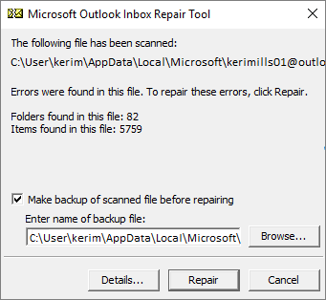
NOTE: The scan creates a backup file during the repair process. To change the default name or location of this backup file, in the Enter name of backup file box, enter a new name, or choose Browse to select the file you want to use.
- When the repair is complete, start Outlook

