1. In the top-right corner of the browser window, click the Chrome Menu
2. Select Settings.
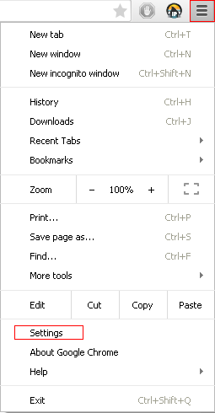
3. At the bottom, click Show advanced settings.
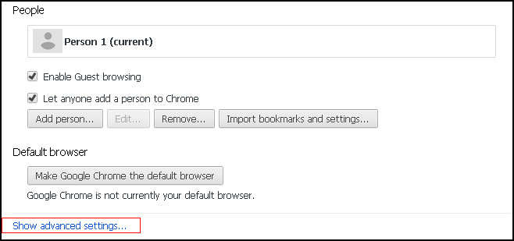
4. Under the section "Reset settings,” click Reset settings.
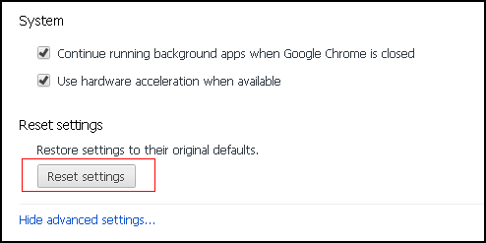
5. In the dialog that appears, click Reset.
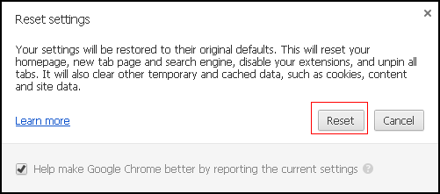
6. Done! Chrome has been reset!

