Download a software from below link :-
http://www.iosdevicerecovery.info/free-download.php
Step 1. Download the program and connect your iOS device to your system
Download and install iOS Data Recovery and with the help of USB cable to connect your iPhone/iPad/iPod to your system. You will get the below interface.
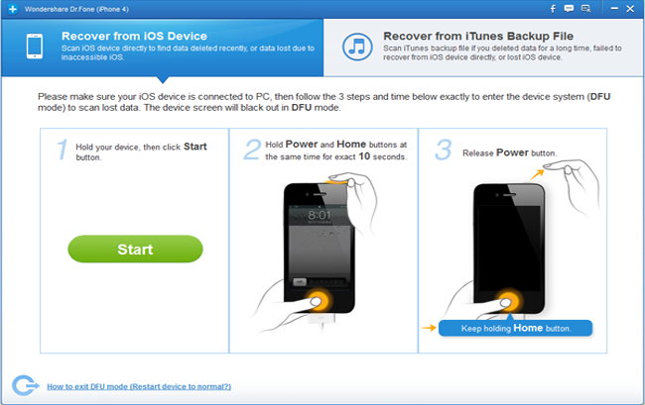
Step 2. Scan your iOS device by entering into the DFU mode
Note: Before scanning the iOS device get into DFU mode and then scan the lost or deleted data in your device.
- Hold your device and hit the “Start” button from the software interface.
- Hold the “Power” and “Home” button on your device for 10 sec. This data recovery software will count the time for you.
- When 10 seconds will get over you can leave the “Power” button, but keep holding the “Home” button for more10 seconds, You will get a message that you have successfully entered the DFU mode and now you can leave the “Home” button now.
The program will start scanning your device for the lost or deleted reminder, and you will find the below interface.
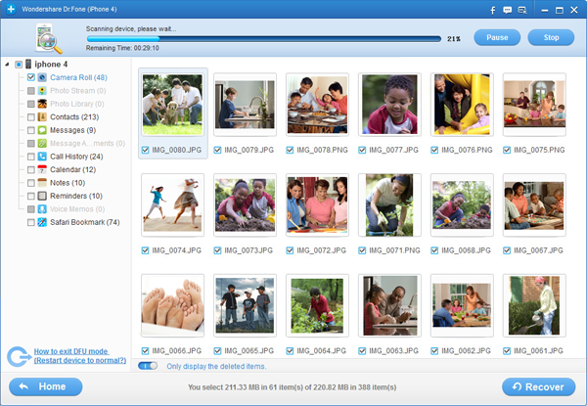
Step 3. Preview and select the recover files
As soon as the scanning process gets over all your files will be displayed. You can preview the file one after another before recovery.
Note: If you want to get them back you can select the data by clicking the “Recover” button to save them on your system in just one click.
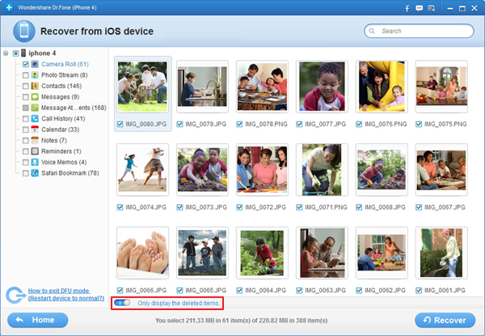
But if you want to recover your few deleted data then you can use button in red area on above interface to choose the deleted files and mark them to recover.
Note: As soon as the scanning process get over you will get the recovered data in a categories, such as camera roll, contacts, notes, reminders, message attachments, messages, call history, photo library, voice memos, photo stream, calendar and safari bookmark.

