To customize the Ribbon in Excel 2013:
You can customize the Ribbon by creating your own tabs with whichever commands you want. Commands are always housed within a group, and you can create as many groups as you want in order to keep your tab organized. If you want, you can even add commands to any of the default tabs, as long as you create a custom group in the tab.
- Right-click the Ribbon and select Customize the Ribbon... from the drop-down menu.
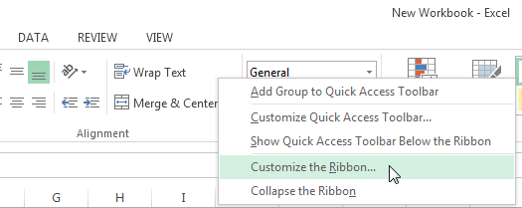
- The Excel Options dialog box will appear. Locate and select New Tab.
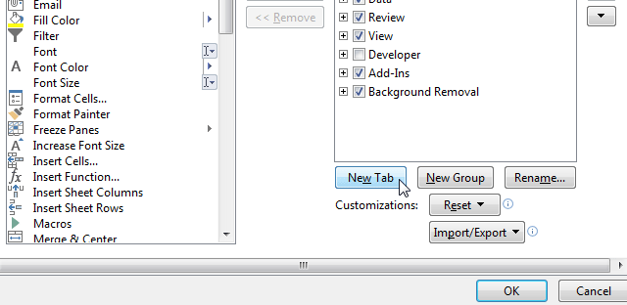
- Make sure the New Group is selected, select a command, then click Add. You can also drag commands directly into a group.
- When you are done adding commands, click OK. The commands will be added to the Ribbon.
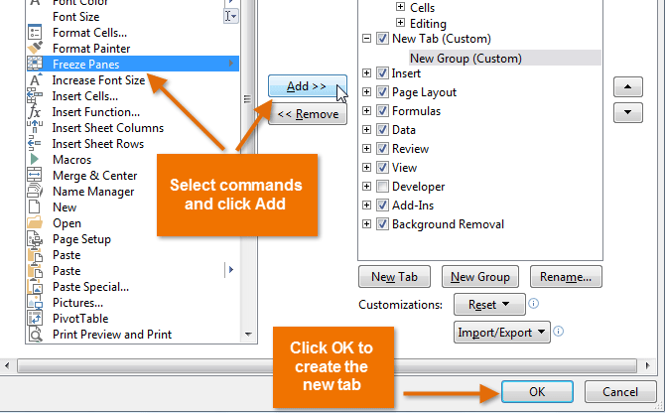
If you don't see the command you want, click the Choose commands from: drop-down box and select All Commands.
