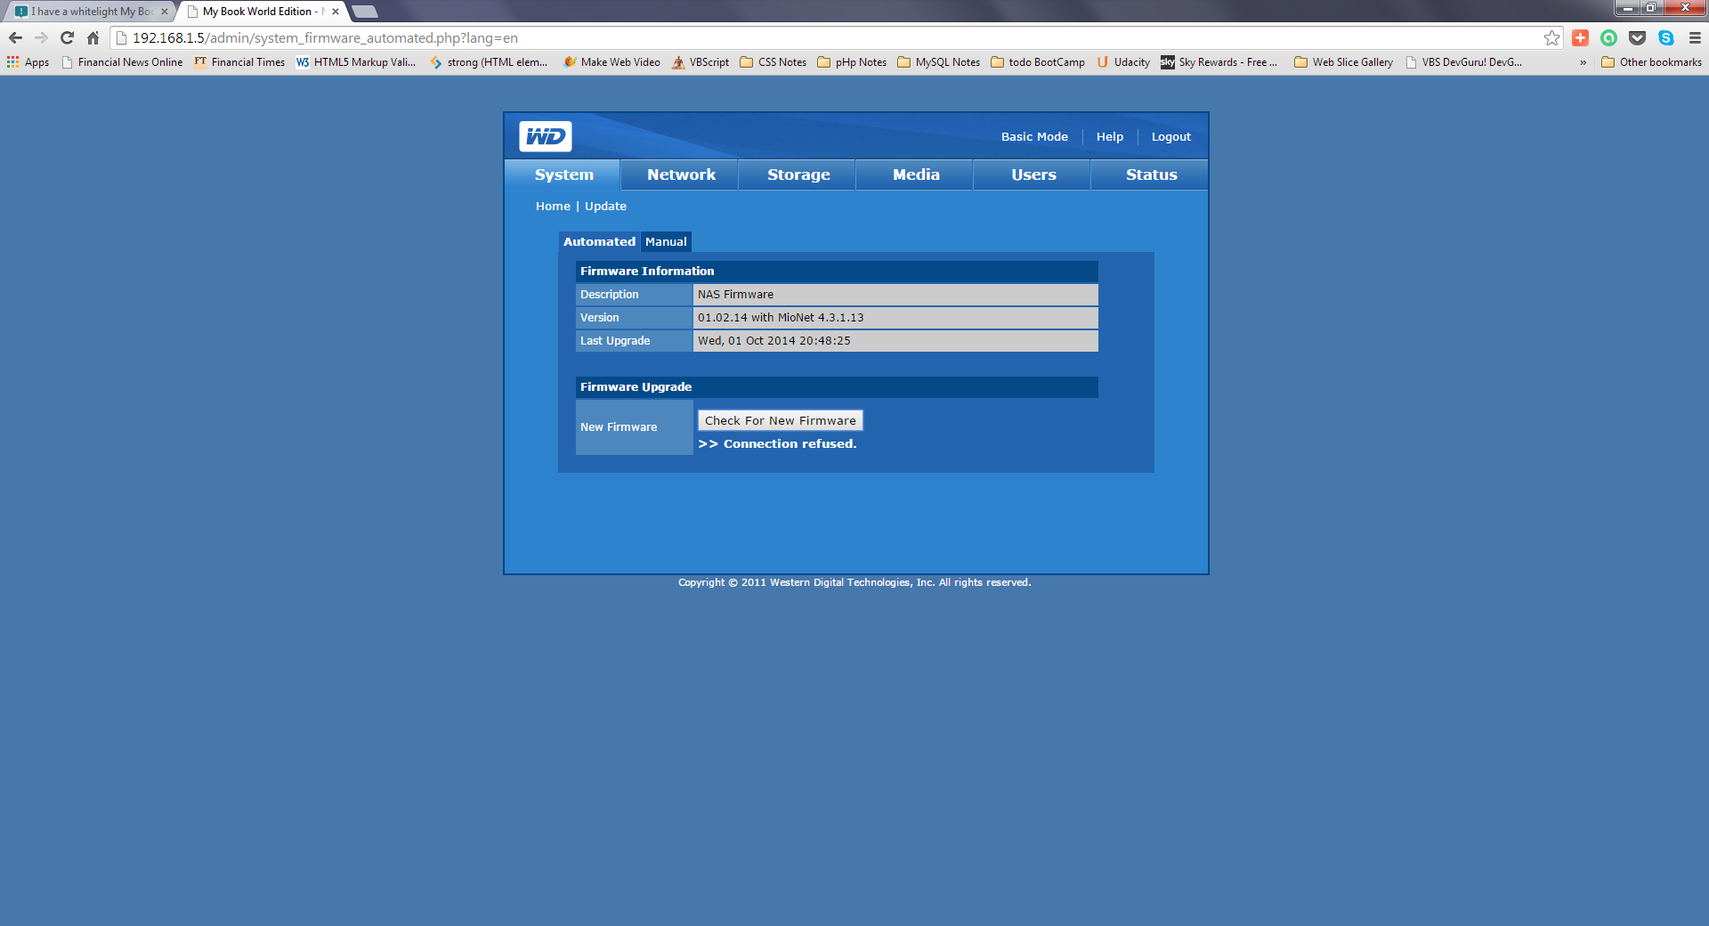
The Auto Update for this firmware – has connection refused
Could this be some firewall issue at the router?

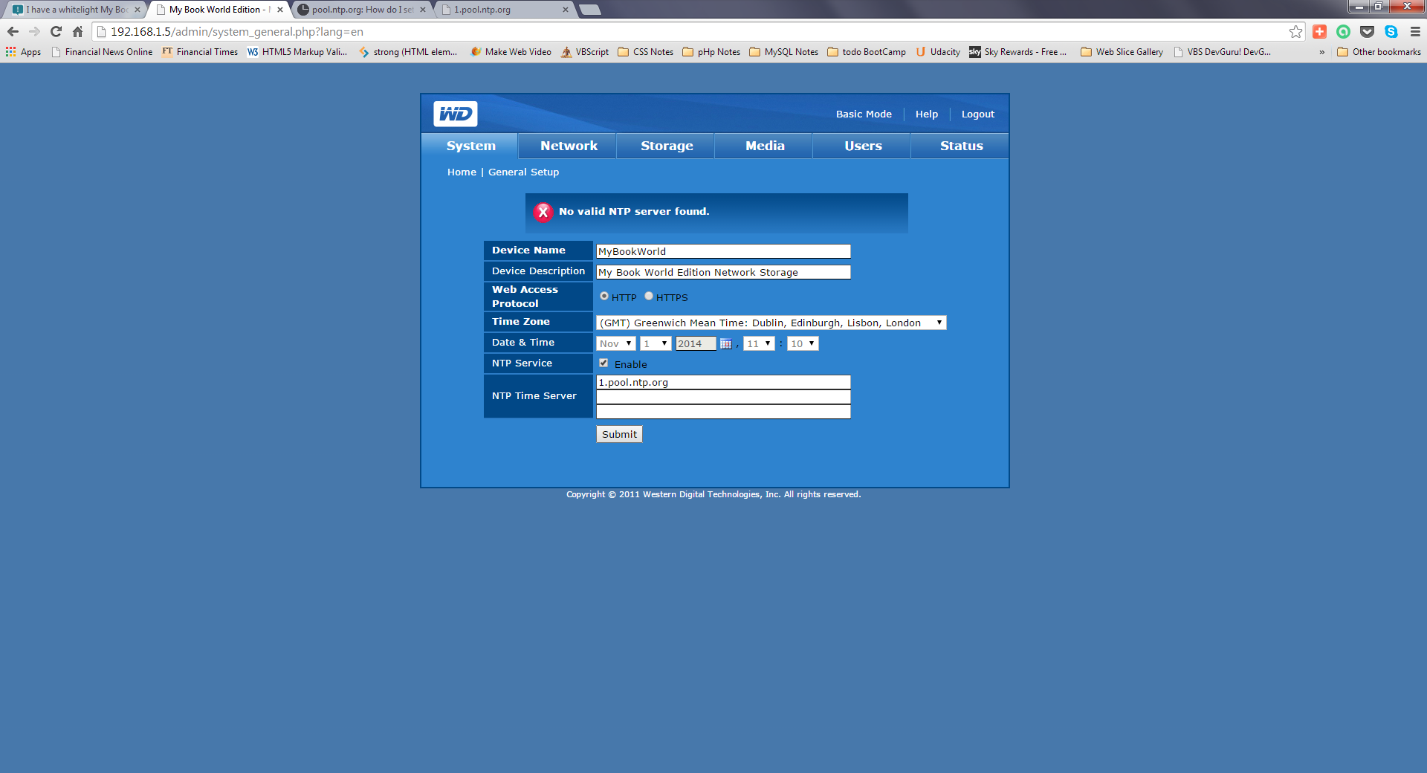

I have used the same url in a browser where it has returned OK
